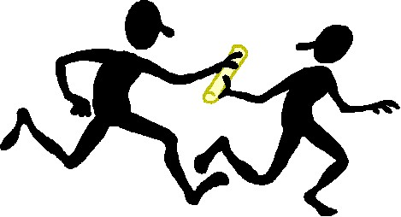
RUN-ON SENTENCES
Four Ways to Find Them
The Writing & Learning Studio Room 4301 Shoreline Community College
rev: 02-19-20

WHAT’S A “RUN-ON”? A run-on sentence occurs when two or more main thoughts run together without correct punctuation. Writing run-on sentences is a common writing error.

- How to Find Run-ons: LISTEN to the Words!

Read each sentence ALOUD at your regular pace. Listen closely for clues to where a sentence might end:
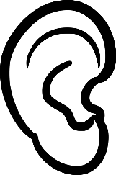
- If your voice stops and drops in tone, a period could be needed.
- If your voice raises, a question mark could be needed.
- If your voice expresses strong emotion, try an exclamation mark.
- Remember to begin new sentences with a capital letter.

Try the sentences below. Read each one aloud and listen to your voice. See if you can put in the correct punctuation:

- We rushed out for lunch then we walked 10 blocks to a restaurant.
- Does your boss answer the phone, mine always waits for me to do it.
- I waited and waited for my tax refund finally it came.

- How to Find Run-ons: L K for the TROUBLESOME WORDS!

  - Certain words are often responsible for run-on sentences. If one of these words starts a complete thought, use an end mark before it:

then here consequently
finally there therefore
usually soon however
  - Run-on: Margo waited 10 minutes for her hot chocolate, finally the server brought it.
Correct: Margo waited 10 minutes for her hot chocolate. Finally, the server brought it.

Run-on: Mimi laughed until she cried, then she fell out of her chair.
Correct: Mimi laughed until she cried. Then she fell out of her chair.

Run-on: Ralph tried to grow orchids, however, the climate was too cold.
Correct: Ralph tried to grow orchids. However, the climate was too cold.

Run-on: I was surprised to see monkeys at the party, usually only rabbits attend these events.
Correct: I was surprised to see monkeys at the party. Usually only rabbits attend these events.
- How to Find Run-ons: Watch for PRONOUNS!

  - Another common mistake is a run-on error with one of these pronouns: I, you, he, she, it, we, they.
If you slowly read aloud the run-on sentences below, you will see that in each run-on, a complete thought ends just before the italicized pronoun.

  - Run-on: Cinderella tried on the glass slipper, it fit perfectly.
Correct: Cinderella tried on the glass slipper. It fit perfectly.

Run-on: My two brothers collect bottle caps, they are planning to build a metal sculpture.
Correct: My two brothers collect bottle caps. They are planning to build a metal sculpture.

Run-on: The hotel hosted a fire-walking contest I won a hundred dollars walking on hot coals.
Correct: The hotel hosted a fire-walking contest. I won a hundred dollars walking on hot coals.

Reminder: Whenever you use one of the pronouns listed above, stop for a moment. Does the word start a
complete thought? Does your voice stop and drop before it? If so, use a period and start the pronoun with a
capital letter.
Try These:

Run-on: Don’t be late for the fashion show, it is a spectacular event.

Correct: _________________________________________________________________

Run-on: Mr. Nisket is very friendly he always has a smile for me.

Correct: _________________________________________________________________

Run-on: Everyone needs a diet full of vitamins, they are very important to our health.

Correct: _________________________________________________________________

Run-on: We arrived at the store at 9:00, it had not yet opened.

Correct: _________________________________________________________________

Run-on: I was hoping you would come to the party I haven’t seen you in such a long time.

Correct: _________________________________________________________________

4. How to Find Run-ons: Watch for COMMAS!

- A comma is NOT an end mark. Used alone, it cannot separate two sentences. When writers incorrectly use
it that way, the run-on sentences is called a “comma splice.” It can be corrected with a period instead of a comma,
or, sometimes, with a semi-colon instead of a comma. (See #5 below, too.)
Comma splice: The hamburger weighed five pounds, he was unable to finish it.
Correct: The hamburger weighed five pounds; he was unable to finish it.
Comma splice: Joan runs like wildfire when wolves are chasing her, she howls a lot, too.
Correct: Joan runs like wildfire when wolves are chasing her. She howls a lot, too.

- Two Other Ways to Fix Run-ons

- When two complete thoughts are very closely related in meaning, you can use a semicolon to connect them.
Run-on: We tried to catch the bus, however, we left too late.
Correct: We tried to catch the bus; however, we left too late.
Run-on: She laughed loudly, then she covered her mouth.
Correct: She laughed loudly; then she covered her mouth.
Run-on: The camera broke, consequently, no wedding pictures are available.
Correct: The camera broke; consequently, no wedding pictures are available.

- If the two run-on word groups are equal in importance, you can also join the run-on by using one of these connectors: for, and, nor, but, or, yet, so. When you use one of these connectors to fix a run-on, use a comma
before it.
Run-on: We tried to catch the dinosaur, it ran too fast.
Correct: We tried to catch the dinosaur, but it ran too fast.

Run-on: My ankle broke, I couldn’t finish climbing Mt. Everest.
Correct: My ankle broke, so I couldn’t finish climbing Mt. Everest.

Run-on: Give Macy the extra cake, it’s her birthday.
Correct: Give Macy the extra cake, for it’s her birthday.

