

Workforce/GAC Joint Advisory Committee Meeting Tuesday, June 3, 2025 12:30 – 1:30 p.m.
Via Zoom
Minutes

Members Present:
Industry Representative:
Nathan Daum, City of Shoreline (Chair)
Leslie Patten, Workforce, SeaKing/Business Services Mike Schulte, Workforce, ESD
Alyssa Jackson, Snohomish STEM Network Developer Mike Chan, Software Developer

Shoreline community College:
Lauren Hadley, Director of Workforce

Shoreline Public Schools:
Dan Gallagher, Director Secondary Academic Programs & CTE Roxie Brendible, CTE Specialist
Nathan welcomed and introduced committee members Committee reviewed and approved March 6, 2025 Minutes
Dan presented the Shoreline School District updates
Committee approved the conditional certiﬁcations for the following teachers, deeming them competent based on industry and teaching experience and training plans:

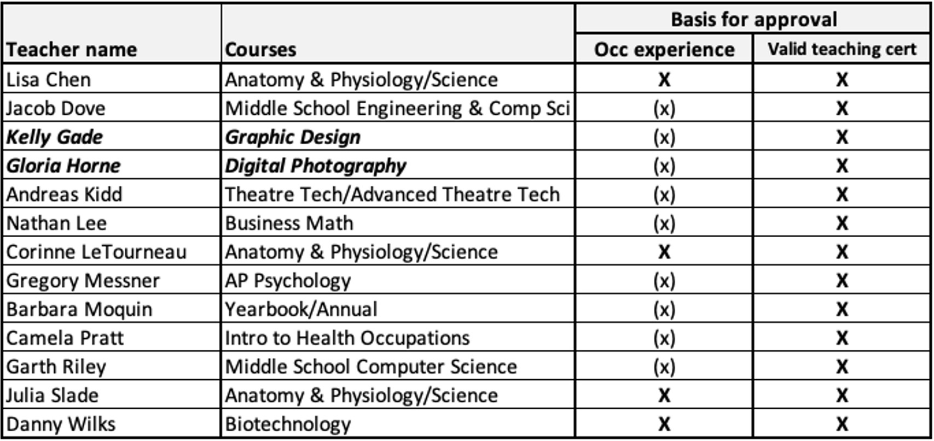
Program evaluation components were reviewed across all CTE program areas. Highlights included dual credit expansion, particularly in Business Writing, and progress on Health Sciences.
The committee provided input and approval for the district-wide CTE multi-year plans, including use of Perkins funding. Initiatives include postsecondary advising/counseling, postsecondary alignment, extended student learning/leadership experiences, and maintaining district ﬁscal responsibility.

Committee thanks Nathan Daum for serving as the 2024-25 committee Chair and elected Leslie Patten as the Chair for the 2025-26 school year.
Committee members shared what they are hearing or experiencing in the workforce; ie., trends, skill gaps, and opportunities.
Committee Adjourned 1:48 p.m.

Next meeting: Advisory Committee Kickoa October 30, 2025, 5-7 p.m.

