

Workforce/GAC Joint Advisory Committee Meeting Tuesday November 7, 2025, 11:30 a.m. – 12:30 p.m.
Via Zoom
Minutes

Members Present:
Industry Representative:
Nathan Daum, City of Shoreline (Interim Chair) Mike Schulte, Workforce, ESD

Shoreline Community College:
Lauren Hadley, Director of Workforce Fikru Diro, Program Specialist III
Tsai-En Chang, Dean of STEM-Career Technical Education (CTE)

Shoreline Public Schools:
Dan Gallagher, Director Secondary Academic Programs & CTE Roxie Brendible, CTE Specialist

Leslie Patten is unable to fulfill her position as Chair this year. A new Chair will be elected in a following meeting.

Nate Welcomed committee and opened the meeting at 11:15am
Committee approved of the Winter 2025 minutes with correction to Alyssa’s title

Dan presented the Shoreline School District Updates with a list of the new teachers with
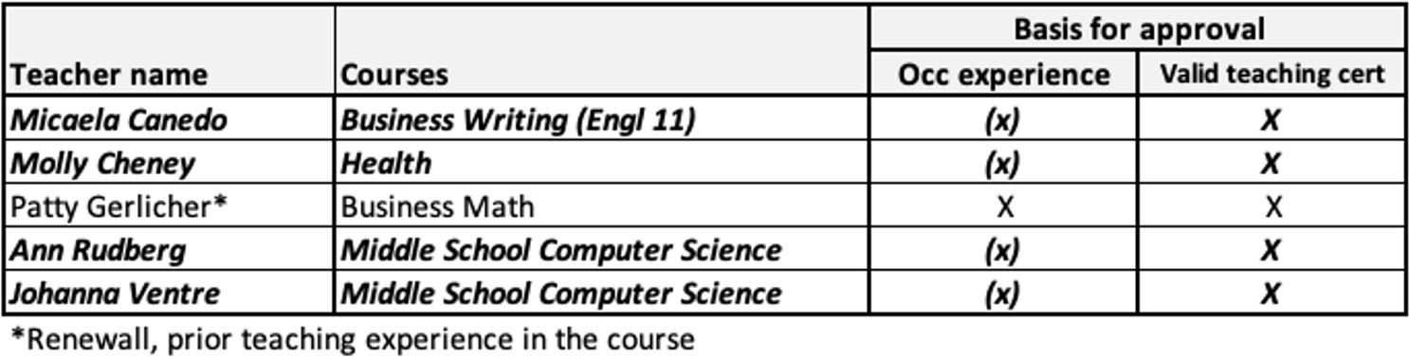

Conditional Certifications

Committee approved the conditional certifications for the following teachers, deeming them competent based on industry and teaching experience and training plan:

Dan also presented an English Running Start / Dual Credit program being piloted here at Shoreline, which is similar to the math dual credit offered through running start for the third year.
- Regardless of their pathway, students that participate in this program have the opportunity to fulfill their requisite college Math and English credits before they graduate from high school.
Committee welcomed Tsai-En Chang, the new SCC Dean and Committee Introductions:
- Tsai-En spoke on her focus areas within CTE and promoting SCC connection with the community, and building career pathways for our students, worker retraining, and immigrant support.

Lauren led a discussion regarding the updates from labor market trends across King and Snohomish Counties, examining differences in job losses and discussing occupation demand data for both regions.

Meeting Adjourned 12:30pm

Next Meeting: Advisory Committee TBD
Lauren will send doodle poll in the new year to schedule next meeting time

