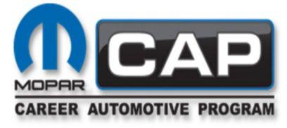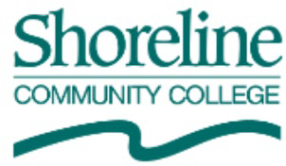

Mopar CAP Advisory Meeting
Date: Thursday May 8, 2025

Attendance:
Rob Allred; SCC, Brandie Biering; SCC, Gary Fantozzi; SCC, Mark Stark; Hazlewood, Marc Wheeler; Hazlewood CDJR, Jon West; Marysville CDJR, Kelvin Fernando: Kirkland CDJR

Meeting started at 11:15 a.m.
The last meeting minutes were approved- not a quorum

State of the class
All the students have been placed and are on track to complete next quarter Differentials and halfway thru transmission
Starting the next cohort with brakes and suspension and then electrical. Mark asked from the last minutes if the Wi-Advisor for digital MPI was implemented? Rob responded that it has not been implemented. The students have been working on improving stories.
Stellantis did a survey of dealers in the area. Stellantis has sent a formal notice to the college. Several dealers have communicated that the quality of training a student graduates is below their expectations of a Mopar CAP Traditional student.
- Stories and Changing the program around should help a little bit.
- John like the 2-year better than 1-year. Their ability to perform repairs was better.

- Mark thinks both have pros and cons. But believes this comes back to the dealership and how they help the students. He thinks the dealerships need to help more. The students cannot be on the lube bay the whole time. Maybe we need to try the 2-year program to see if it helps and if it doesn’t go back to the one year.
- Stellantis should be here to help with what works and what doesn’t work at other classes.
- Part of the program problem is the dealers’ involvement
- Changing it back to a 2-year program would only change the internship, which will give them more time at the dealership. The in-class time would not change.
- The 2-year program will cost the student more in tuition.
- The other item Stellantis brought up was placement and graduation.
  - The students had a hard time getting a job.
    - Mark mentioned it is on the student and the dealership to move the students up from the lube bay.
Rob is going to send out a survey seeking information on how to improve the program and student preparedness, what is the expectation of the student coming out of the program.
The school is on formal warning and need to come up with an improvement plan.
All the grants for Automotive are being canceled for the school. Our regular operating budget is
$40,000, we asked for an increase but do not know if we will get it. The college overall budget is going to be lower than what we receive this current year.
Tools to get hybrid and diesel tools.

The meeting ended at 11:47 a.m.

