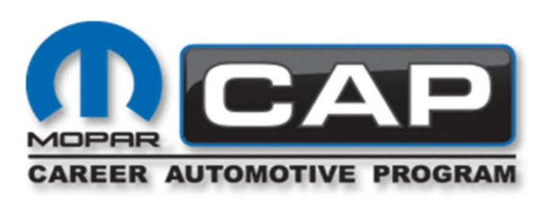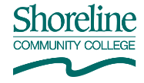
Mopar CAP Advisory Meeting
Date: Thursday October 17, 2024

Members Presented:
Rob Allred, SCC
Brandie Biering, SCC
Kelvin Fernando, Kirkland
Derek Carrol, Seattle Jeep
Mario Vergara, Marysville
John West, Marysville
William Leavitt, Rairdons Monroe
Terry Burkhalter, Renton

Meeting started at 5:15 p.m.
The minutes from May 8th, 2024, were approved

- State of the class
  - Started with 12 students.
  - Currently have 9 students
- Curriculum
  - First 2 weeks was fundamentals
  - Currently doing electrical
  - Last week will be HVAC
- Budget
  - The grant got knocked down to $56,000
  - Our regular budget is at $40,000

- Suggested tools or items and Open discussion
  - The group asked when Rob and Mopar would let them teach Hybrid
  - MPI- Digital repair orders (for the students to do what they are doing at the shop)
  - The advisors want to see CAP move to more digital and less paper
  - Ask Kelly to see if the program can get on wiADVISOR for MPI
  - Teach students to always read the stories about warranties even if the Tech has already cause MOPAR is always changing something on the process and will not approve the warranty if not done the new way
  - Magnetic under hood lights
  - Pencil wrench is an AI for telling stories, but only after the students have learned how to write stories. Some dealerships do not use it.
  - The group would like Rob to move his quarters around to teach what the student will be doing first in the shop above lube tech:
    - Fundamental, brakes, suspensions
    - Electrical, HVAC
    - Engine
    - Diff and tranny

Meeting ended at 5:35 p.m.

