- 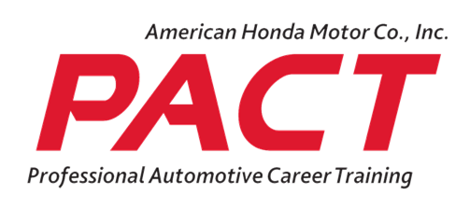
- Honda PACT Advisory Meeting
- April 17, 2025

Attendance:
Rashawn Smith, SCC; Gary Fantozzi, SCC: Brandie Biering, SCC; Matt Waygood, DPSM; Arvin; Merino, Honda of Seattle; Rich Gray, Lynnwood Honda; Oscar Morgana, HONDA PACT; Leslie Macias, HONDA PACT; Jordan Hernandaz, HONDA PACT ; Mark Stark, Hazzle wood; Paul Svenkerud, Carter; Jason Takayoshi, Acura of Bellevue;
Tyler Owens
Robby Choe

Meeting Started at 11:00 a.m.
The previous meeting minutes will be sent out for approval.

Program overview:
Currently in engine repair and engine management. Internship is brakes and steering & suspension. 13 students at 6 different locations. 4-5 students recruited for Fall quarter. The class is open for recruiting for fall.
We need to know how many students the dealerships projected how many students they will need next year.
Program Analysis:
The school just got our budget for this year. WE still have the grant that is $80,000 to spend. We are trying to figure out what ADAS system will work for the whole automotive program. The Bosch system piggy backs the hunter machine.
The state overpaid the college. The college agreed not to spend the 1.2M that we got overpaid.
Industry Update:
Honda PACT industry came during fall quarter to the school. They updated the Honda Pact website in March. 89,000 people visited the website. They also launched their social media campaign for 30 days. It was all to get the word out about the PACT program. Acura of Bellevue student Ethan is going on the PACT Trip this year. The brochure also got an update. If you need any let Rashawn know. If you would like Rashawn to come out to the dealership to talk to you or potential students, let him know.
Program Length:
The program is going back to the 2-year cohort starting Fall ’25. The one-year model has not shown the experience Rashawn would like. The cohort would give students more time with a mentor. Finding someone who has the ability to give the student opportunities and help them. The students want to know more about vehicles and not just how to fix them. The students are in class 134 days and are on internship 82 days. When we flip it, the instruction will be 134 and 205 days. The goal is to have a student in class and one in internship. Rashawn will eventually have 2 different classes. The second class will start winter ’26. The review phase will be in spring 2026.
Proposed student evaluation form:
Rashawn would like help with how to evaluate the students and how to share with the dealership how the students are doing in class. Rashawn was thinking of having a form with the options of A B C so you can still see how the student is doing but not giving out too much info because of FERPA. He cannot share student specific information, for example how their life is going. Even with the parents, they are not allowed any information either. The only way he is able to share is if the student gives formal consent about sharing certain information. There will be 3 Rubics, Rubic core framework, Rubic compliance and privacy, Rubic core implementation. The students may have all the modules covered but not have any hands-on or dealership experience. There was a previous because he had 70% of the modules done but didn’t complete the other stuff.
Rashawn has been going into the dealership to talk about the students for evaluation currently.
The school has all the vehicles they need. The only cars we do not have are EV cars. The PACT schools are not required for hybrid. They are in the process of trying to incorporate EV into the curriculum.

The meeting closed at 11:54 a.m.

