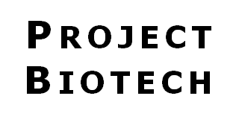 ***Shoreline Community College***

Presents

**Biotech Summer Camps**

**for High School Students**

**July & August 2020**

**July 6 - 10, 2020**

**I. Biotechnology Essentials & Beyond**

Recommended for up-coming 9th & 10th graders but open to all high school (HS) students for basic biotechnology training

*►* Micropipetting

*►* DNA purification & DNA sequencing

*►* Polymerase Chain Reaction (PCR)

*►* Discussions with scientists

*►* Use computers to analyze data for genetic testing

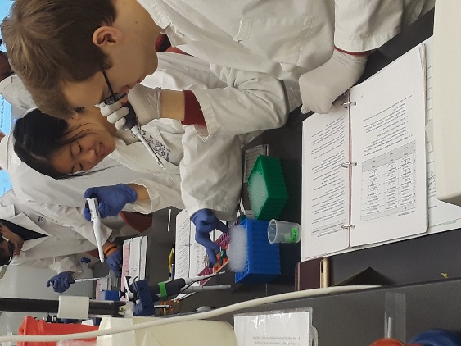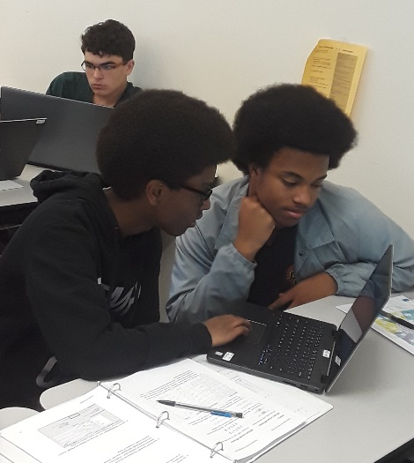

**July 20 – 24, 2020**

**II. Biotechnology & Orca Conservation**

For HS students with biology or biotech lab experience

► DNA sequencing to identify food sources for Orca

► Protein assays to analyze stress hormones in Orca

► Exploration of how ocean acidification is affecting sea life

► Tour of environmental research labs at the UW

► Panel of scientists discussing jobs and career paths

***When and where is camp?***

* 9 am until 4 pm – Mon. through Fri.
* Shoreline Community College
* Only 24 spots available per camp

***What does it cost?***

* $450 per student per camp
* Registration includes daily snacks and Friday lunch
* A limited number of financial need-based scholarships are available.

**August 3 - 7, 2020**

**III. Biotechnology & Infectious Disease**

**“Tracking Pandemic Flu”**

For HS students with biology or biotech lab experience

► Advanced lab techniques to diagnose & treat disease:

outbreak investigations, SDS-PAGE, Western blots & ELISAs

► Biotech company and research institution tours in Seattle

► Career panel and discussions with scientists

► Biotechnology & human health career exploration

***How does one apply?***

Online applications available on the Shoreline Community College website in February 2020 http://www.shoreline.edu/project-biotech

.

Providing high school students with hands-on science activities, face time with scientists, exposure to potential careers, and a glimpse of community college life can have a lasting, positive impact.

The camp program has been designed and will be taught by experienced educators from Shoreline Community College’s Biotechnology Program and scientists/educators from the Seattle biotechnology and research community.

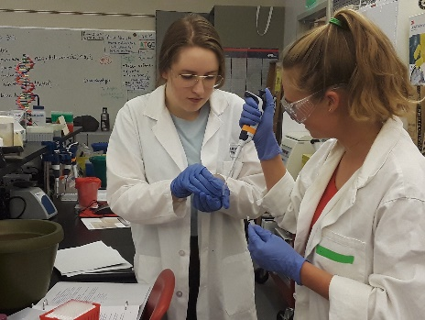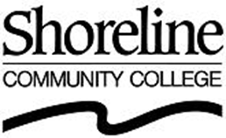

**Thank you to our 2019 sponsors!**

***Celgene*** *-* ***Juno Therapeutics***

***Seattle Genetics*** *-* ***AGC Biologics***

*Bristol-Myers Squibb*

NanoString Technologies

Seed Intellectual Property Law Group - Covance

   SystImmune Inc. - Bluebird Bio

School Districts:  Edmonds, Everett and Northshore

For sponsorship information, contact Dr. Reitha Weeks, Camp Program Coordinator, at [reithaweeks@gmail.com](mailto:reithaweeks@gmail.com)

For more camp information contact:

Dr. Dina Kovarik at [dkovarik@shoreline.edu](mailto:dkovarik@shoreline.edu)

<http://www.shoreline.edu/project-biotech>