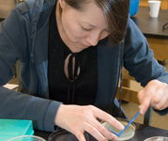

# INSTRUCTOR: Ford Morishita

# OPEN TO: Middle and High School Biology/Science Teachers

**WHEN:** Saturday, November 9th 8:30-3:30

# WHERE: Columbia River HS

# COST: $90.00

# CLOCK HOURS: 6

REGISTER: [www.esd112.org/courses](http://www.esd112.org/courses)

Course Number: 37089

**ESD 112 is offering a ONE-DAY Workshop to all ESD 112 Middle and High School Teachers**

This workshop will cover:

* Micro- pipetting
* Gel electrophoresis
* Basic transformation of E. coli bacteria.

These activities help teachers develop pipetting measurement and diagnostic skills, along with design and implementation of hands-on labs for students.

Following completion of this workshop, teachers will have access to loan equipment and reagents/supplies to perform these labs in the classroom. Details for sign-up will be discussed at the workshop.

**The Amgen Bruce Wallace program is housed at Shoreline Community College and funded by the Amgen Foundation. This program trains teachers in biotechnology concepts and skills, which enables students to use this cutting-edge technology.**

**Amgen-Bruce Wallace Biotechnology Workshop**

**The Amgen**

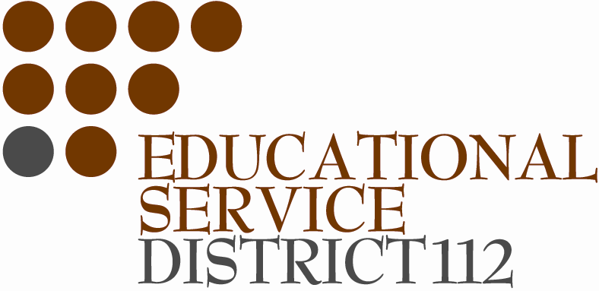 **Questions? Contact: Adrienne Houck at** [**ahouck@shoreline.edu**](mailto:ahouck@shoreline.edu) **or Ford Morishita at** [**ford.morishita@esd112.or**](mailto:ford.morishita@esd112.or)**g | phone 360 750 7500 Ext. 313**