Submitting an Exam Request in Student AIM Portal

- Log-in to your Student AIM Portal .
- Click “Alternative Testing” (left-hand side under “My Accommodations” heading)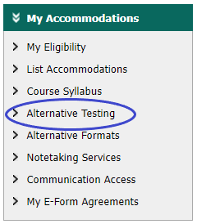
- Select the class for which you are requesting to schedule an exam from the dropdown.
- Choose “Request Type” from dropdown menu (e.g. Exam, Final, Midterm, Quiz).
- Enter Date for test (MM/DD/YYYY format)
- Enter time of day that you would like to take the test.
- Enter the typical length of the exam (without accommodations) in minutes (e.g. 60 minutes).
- Select desired testing accommodations from those for which you were approved.
- Add any additional notes for the Assessment & Testing Center and the SAS office. (Instructors will not see these.
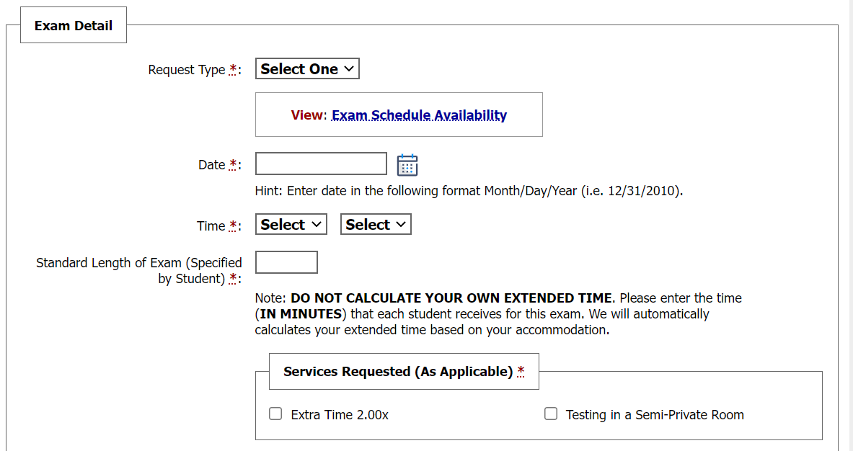
- Read and check off the Terms and Conditions.
- Click “Add Exam Request” Button.
- Contact the Assessment & Testing Center with any questions regarding your exams.

