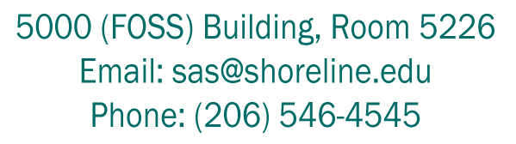
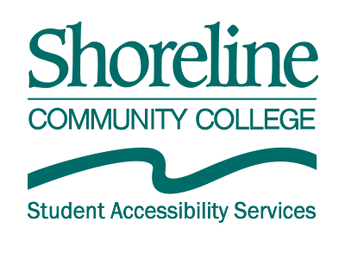

AIM (Accessible Information Management) Guide for Students:
  - Submitting a Custom Request

- From the My Dashboard tab in your AIM portal, under My Accommodations in the left margin, click on Communication Access.
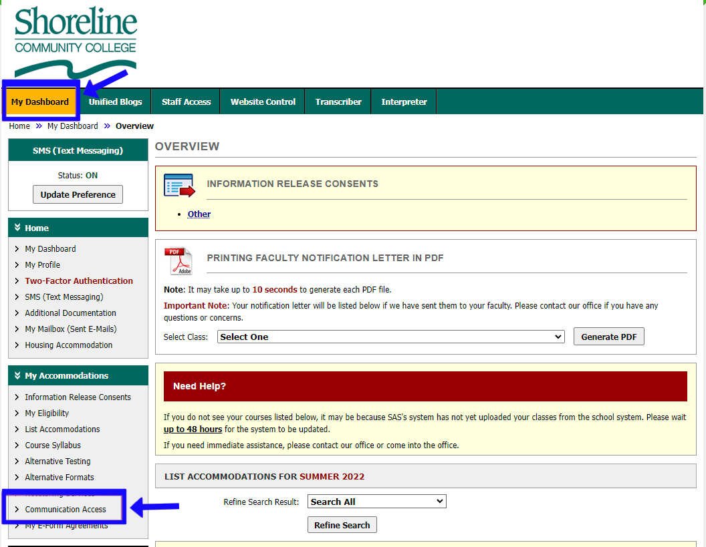

- On the top right side of the Communication Access page, click Custom Requests.
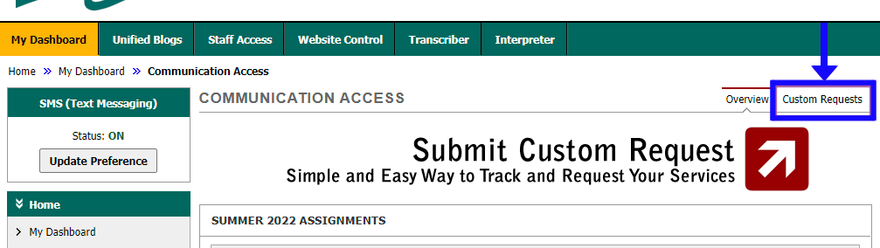

- Click Schedule Custom Request on the right side of the page.
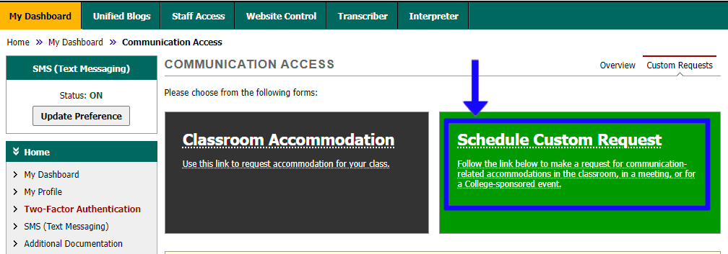

- Under Custom Request Form, use the Select Course drop-down menu to select Non Class Related Request for such things as meeting with an advisor, meeting with an instructor outside of class, a campus activity or other single event. Then click Continue to Specify Custom Request. OR
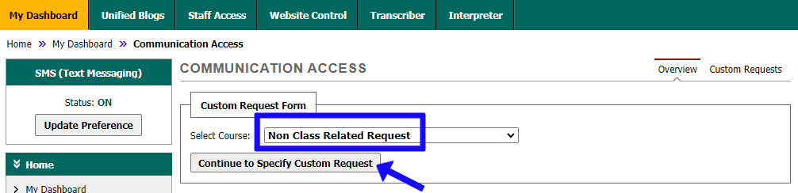

- Use the Select Course drop-down menu and select the desired course when submitting a request that is needed during class hours or for course material. Click Continue to Specify Custom Request.
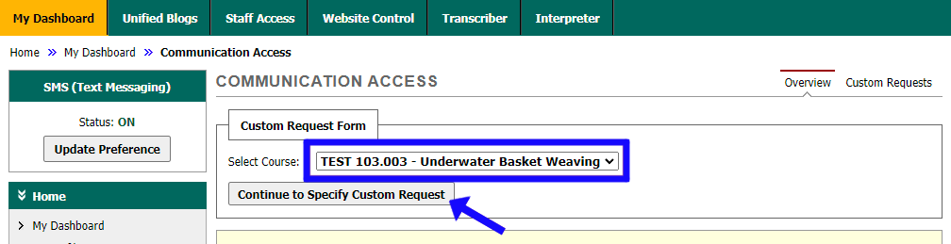

- First read the Terms and Conditions of Submitting Custom Request at the top of the page. Next, below the Terms and Conditions, fill out the Event Information form as follows:
  - Do not leave a field blank unless otherwise indicated.
  - Event Name:
    - If requesting for a class, list name and course number.
    - If requesting for a single event, put title or description of the event.
  - Speaker(s): LEAVE BLANK.
  - Event Date:
    - If requesting any service for the entire duration of a class, put the first day class begins.
    - If requesting INTERPRETER OR TRANSCRIBING for a single event, in or outside of class, put the date service will be needed.
    - If requesting CAPTIONING OR AUDIO DESCRIPTION for a single event and the video has a date you will need to view it by, place that date in the field. If not, use the day you are submitting your request.
  - Time Start/End:
    - If requesting any service for the entire duration of a class, put the usual time class will start and end.
    - If requesting INTERPRETER OR TRANSCRIBING for a single event, in or outside of class, put the start and ending time that the event is taking place.
    - If requesting CAPTIONING OR AUDIO DESCRIPTION for a single event, put 8:00 a.m. in “Time Start” and 9:00 a.m. in “Time End.”
  - Location/Meeting Link:
    - If requesting INTERPRETER OR TRANSCRIBING for an in-person event, put the address of where the event will take place.
    - If requesting INTERPRETER OR TRANSCRIBING for an online meeting, put the meeting link.
    - If the request is for video media, put either CAPTIONING or AUDIO DESCRIPTION.
  - If requesting for a class, list days class meets (example: M/W/F), 1st and last day of class, and date of final. If requesting for a single event, write “N/A”: Follow instructions on form.
  - Request Type(s): Check only one request type per form.
  - Event Media/Materials: Check only one media type if you are submitting a request for Captioning or Audio Description. LEAVE BLANK IF SUBMITTING INTERPRETER OR TRANSCRIBING REQUEST.
  - Any additional information needed, such as preferred interpreters, video quality, etc. If submitting for an interpreter request, please indicate ASL (American Sign Language) or signed English: Follow instructions on form. YOU MAY LEAVE BLANK IF YOU DO NOT HAVE ANY ADDITIONAL INFORMATION TO REPORT.
- When you are finished filling out the form, click Submit Custom Request at the bottom of the page.
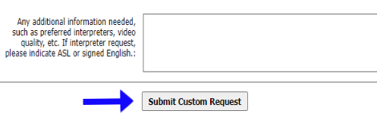
- You can view your Communications Access requests from your Dashboard.

