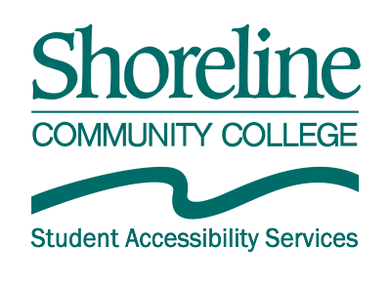

AIM Guide for Instructors:
  - Submitting a captioning request
- From your Instructor Homepage in AIM, go to Overview. Under Views and Tools in the left margin, click on Communication Access.
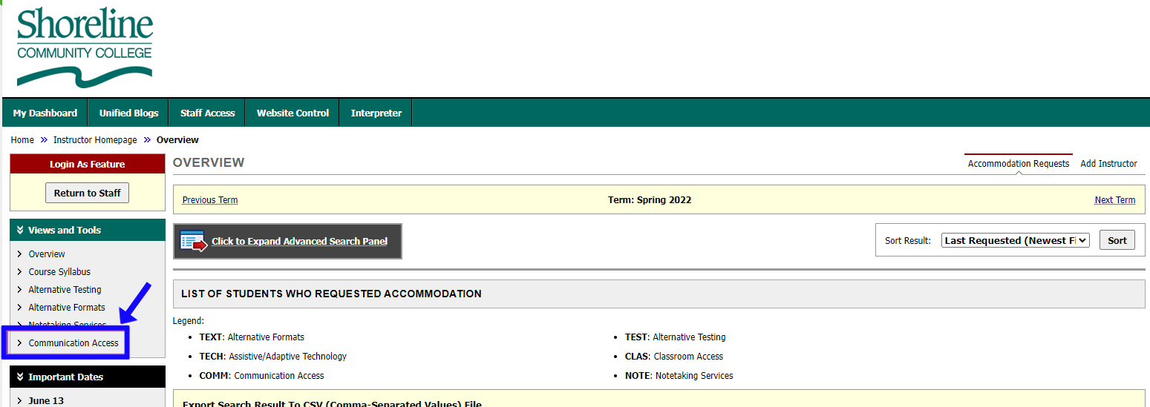

- At the top of the Communication Access page, check that the correct term is set. If you need it set to a different term, click on either Previous Term or Next Term. Then click Submit Video Captioning Requests or List All Requests.
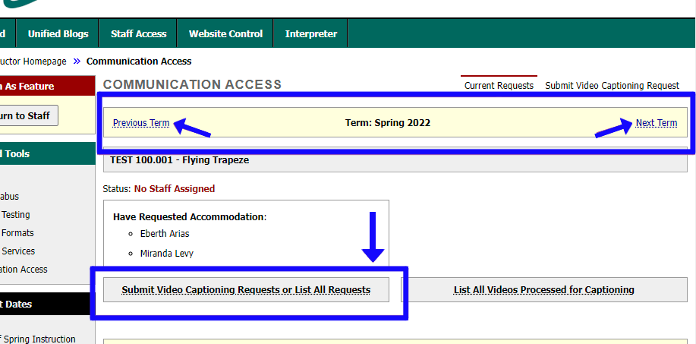
- Fill out the form under Step 2: Add Video.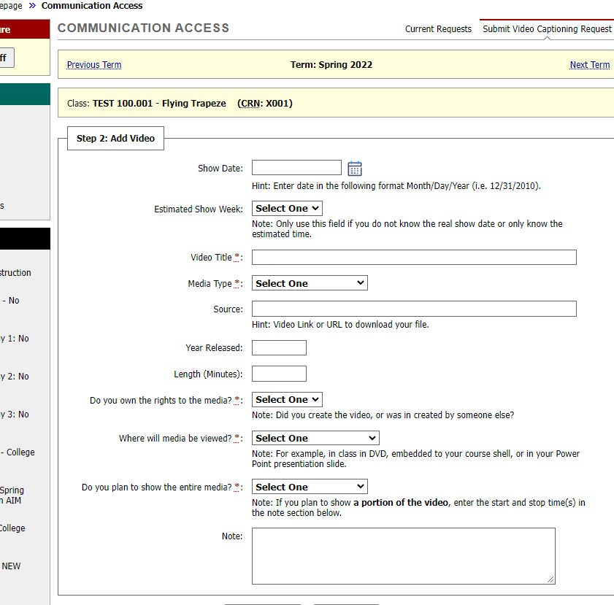

- If you know the exact date your students will have access to the video, put that date in Show Date. Use the format of month/day/year, with all four digits used for the year. OR
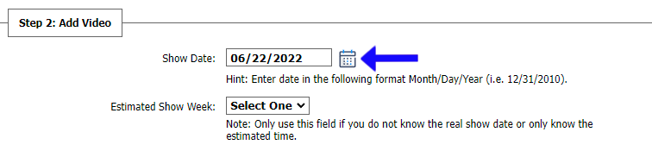

- If you don’t know the exact date the video will be viewed by students, choose the soonest week you know you will need the captions by in the Estimated Show Week drop-down menu.
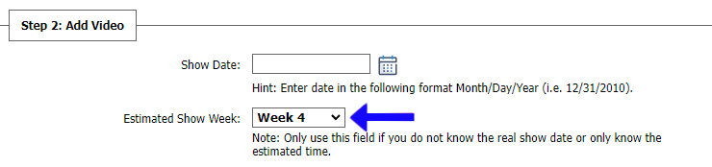

- Fill out the rest of the fields as usual. Please note that Length (Minutes) can only be entered in total minutes. When finished, click Add Video List at the bottom of the form.
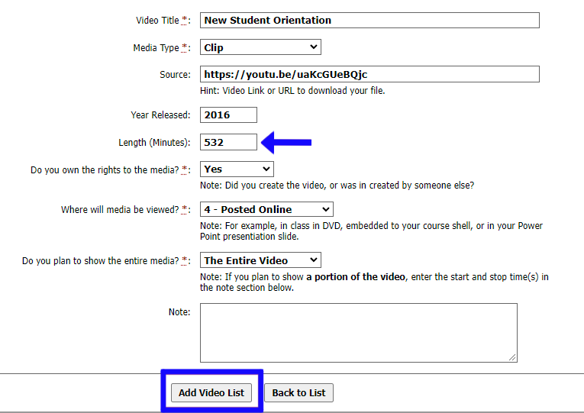

- A notification will appear on screen if your request was successfully submitted. 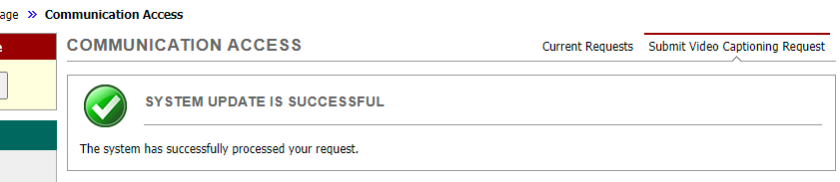

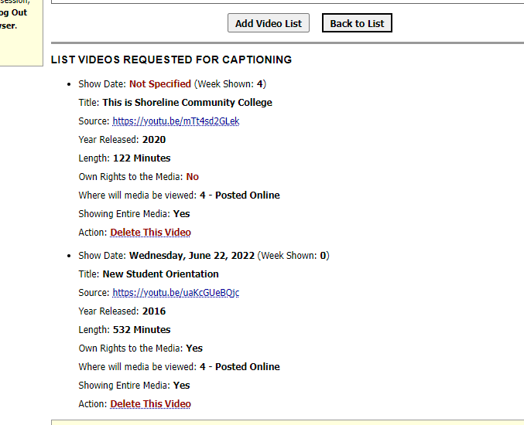
- A list of all videos that you have submitted can be found at the bottom of this same page.

