If you find you are unable to read a PDF using your PDFaloud tools (pictured below), your document is not “accessible” You can use Read&Write GOLD (RWG) to read a PDF that is not accessible by following these simple steps:

Scan the file using the Scan from File feature on the Read&Write Toolbar. You can choose to Scan to PDF or to Word. PDF is best for exact replication with graphics and complex layouts. Word will work for text heavy documents or when you want to use the highlight tools in RWG.

1. 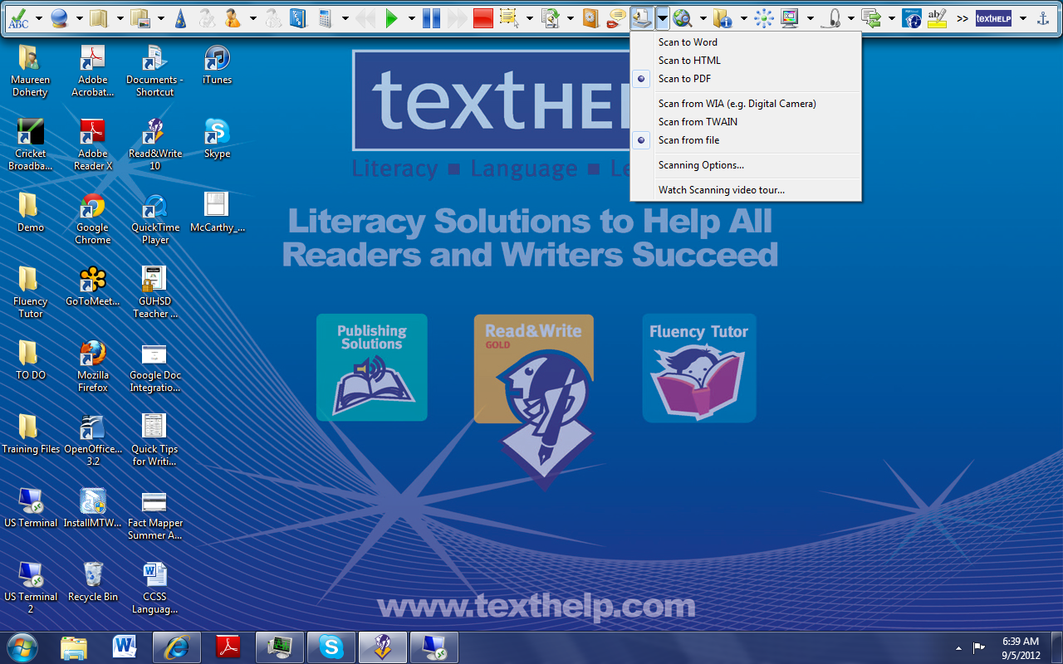Locate the document you want to Scan
2. Set your parameters using the Options on the Pull down Menu next to the Scan Icon
3. Click on the Scan Icon (See diagram)

You will know that your Document is scanning when this dialog box appears 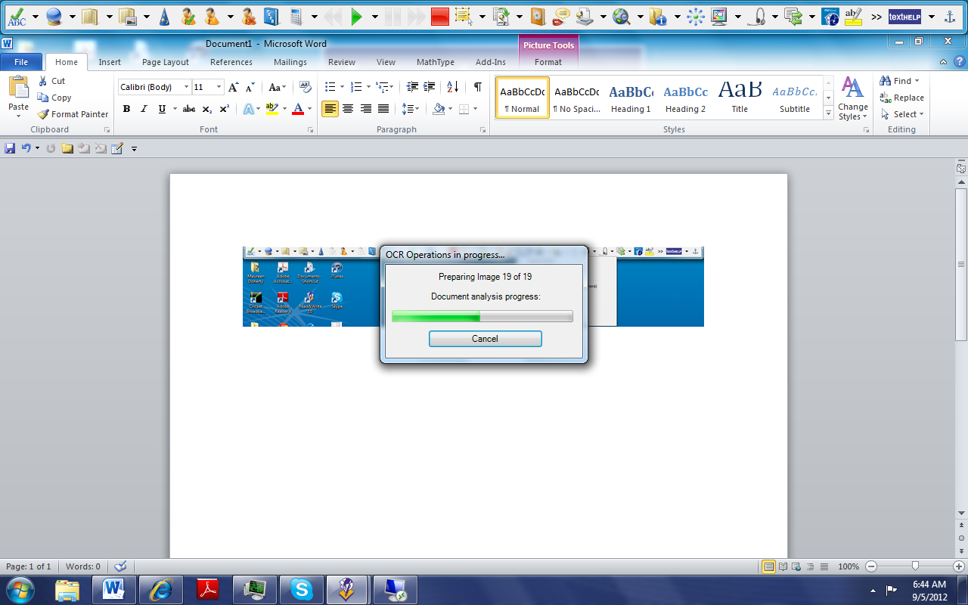

A ten page article will take 2-3 minutes to Scan and a 25 page document will take 3-4 minutes to Scan. Documents with graphics and complex formatting take longer to Scan.

If you have Scanned to PDF the PDF Aloud tools will appear when the Scanned PDF opens. Click on the Extended Tools in Reader and then click on PDFaloud Toolbar. Customize the way you would like to have your document read aloud.

