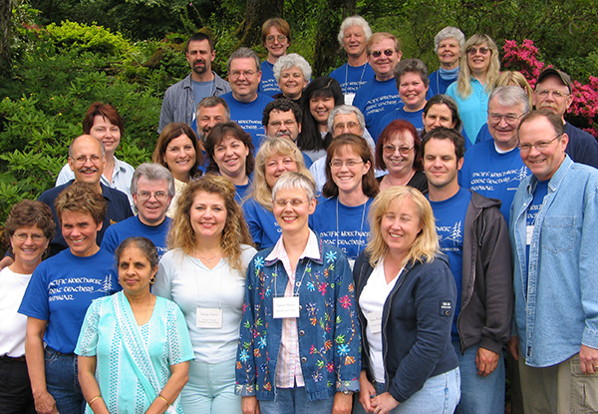
26th Annual

Pacific Northwest Great Teachers Seminar

June 12-16, 2005

“If you ever decide to rename your conference, my suggestion is ‘Hope Across the Curriculum.’”
Shirley Geiger
Portland Community College

“I can’t think of when I’ve laughed so much or learned so much in such a short period of time.”
René Kratz
Everett Community College

“Overall, this has been the best seminar I have ever been blessed to experience.”
Les Rivera
Clark Community College

“Thank you for the greatest conference I have ever attended in 30 years in education.”
Perry Johnson
Western Nevada Community College

“An empowering conference.”
Peggy Kroll
Modesto Junior College
Too often, community college teachers work in isolation: Our schedules are different from those of our colleagues; our days are spent inside classrooms and small offices. We don’t have an opportunity to discuss the daily successes and problems that make up our professional lives. The Great Teacher Seminar is a response to these conditions, and the belief that the best teaching ideas, innovations, and strategies come from within our own ranks. There will be no “experts” at this seminar, only peers who practice the art of teaching like you.

We welcome anyone searching for new ideas to enhance their teaching and learning skills. Well over 500 educators have come to our seminar from community colleges in Alaska, Arizona, California, Canada, China, Colorado, Guam, Hawaii, Idaho, Illinois, Minnesota, Montana, Nevada, New Mexico, Texas, Utah, Washington, and Wyoming.

The rigid minimal structure of the seminar draws on ideas, innovations, and problems presented by the participants. Intensive small group discussions and lively teaching demonstrations are the core. Good food and free time for abundant recreational opportunities, casual talk, browsing the library of teaching ideas, and enjoying the company of colleagues round out the experience.

The Site, Menucha, is nestled among the towering trees of the Columbia River Gorge Scenic Area, 25 miles east of Portland, near the small city of Corbett. The main lodge, where you will be staying, is spectacular. Perhaps our site’s greatest attraction is its surrounding 100 acres of property, which include spectacular Gorge views, hiking trails, a swimming pool, tennis, basketball, and volleyball courts.

Contact the director, Jan Woodcock at 541.440.4706 or e-mail her at jan.woodcock@umpqua.edu, before May 10th to reserve your spot. The registration fee of $550 includes room, meals, and all other expenses except transportation. Enrollment is limited to the first 35 persons to apply. The seminar usually fills before the deadline, so we urge you to make your reservation now. See us on the web at www.umpqua.cc.or.us/gts/gts.htm.

