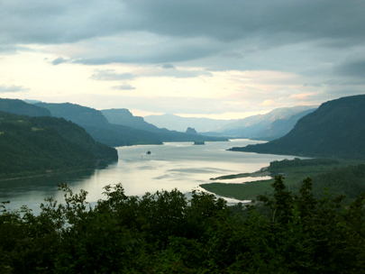
Pacific Northwest Great Teacherrs Seminar
Jan Woodcock, Director
Umpqua Community College
P.O. Box 967
Roseburg, OR 97470

“Thank you for the greatest conference I have ever attended in 30 years in education.”
Perry Johnson
Western Nevada Community College

“I can’t think of when I’ve laughed so much or learned so much in such a short period of time.”
René Kratz
Everett Community College

“Overall, this has been the best seminar I have ever been blessed to experience.”
Les Rivera
Clark Community College

“If you ever decide to rename your conference, my suggestion is ‘Hope Across the Curriculum.’”
Shirley Geiger
Portland Community College

“An empowering conference.”
Peggy Kroll
Modesto Junior College

What People Say…
26th Annual
Pacific Northwest
Great Teachers Seminar
June 12-16, 2005

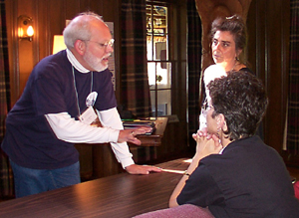
Jan Woodcock, Director
Umpqua Community College
P.O. Box 967
Roseburg, OR 97470
Phone: 541.440.4706
Email: jan.woodcock@umpqua.edu

What is the Great Teachers Seminar?
- A five-day exchange of classroom-tested teaching ideas and techniques, that you can use immediately, from community college teachers across the West and beyond
- An opportunity to share and resolve problems common to community college teaching
- A chance to network with colleagues from other community colleges
- An academic year-end retreat in a magnificent country lodge in the Columbia River Gorge near Portland that will both relax and stimulate you
- A celebration of good teaching

Welcome Colleagues!

Too often, community college teachers work in isolation: Our schedules are different from those of our colleagues; our days are spent inside classrooms and small offices. We don’t have an opportunity to discuss the daily successes and problems that make up our professional lives. The Great Teacher Seminar is a response to these conditions, and the belief that the best teaching ideas, innovations, and strategies come from within our own ranks. There will be no “experts” at this seminar, only peers who practice the art of teaching like you.
We welcome anyone searching for new ideas that will enhance teaching and learning. Well over 500 educators have come to the seminar from community colleges in Alaska, Arizona, California, Canada, China, Colorado, Guam, Hawaii, Idaho, Illinois, Minnesota, Montana, Nevada, New Mexico, Texas, Utah, Washington, and Wyoming.

Our Purpose

- To share educational innovations and problems.
- To venture beyond separate disciplines. We don’t know each other’s fields, so we aren’t limited by them.
- To stimulate the exchange of information and ideas within the community college movement by building an expanding network of communication among faculty.
- To promote an attitude of sharing among motivated professionals in a relaxed, open setting.
- To celebrate good teaching and renew our commitment to education.

People Places and Things…

Our Site
Menucha, is nestled among the towering trees of the Columbia River Gorge Scenic Area, the Menucha Retreat and Conference Center lies 25 miles east of Portland, near the small city of Corbett. The main lodge, where you will be staying, is spectacular. Perhaps our sites greatest attraction is its surrounding 100 acres of property, which include spectacular Gorge views, hiking trails, a tennis and basketball court, swimming pool, and a volleyball court

Our Staff
Jan Woodcock
Psychology instructor at
Umpqua Community College
Roseburg, Oregon.

Phil Corlis, Photography instructor
North Idaho College
Coeur d'Alene, Idaho.

Mark Palek: President, SFCC and previous English instructor Spokane Falls Community College
Spokane, Washington.

Doug Dickston, English instructor
Mt. Hood Community College
Gresham, Oregon.

How Can You Reserve a Spot?
Contact Jan Woodcock, Director
Phone: 541.440.4706
e-mail: jan.woodcock@umpqua.edu,
or send in the reservation form by May 10th. The registration fee of $550 includes room, meals, and all other expenses except transportation. Enrollment is limited to the first 35 persons who apply. The seminar usually fills well before the deadline, so we urge you to make your reservation now. See more of us on the web at www.umpqua.cc.or.us/gts/gts.htm. Information about the retreat location is also available on the web at www.menucha.org.

Name __________________________________________

Teaching Position _________________________________

Department ______________________________________

College__________________________________________

Mailing Address ___________________________________

_______________________________________________

City ____________________________________________

State ____________ Zip __________________________

E-Mail __________________________________________

Address After June 1st:

Make checks payable to
Pacific Northwest Great Teachers Seminar
Mail to: Jan Woodcock, Director
PNWGTS
Umpqua Community College
P.O. Box 967
Roseburg, OR 97470

Phone: 541.440.4706
Email: jan.woodcock@umpqua.edu

