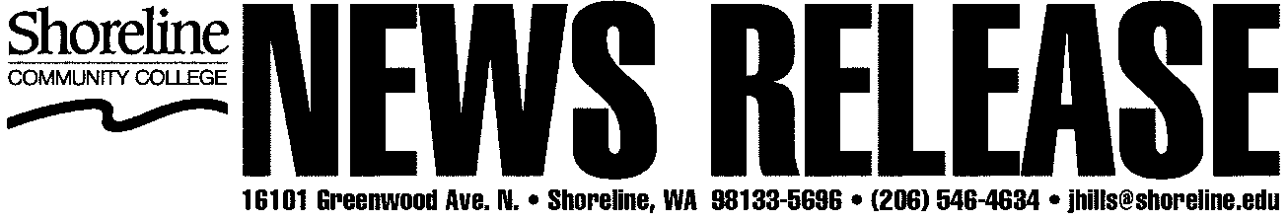

## DATE: September 29, 2011

**CONTACT: Natalie Niblack, 206-546-4101, x4433**[**nniblack@shoreline.edu**](mailto:nniblack@shoreline.edu)

**John Nold, 206-546-4728**[**jnold@shoreline.edu**](mailto:jnold@shoreline.edu)

**Poetry Night at Shoreline Community College  
on Shoreline Arts Crush Agenda**

**October 12, 2011**

Shoreline Community College hosts an evening of poetry readings and an artists’ reception on Wednesday, October 12, 2011 as part of Shoreline Arts Crush 2011. All events are free.

The evening begins at 5 p.m. with an artists’ reception for the current show, “Crosscurrents 30th Anniversary Traveling Exhibition” in the College Gallery in the Administration Building (1000). Following the reception, from 6 to 7:30 p.m., poetry readings will be made by faculty members who have contributed to Crosscurrents, followed by students who have contributed to the 2011 edition of *Spindrift*, the college’s student art and literary journal. The readings will take place in the Board Room near the gallery.

“Crosscurrents” is an arts and literary magazine of work by Washington state community college instructors. The exhibition celebrates 30 years of publication and includes work by a variety of instructors from across the state. This year’s traveling exhibit will end at Shoreline Community College on October 28, 2011 before moving on to another college.

Spindrift has been published annually since 1966 and includes works by local and national writers and artists. Shoreline Community College students design, edit and produce the anthology. The journal has won many awards.

The College Gallery is located in the Administration Building (Bldg. 1000) near the front entrance to the college. Parking and pay stations are nearby. Shoreline is located at 16101 Greenwood Avenue North, just west of Aurora and north of Seattle city limits.