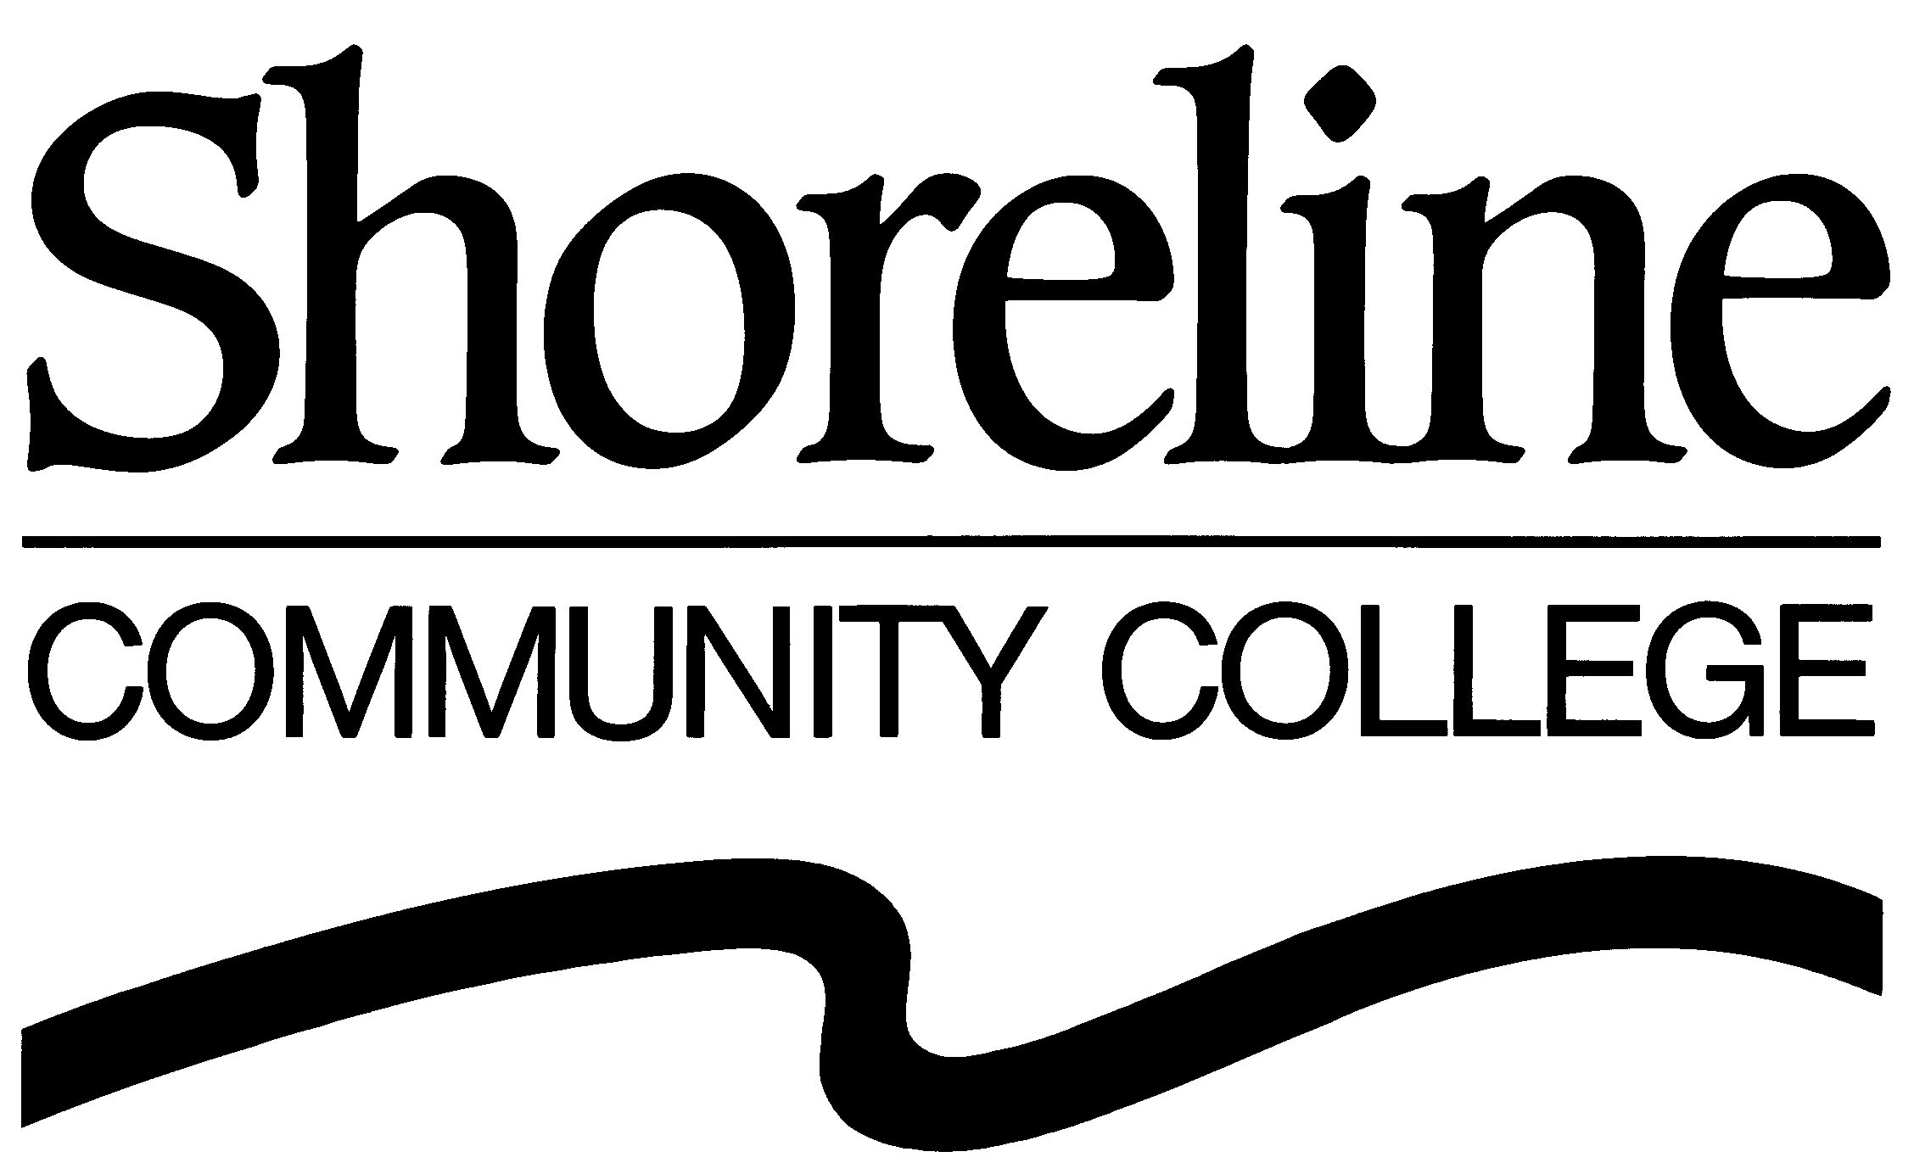

P A R E N T - C H I L D C E N T E R

RE: Parent-Child Center Annual Auction – Can we count on you for a donation?

The Parent Advisory Group at Shoreline Community College’s Parent-Child Center will host a Silent Auction fundraiser on Friday, April 27, 2012. This annual event will feature original artwork created by center children, as well as a wide variety of donated items. The proceeds from the auction will help to further advance our quality early care and education programming, in addition to meeting the needs of student-parents, families and the community. All young children need and deserve quality early learning experiences that will give them a great start in life. This is vital to our community.

You can help us to celebrate our role in the community by contributing items or providing financial assistance to this fundraising event. Your donation will support our efforts to provide quality care and education that builds a foundation for school readiness and supports children throughout their lives. You can trust that 100% of the net proceeds will be devoted to the best interests of young children.

We are extremely grateful for your support and want to make certain that you are acknowledged. Donor names will be listed on the bid sheets and we will publish a list of all donors for our Parent-Child Center community. The donor list will also be posted on our webpage. Auction attendees include parents, family members, friends, community members and campus students/faculty/staff.

We look forward to hearing from you as the excitement builds for this years’ auction. Please let us know your response by mailing, or scanning and emailing, the enclosed form. We can make arrangements to pick up your donation or you can send it to: Shoreline Community College, Attn: Parent-Child Center, 16101 Greenwood Ave. N, Shoreline, WA 98133.

Thanks so much for your support – this wonderful event could not happen without you!

With gratitude,
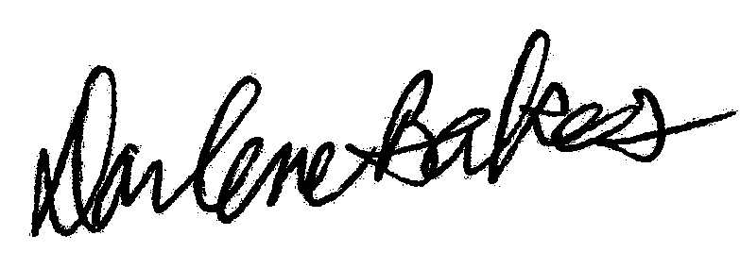


Darlene Bakes
Director

SCC Parent-Child Center
dbakes@shoreline.edu
206.533.6665

Attachment: Auction Item Donation Form

