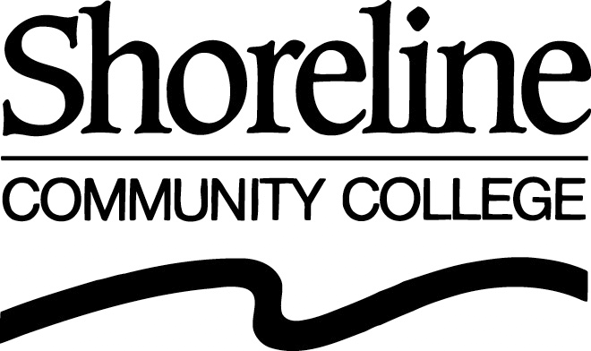

COLLEGE COUNCIL
Tuesday, April 19, 2005, 2:00 p.m. to 4:30 p.m.
Co-Chairs Barbara Kristek & Sean Keller

AGENDA

STANDING ITEMS
Item | Time  Est. | Subject | Purpose | Presenter
1. | 5 min | Review April 5 Meeting Summary | Action | Co-Chairs
2. | 15 min | Open Comment Period |  | Co-Chairs
3. | 5 min | Board of Trustees Agenda (April 27) | Information | Moore
4. | 2 min | Changes to the April 19 Agenda | Action | Co-Chairs

OLD BUSINESS
Item | Time  Est. | Subject | Purpose | Presenter
5. | 15 min | College Council Mission Statement Report | Discussion | Backes/Keller
6. | 15 min | Procedural Guidelines – Cancellation of Meeting | Discussion | Newlin
7. |  | College Council Review and Assessment | 2nd Discuss | Backes
 | 10 min | Break

NEW BUSINESS
Item | Time  Est. | Subject | Purpose | Presenter
8. | 10 min | Inventory Procedure | 1st Discuss | Brandt
9. | 10 min | Board of Trustees Reserve Policy | 1st Discuss | Brandt
10. | 15 min | Secrecy on Campus | 1st Discuss | Kristek/Solland
11. | 25 min | Procedural Guidelines (Proxy, Consecutive Terms, President’s Statement, Flow Chart, the way items are brought before the Council) | 1st Discuss | Kristek
Est. meeting total: 2 hr 7 min
FUTURE BUSINESS
Item | Time  Est. | Subject – | Purpose | Presenter
- FERPA
- Return of Policies 5120 and 6291
- Policy 5270: Students Freedom to Read
- Appendices to Policy 4111
- Election of Summer/Fall Quarter Co-Chairs
- New Community College Baccalaureate Degrees
in Washington

NEW BUSINESS
Next Council Meeting – May 3, 2005

