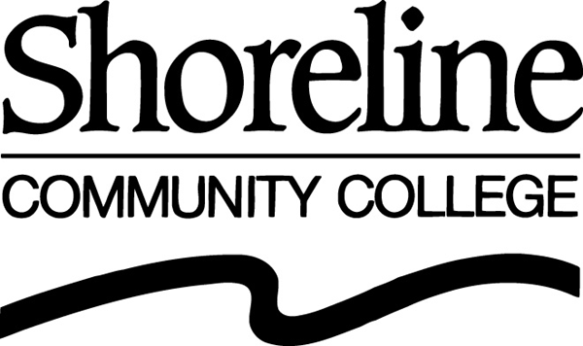
Essential Skills Program
Quick Facts

“Essential Skills” includes Adult Basic Education (ABE), General Educational Development (GED) and English as a Second Language (ESL)

2004/05 (SCC Institutional Effectiveness data)
ABE/GED – duplicated headcount of 1,505; 155 annualized FTEs
Basic ESL – duplicated headcount of 2,543; 322 annualized FTEs
Academic ESL – duplicated headcount of 793; 141 annualized FTEs
Total – duplicated headcount of 4,841;( unduplicated count of 1293 indicates that the average student takes 4 classes) 578 annualized FTEs

Population
- A major part of our ABE/GED population is at-risk youth, from the CEO program and the off-site Learning Center North.
- ESL is the primary “gateway” for International Students to Shoreline – in Fall 2005, 87% of the entering International Students were in the ESL program.
- Our evening ESL program is focused solely on immigrants and refugees, most of whom are working and/or have families to care for.

Funding
    - 1018 international students(duplicated) registered for 10,204 ESL credits in 2005/06, generating approximately $1,600,000 in tuition.
    - Academic ESL classes (levels 6-8) are tuition-based classes.
    - Levels 1-5 ESL and ABE/GED classes charge $25 per quarter or are free for low income students.
    - In 2005/06 we received about $300,000 in basic skills funding from the State Board for Community and Technical Colleges and about $43,000 from the Department of Social & Health Services for services to TANF recipients and low income refugees.
- Our federal ABE funding for the coming year was decreased by 10%, as for all programs in our funding region, because the demographics of this region indicate a lesser need than in other regions.
Challenges
Our target populations often have barriers that make recruiting and retention difficult:
    - They either have little experience with the educational system, or perhaps have had negative experiences.
    - They are often living in poverty. They may hold down more than one job.
    - They may have emotional trauma – either as a result of their immigration or because of difficult family situations.
    - They have very limited support systems.
    - They are more likely to have learning disabilities.
    - They are often not well connected with their communities or with information “systems.”

New Directions and Initiatives
- Connecting to College and Careers hybrid class for level 5 students
- AIDDE Task Force to analyze data to improve retention and transition of level 5 ESL students (AIDDE = Analyze, Identify, Design, Document, Evaluate)
- General Service Technician (GST) for Automotive (I-BEST) ESL and ABE versions.
- Potential I-BEST classes in Phlebotomy and business basics branching to Prof/Tech (Accounting, Dental Business Office Specialist, Medical Receptionist, etc.)
- On-line version of ESL 100, Academic ESL 3
- World of Work for ESL Level 1&2
- Re-structure evening program to meet community needs
- Revise intake and advising procedures for ABE/GED students.
- Re-institute Program Advisory Committee
- Outreach to students who cannot pass the WASL
- Increased information to students about other college programs (monthly “featured program”)

Staff
Donna Miller-Parker, Director; Aura Rios Erickson, Student Advisor; Debby Hunter, Program Assistant; Nina Grishinchuk, Assessment Assistant

ESL Faculty
Vince Barnes, Donna Biscay, Ruthann Duffy, Elizabeth Hanson, Jo McEntire, Bruce McCutcheon, Daina Smuidrins, Lauren Wilson and 16-20 part-time faculty (varies by quarter).

ABE/GED Faculty
Kristin Marra and 3 part-time faculty

