|  |
| --- |
|  |
|  |
| Advising Financial Orientation Document  149-063-1323 |
|  |

*Orientation Document*

Fiscal Year 2019-20

1. **Please provide an overall description of your unit and what support, services & activities it provides for students.**

Advising is a process based on a close student-advisor relationship intended to help students achieve their educational, career and personal goals through the use of the college and community resources.

We help students from the beginning to the end with the following services.

* Experience Shoreline (an information session for prospective students)
* START (a session that teaches students about registration and then gets them registered for the next quarter)
* New Student Orientation (interactive session teaching students what they need to know to be a successful student, with a focus on the first quarter)
* Educational Plans (in appointments, advisors map out the course plan for the student’s desired degree/cert)
* Shoreline Early Alert – advisors respond to alerts provided by instructional faculty about students who appear to be struggling in classes.
* Navigator/referrer – from meetings with students, they might refer students to various services both on and off campus to support their needs
* Transfer planning – provide information, tools, and guidance on preparing for transfer (includes transfer workshops, one-on-one meetings, transfer fairs)

1. **Please utilize the graphs below to visually display how your unit uses your budget allocation. If your unit receives funding or revenue from sources other than the state, please utilize the third graph showing a breakdown of your unit’s total revenue/funding. (Placeholder figures have been included in the excel spreadsheet as examples). You may use your own labels such as described at the budget meeting (Program index: Instruction, Instructional support, Library operations, Student Services, Institutional Support, Plant Operation & Maintenance) or some other label to describe your budget allocation.**

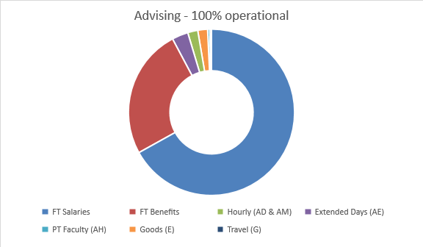

1. **How has your unit responded to changes in funding levels over the previous two (2) fiscal years? Please also address any changes in non-state funding for your unit.**

* The funding level has not changed in the past two fiscal years (besides salary and benefits increases).
* I have rearranged the money to appropriate categories to ensure we have enough funding in each line. Example – where there was no funding for travel, I moved money within the budget to ensure there was.
* There have been large faculty salary increases and back pay to faculty in the last two years that was not budgeted for.

1. **What are your unit’s short (1-2 year) and long term (3+ year) organizational goals? What are your unit’s strategies for achieving these goals? Please explain the impact these goals will have on students and your funding, both from state and non-state sources.**

**Short-Term**

* Norah is the Advising Program Coordinator but there is no budgeted line item for her in this budget. She is currently paid from the Running Start budget. This is a remnant from when Advising/Counseling/Running Start split in 2014-15. This is important because a goal for Running Start is to have a program coordinator specifically for that program and there is money for that. A program coordinator is essential to Advising to ensure students are getting appointments, events are coordinated (such as room scheduling, advertised on the calendar, sign-up sheets/RSVPs, folders stuffed, signage). This position also supports the associate dean with administrative tasks like calendaring and budget and keeping her in the loop of staff needs.
* Before Derek became Dean, a goal for our department was to increase the number of success coaches to support students. We submitted an Innovation Grant in 2018-19 for 2 more. Still waiting to hear back.

**Long-Term**

* How do we better prepare students when they first get here with career exploration/readiness?
* How do we better prepare student when they are about to leave for transfer/careers?

**Short (1-2 year) and long term (3+ years) organizational goals:**

**Strategies for obtaining these goals**:

* aSAPs

**Impact of goals on students and your funding, both from state and non-state sources:**

1. **Looking over your unit’s short and long term organizational goals from past *budget cycles*, what has been done to reach those goals? Which goals have been reached and which goals are still in progress? Please explain how reaching these goals has impacted students and your funding, from both state support and non state support funding.**

* We applied for aSAPs in the past for 2 faculty advisors for 2015-16 year (approved)
* We applied for aSAPs in the past for 2 more faculty advisors for 2015-17 year (approved)
* We applied for aSAPs in the past for 3 success coaches and additional hourly funds to support the admin work for early alerts (approved)
  + - We had permanent funding (from aSAP) in 2015 for one success coach (the money line is now gone)
    - We had permanent funding in 2017 for two additional success coaches (one still exists and the other position went to C&M)
* eLearning funded a 4th Success Coach position from 2015-17 using eLearning fees
* Former supervisor applied for innovation grant (I think?) in 2015-16 to get us funding to purchase tablets for the students attending our workshops
* I’ve used the money that was in past budgets and moved it to where we were actually spending (example, we did not get an increase in our budget to fund extended days, I moved PTF funds to extended days)

1. **What do you foresee as your unit’s short and long term potential funding sources, both operating and capital?**

* 98% of the current advising budget is salary and benefits which comes from 149 budget.
* There are 261 workdays in a year but faculty contracts are only for 172 days. Extended days are important to provide more coverage to students so that they have more access to their advisor
* Average advising caseload is 393 students (median is 418) (Data from 2017) – NACADA recommends 300 students
  + Could we apply for state and/or federal grants (e.g. TRiO) to hire non-tenure faculty advisors? Next application cycle is 2019 or 2020

1. **If you have to make adjustments in the future, please indicate what adjustments would be made at the %2 level of reductions to your budget and the impact on your operations, services or programming.**

* See Excel Documents presented.

1. **In the future, there may be a need to make adjustments at a greater degree in the FY21 budget. Please provide scenarios of potential budgetary adjustments at the 5%, 10% and 15% level of reductions. Please indicate what impact these reductions would have on your operations, services or programming.**

* See Excel Documents presented.