**New Student Orientation (Online)**

*Last updated on 1/30/2017*

**Winter 2018**

Started content but didn’t finish: 146

Completed all content except survey: 113

Completed all content: 93

*Note: Excludes International, ABE, Parent Ed, ESL/ABE, Running Start and GED/HS21+.*

**Survey Data**

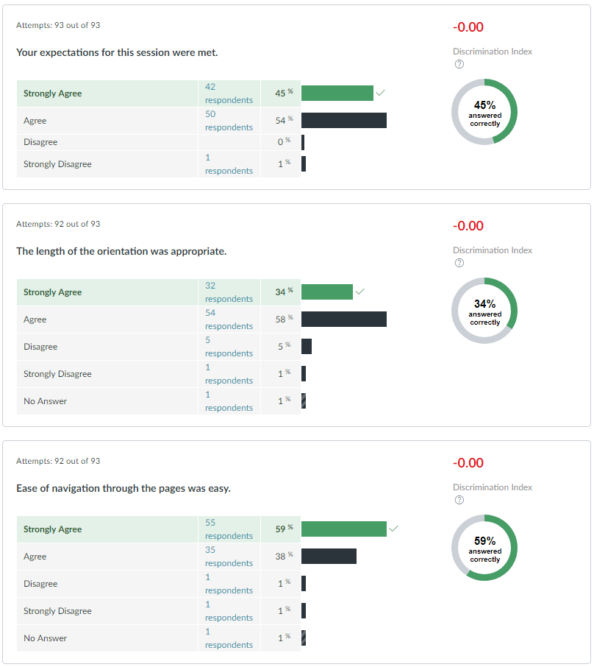

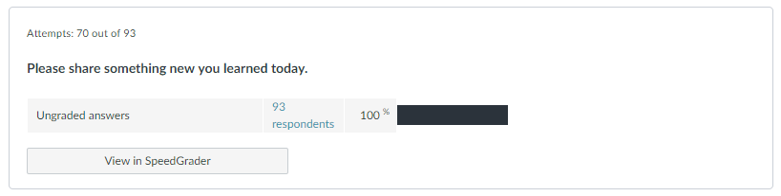

* "I was not aware of all of the free resources that SCC has to offer. Including tutoring, financial aid assistance, and a fitness center.
* how the school works
* "Well I learned that Shoreline Community College offers many educational services, programs and wonderful educational staff for the students. If one has questions I learned it can be found online, and if questions cannot be answered online, then students are welcome to come to campus. Students can also call by phone, to find out about any of the educational available services/advising that are offered at the Shoreline Community College. Â
* Â I was provided a wealth of important FYI at my fingertips, and also ways to conduct my own actual research online with valuable educational links that linked to important tutorial information I needed to know. Very impressed with the educational services that are offered. Everything is so organized. I especially love the read out aloud webpages. Makes learning online and offline courses assessable and attainable for everyone.
* Thanks,
* Janice Chimezie"
* Great to learn about the free resources for students!
* Where the library is.
* I had never heard of a 'Success Coach', that sounds pretty amazing.
* Thank you!
* I learned a bunch of information today that helped me understand the school better such as, security and safety, important people we should know and what their roles are in the school, and resources that is provided to us students. This online orientation is very useful and makes students like me, who has a very busy schedule help answer questions about the school.
* There are soooo many services and ways to get help at SCC.
* Learnt many different ways my user name and password could be beneficial to me.
* every college has the same orientation.
* You can be escorted around campus by campus security.
* Many resources are available to students
* I didn't know I could get the parking pass and student ID at the library. Will be doing that soon. Thank you!
* I learned how navigate website more effectively.
* There's a ton of great resources in the library.
* I learned where the library is and what it has to offer.
* I learned of the many resources available to me!
* I have never used canvas and this page helped me so much. made it quick and easy on how to use canvas.
* I learned how to navigate the many online portals that Shoreline uses.
* The wifi information is my email
* how to get onto the campus wifi.
* "Â
* I learned that I can have etutoring and that the Math Learning Center is open on sundays from 2 to 6pm ! which is great because I work Monday to Friday from 8 to 5:30 :)
* As a new student, I learn so many good things from the Orientation, like, how to by books from bookstore website, how to contact with security when I have emergency, and so on. I really love this school. This my first quarter of nursing program, so I cannot wait for my class.
* I learned that Shoreline provides Microsoft Office.
* I learned that I could call campus security anywhere on campus. I also learned that I can easily look up books I need on the online bookstore.
* The title XI.
* There is a shuttle from the Sears parking lot. Awesome perk.
* Shoreline CC has a dolphin for a mascot.
* I learned that some courses do not require textbooks and therefore would not show up in the campus bookstore directory.
* Students get free Lynda.com access.
* No books in the bookstore.
* I learned how to become part of the community, Buy books, and how to navigate around the school.
* I learned how to access more information and feel more comfortable with the online information and access
* to contact the professor if textbooks are not found in university bookstore website
* How to order books and the fact that the bookstore does not have physical books. Thank you
* Being able to look up the necessary course materials in the library before class begins.
* The name of the mascot is Dolphie.  As well as information on student groups and services.
* i had no idea that SCC was so involved and commited to the success of their students both past and present!
* How to look up and buy books
* that the school provide Microsoft office 365 and lynda.com
* How to connect to school WiFi
* I learned how many resources there are for online students.
* I learned about where I can obtain my student ID card.
* was surprised & frustrated when I hit next button bu7t couldn't proceed because I missed the 'next' button for multiple part question. then had hard time figuring out how to navigate back to retake the questions.
* That even though I attended Student Orientation in person, I still had to do it in Canvas.
* There is a lot of help available for me if I need it!
* I didn't know i could gain access to Microsoft Office for my Mac as well as help for preparing for online classes.
* I learned about all the student organizations, and activies
* That there is free parking/shuttle!
* Since I've never been to Shoreline, everything I learned was new and very interesting.
* I learned more about academic recourses that are available to me.
* How to find my textbooks
* How to use Canvas
* All the many different services Shoreline has to offer and where they are located.Â
* I learned how to access which textbooks are needed on bookstore site.
* tutoring is available both in person and on line
* how to connect to wifi
* Shoreline really strives for equity and comfort of students. I was really thankful upon hearing.
* I learned that the pagoda building is where student leadership meets.
* I learned how integrated the students are at Shoreline. I also was not aware of home many services, like Microsoft or even security escorts, SCC has to offer.
* I learned how to access wifi on campus, who the appropriate person to contact, and the different resources available.
* Excited to attend Shoreline CC.
* "I learned that I can order books from the bookstore at their computers and have books be delivered to the bookstore for me to pick up.
* Shoreline CC has a very active and hardworking ASG, the active clubs page looked interesting. Unfortunately I'm an online student
* Very helpful!
* I learned about Success Coaches.
* how to access my textbooks needed for class
* The programs seem well-designed for student success.

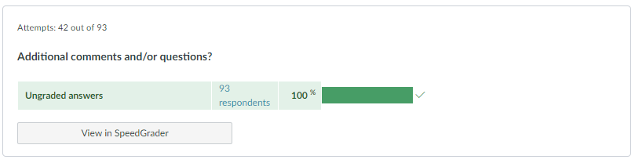

1. "I am excited for my future time at SCC.
2. "At the present time I do not have any additional comments and/ or questions.Â  I will keep in mind all the educational services/links that have been provided through new orientation at Shoreline Community College.
3. I understand that I can call, drive to campus or contact the needed educational staff or advisement  by phone.  Thanks for asking me if I have any additional comments and/ or questions.  Your concerns and care are much appreciated.
4. Blessings,
5. Janice Chimezie
6. Great organization of the orientation. Flow made me understand the topics better.
7. I'm looking forward to becoming a Dolphin and learning the ins and outs of SCC.
8. Thank you for putting this together.
9. None. Very nice orientation! Easy to follow and useful information.Â
10. n/a
11. None
12. None.
13. Nope
14. Thank you so much. All the information was greatÂ
15. no comments
16. Good orientation.
17. I can't think of anything...
18. No.
19. Everything was great! Learned everything that i needed to know! thank youÂ
20. none
21. The videos in the first section were annoyingly necessary to continue. i suppose i ended up just guessing and then retaking the quiz because i didn't want to watch all of them as many do not pertain to me as an online student.
22. Thank you
23. Not at this time.
24. Very informative and helpful.
25. Can't wait to begin classes on 1/8/18.
26. I wish there were more information on clubs.
27. No
28. no but thank you
29. Great job!
30. None!
31. N/A
32. None.
33. Great training, I feel welcomed.
34. Useful source.Â
35. I am having trouble using the online bookstore.Â