**Table of Contents**

**The Honors College & College Council Members**2

**The Honors Courses**3

2018-19 Course offering2

**The Honors Student Council Officers 18-19**4

Photos & Event Update in Fall 2018 by Student Council5-6

**The Honors Student Handbook 18-19**

**The Honors College Team**

**Assistant Deans for Honors**

Brooke Zimmers (Honors 100, Fall 2018, Honors 250, Winter 2019 and Honors 296, Spring 2019)

Terry Taylor (Honors 100, Fall 2018, Honors 250, Winter 2019, and Political Science 202, Spring 2019)

**Director**

Mari Kosin

**Honors Advisor**

Audrey Fischer (Honors 201, Fall 2018)

**Honors Council Members[1]**

Guy Ting (Chemistry 171, Fall 2018)

Diana Knauf (Psychology 100, Fall 2018, Honors 101 Fall/Winter 2018/19)

William Lindenmuth (Philosophy 101, Fall 2018)

Heather Munsell (Communication Studies 220, Winter 2019)

Davis Oldham (English 102, Winter 2019)

Chip Dodd (Geography 100, Winter 2019)

Steve Bogart (Math 146, Winter 2019)

Ernest Johnson (MCS 105, Spring 2019)

Emma Agosta (Geology 101, Spring 2019)

Neal Vasishth (English 101, Fall 2016)

Paul Herrick (Philosophy 101, Winter 2017)

Kira Wennstrom, Professor of Biology

Claire Murata, Librarian

John Tankersley, International Advisor

Anne Colpitts, International Advisor

The Honors College team and the Honors Council meet monthly to consider issues related to the program. In 2017-2018, we discussed about the Student Handbook; academic and admissions policies and procedures; scheduling annual course offering; student advising; programmatic and collaborative planning and events with other departments on campus; dealing with current issues as they arise; recruiting instructors; and unifying our language and goals for the unit.

We now allow honors students to count 5 credits from GIG, IDS, or study abroad classes toward the 30 honors credits.

**Honors Courses (All Listing)**

Chemistry 171H General -Inorganic Chemistry I HC (4)

Communication Studies 220H Public Speaking HC (5)

English 101H English Composition I HC (5)

English 102H Reasoning/Research/Writing II HC (5)

Geography 100H Introduction to Geography HC (5)

Geography 204H Weather/Climate and Ecosystems HC (5)

Geology 101H Introduction to Physical Geology HC (5)

Math 146H Introduction to Statistics HC (5)

Multicultural Studies 105H Introduction to Multicultural Studies HC (5)

Philosophy 101H Introduction to Philosophy HC (5)

Philosophy 240H Introduction to Ethics HC (5)

Political Science 202H Introduction to American Government & Politics HC (5)

Psychology 100H General Psychology HC (5)

**Honors Courses (2018-19 Offering)**

Chemistry 171H General -Inorganic Chemistry I HC (4)

Communication Studies 220H Public Speaking HC (5)

English 102H Reasoning/Research/Writing II HC (5)

Math 146H Introduction to Statistics HC (5)

Multicultural Studies 105H Introduction to Multicultural Studies HC (5)

Philosophy 101H Introduction to Philosophy HC (5)

Political Science 202H Introduction to American Government & Politics HC (5)

Psychology 100H General Psychology HC (5)

**Honors Research Courses**

Honors 200 Questions & Methods (5)

Honors 250 Honors Seminar (3)

Honors 295 Honors Seminar (2)

**Honors Seminars**

Honors 101 College Seminar

Honors 201 Transfer Seminar

**Honors Student Council Officers**

Azia Lualhati – President

Manages operations of the Honors College (HC) Student Council (leads council meetings). Serves as the primary student official and spokesperson for the Honors College at Shoreline for any official Shoreline meetings and events. Works with the club advisor as needed on council operations. Sets vision and goals for the academic year and help the Council execute activities and events promised to honors students.

Shay Malla - Vice President

Represents the Honors College Student Council and honors committees including Honors College Council (faculty and administrators involved in the Honors College) and other committees and club meetings (UCC). Works closely with President to oversee HC sponsored activities and events that are aligned with the Honors College at Shoreline.

Shujah Sial – Secretary

Records minutes at Student Council meetings and other committee meetings. Responsible with compiling agenda items in advance for weekly Council meetings and updates of upcoming events on campus. Works closely with Social Media Representative for vetting information to be posted. Works closely with the Honors College as well as manages HC and Student Council Event Calendar.

Debby Hsu – Treasurer

Presents proposed budget of activities to Honors Council. Handles and keeps accurate record on all expenditures. Works closely with the Service and Social Chair in  
planning events.

Sarah Fretz- Social Chair

Plans, organizes, and executes social events utilizing funds approved by Student Council and club advisor.  Outreach and advertise upcoming social activities and the Honors College events to both current honors and prospective students through various communication mechanism. Work closely with Social Media Rep and Secretary on calendaring.

Dorothy Kemph - Social Media Rep

Works closely with Secretary to disseminate and monitor information related to Student Council, the Honors College and any official Shoreline meetings and events through social media.  Stay current with Honors related events and news.

**Photos & Event Update by Honors Student Council | Fall Quarter 18 | Fall Fun**

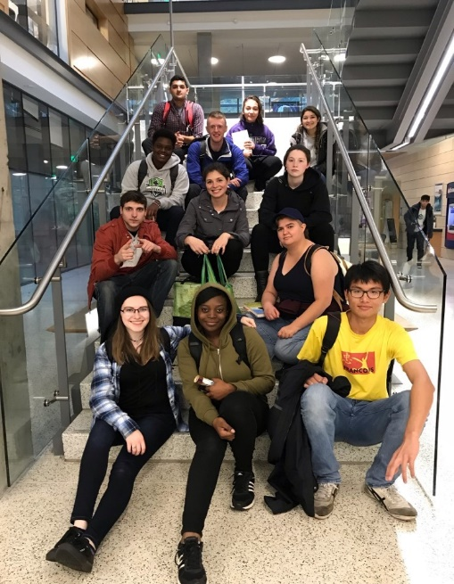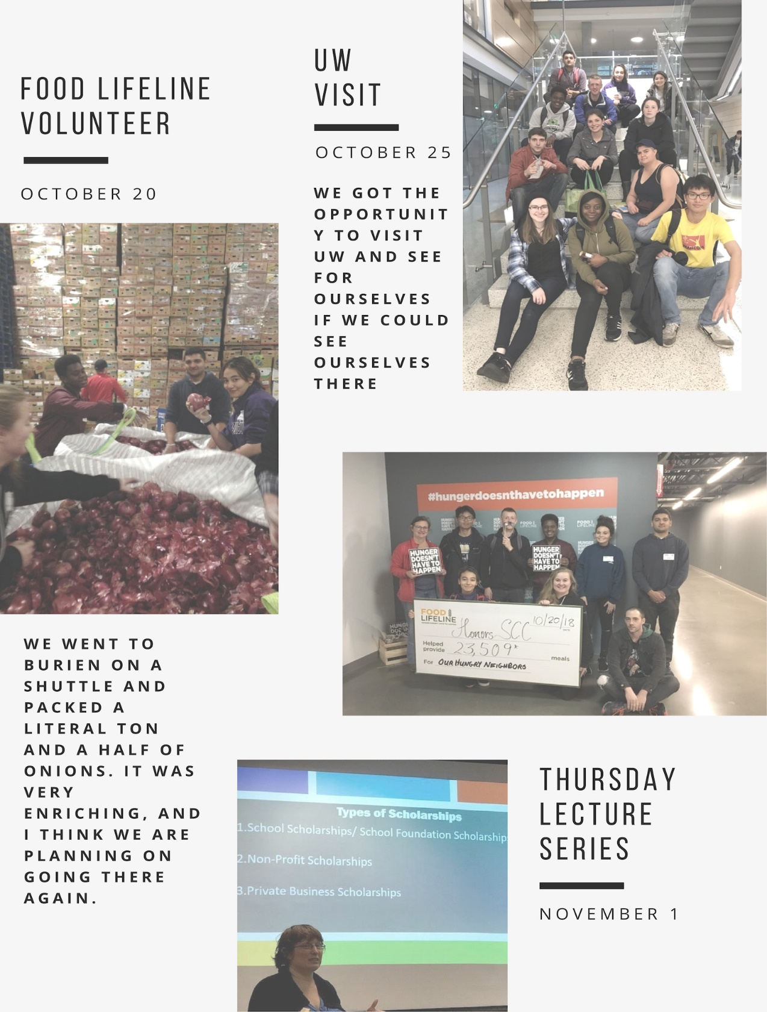

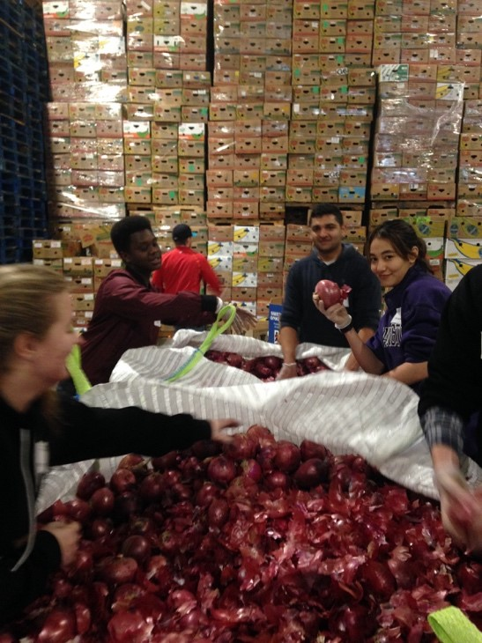

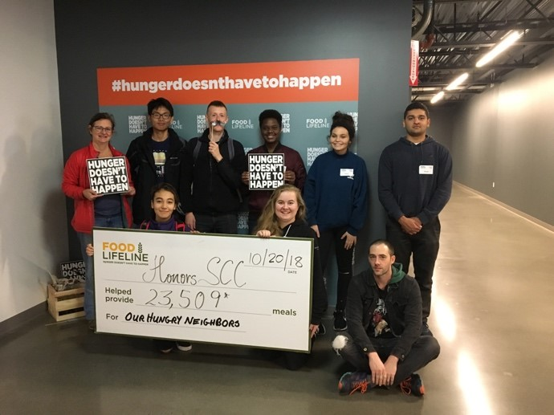

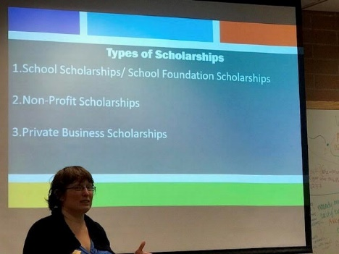

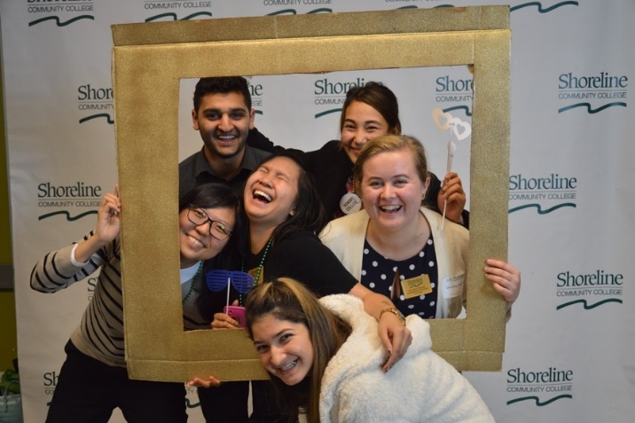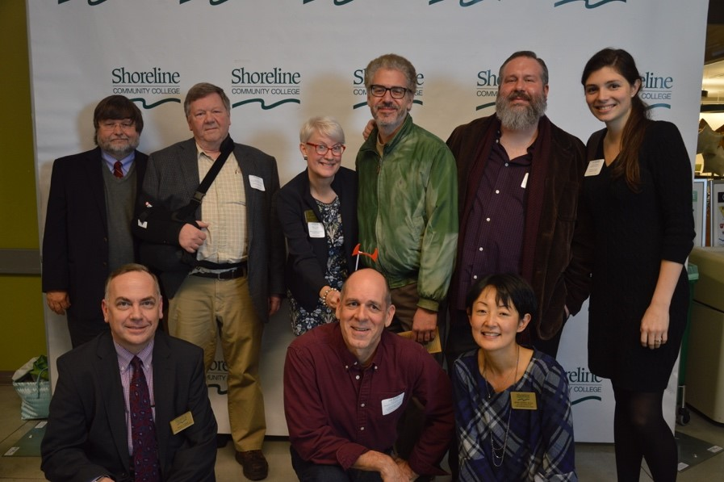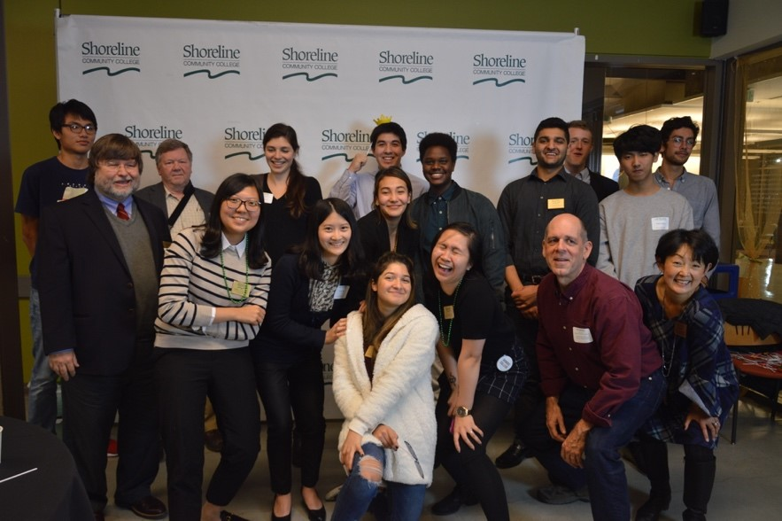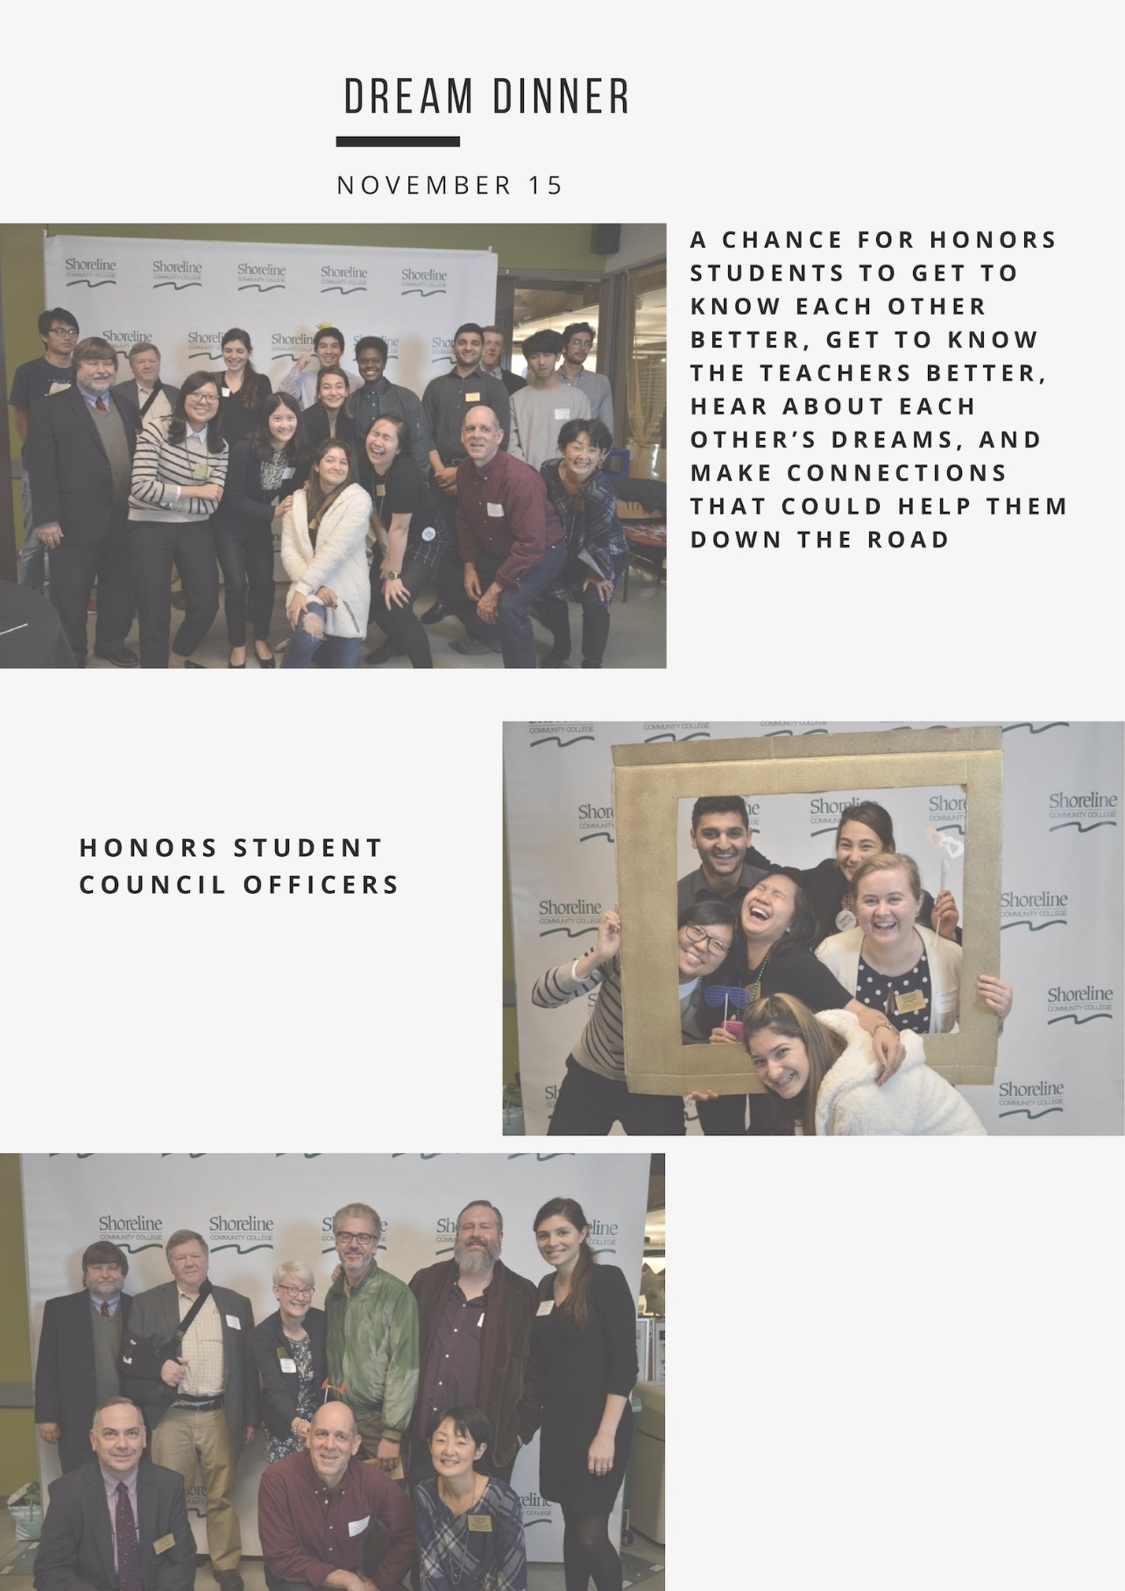

1. Membership is open for any faculty member interested in honors and those who have developed or taught honors classes. The admissions committee is made up of the assistant deans, director, and advisor.