## Biotechnology Program Assessment, Spring 2019

Summary Report, August 2019

This document contains a brief summary of results from an assessment of Shoreline Community College’s biotechnology program. The purpose of the assessment was to gauge students’ attainment of key program learning outcomes based on feedback from potential future employers.

### Methods

During a regularly scheduled meeting of the biotechnology advisory committee, students presented a poster session similar to what would occur at a professional conference. Members of the advisory committee were asked to speak with students about their posters and, where possible, to provide ratings using a set rubric. Below is a snapshot from a sample rating:

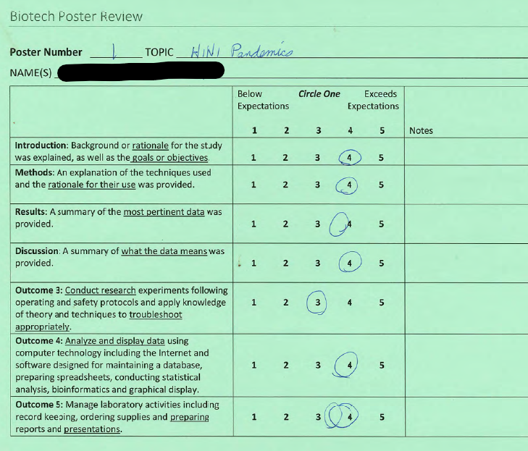

Ten advisory committee members participated, though not all members rated all posters. Each poster was rated by between 5 and 10 members.

### Results

As shown in Tables 1 and 2, almost all ratings were between 4 and 5 (Exceeds expectations), and across all posters, all raters, and all components rated, there were only three ratings that received a rating lower than “3,” which was equivalent to meeting expectations. Only one poster received an average ratings of less than 4.0 (M = 3.99), suggesting that almost all posters were “Exceeding Expectations.”

Table 1. Frequency, mean (M) and standard deviation (SD) of all ratings, as well as a breakdown of

|  |  |  |  |  |  |  |  |
| --- | --- | --- | --- | --- | --- | --- | --- |
|  | 1 Below Expectations | 2 | 3 | 4 | 5  Exceeds Expectations | M | SD |
| Introduction | 0  (0.0%) | 1  (1.7%) | 8  (13.6%) | 25  (42.4%) | 25  (42.4%) | **4.84** | *0.76* |
| Methods | 0  (0.0%) | 1  (1.7%) | 7  (11.9%) | 25  (42.4%) | 26  (44.1%) | **4.88** | *0.74* |
| Results | 0  (0.0%) | 0  (0.0%) | 8  (13.6%) | 28  (47.5%) | 23  (39.0%) | **4.84** | *0.69* |
| Discussion | 0  (0.0%) | 1  (1.8%) | 8  (14.0%) | 22  (38.6%) | 26  (45.6%) | **4.85** | *0.77* |
| Outcome 3 | 0  (0.0%) | 0  (0.0%) | 11  (19.3%) | 28  (49.1%) | 18  (31.6%) | **4.71** | *0.71* |
| Outcome 4 | 0  (0.0%) | 0  (0.0%) | 12  (21.1%) | 18  (31.6%) | 27  (47.4%) | **4.82** | *0.80* |
| Outcome 5 | 0  (0.0%) | 0  (0.0%) | 9  (15.8%) | 25  (43.9%) | 23  (40.4%) | **4.81** | *0.71* |

Table 2. Mean and standard deviation of ratings for each poster

|  |  |  |  |  |  |  |  |  |  |
| --- | --- | --- | --- | --- | --- | --- | --- | --- | --- |
|  | Poster Number | | | | | | | | |
|  | 1 (n = 7) | 2 (n = 10) | 3 (n = 7) | 4 (n = 7) | 5 (n = 9) | 6 (n = 6) | 7 (n = 7) | 8 (n = 5) | 9 (n = 6) |
| Introduction | **4.50**  *0.55* | **4.00**  *0.87* | **4.00**  *1.26* | **4.50**  *0.55* | **4.50**  *0.76* | **4.50**  *0.55* | **4.14**  *0.69* | **4.20**  *0.45* | **4.00**  *0.89* |
| Methods | **4.33**  *0.82* | **4.33**  *0.71* | **4.17**  *0.75* | **4.33**  *0.82* | **4.00**  *0.93* | **4.83**  *0.41* | **4.00**  *0.82* | **4.00**  *0.71* | **4.67**  *0.52* |
| Results | **4.50**  *0.55* | **4.33**  *0.71* | **4.25**  *0.61* | **4.33**  *0.82* | **4.13**  *0.83* | **4.33**  *0.82* | **3.86**  *0.69* | **4.40**  *0.55* | **4.17**  *0.75* |
| Discussion | **4.50**  *0.55* | **4.22**  *0.97* | **4.00**  *0.89* | **4.50**  *0.55* | **4.14**  *0.90* | **4.67**  *0.52* | **4.00**  *0.89* | **4.20**  *0.84* | **4.33**  *0.82* |
| Outcome 3 | **4.00**  *0.89* | **4.13**  *0.64* | **4.33**  *0.52* | **4.17**  *0.75* | **4.00**  *0.76* | **4.33**  *0.52* | **3.83**  *0.75* | **4.00**  *1.00* | **4.33**  *0.82* |
| Outcome 4 | **4.17**  *0.98* | **4.56**  *0.73* | **3.75**  *0.99* | **4.20**  *0.84* | **4.00**  *0.76* | **4.67**  *0.52* | **4.08**  *0.80* | **4.40**  *0.89* | **4.33**  *0.82* |
| Outcome 5 | **4.00**  *0.89* | **4.44**  *0.53* | **4.40**  *0.55* | **4.60**  *0.55* | **4.00**  *0.93* | **4.50**  *0.55* | **4.00**  *0.58* | **4.30**  *0.84* | **4.00**  *0.89* |
| Total | **4.29** | **4.29** | **4.13** | **4.38** | **4.11** | **4.55** | **3.99** | **4.21** | **4.26** |