

Time and Leave Reporting
User Guide for Hourly Employees

January, 2016
Table of Contents
Introduction 3
Login 3
Creating a Timesheet 5
Editing a Timesheet (Full Time Employees) 6
Importing work hours onto a timesheet (for overtime eligible employees only) 6
Adding entries to timesheet and editing existing entries. 7
Editing and deleting timesheet entries. 7
Adding, editing, and deleting timesheet remarks 8
Editing a Timesheet (Hourly Employees) 10
Adding entries to timesheet and editing existing entries. 10
Editing and deleting timesheet entries. 11
Submitting a Timesheet 12
Deleting a Timesheet 12
Timesheet Status 12
Timesheet History 13

Introduction
The Time and Leave Reporting (TLR) application is available to all hourly employees. TLR streamlines the process of reporting time.
TLR allows hourly employees to submit a timesheet and review past timesheets.

Login
Logon credentials required for TLR are employee System Identifier (SID) and Personal Identification Number (PIN) (Figure 1). If assistance with credentials is required, please contact the Human Resources department or Payroll department. Note, when entering a SID and PIN use digits (numbers) only.
Figure 1 - Login Page
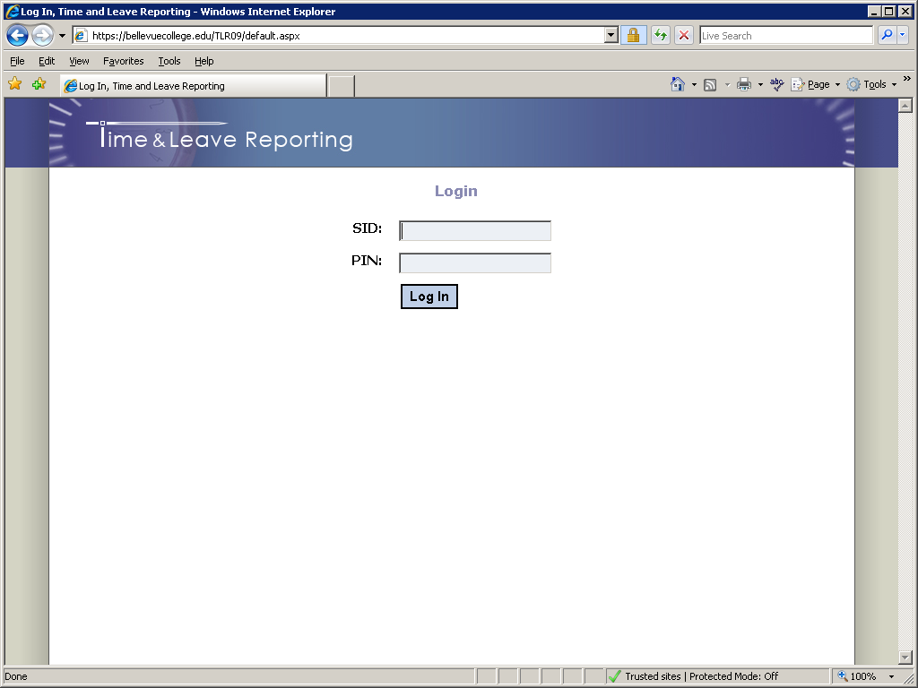

After logging in, users will be taken to the Home page of the application (Figure 2).
Figure 2 – Home Page
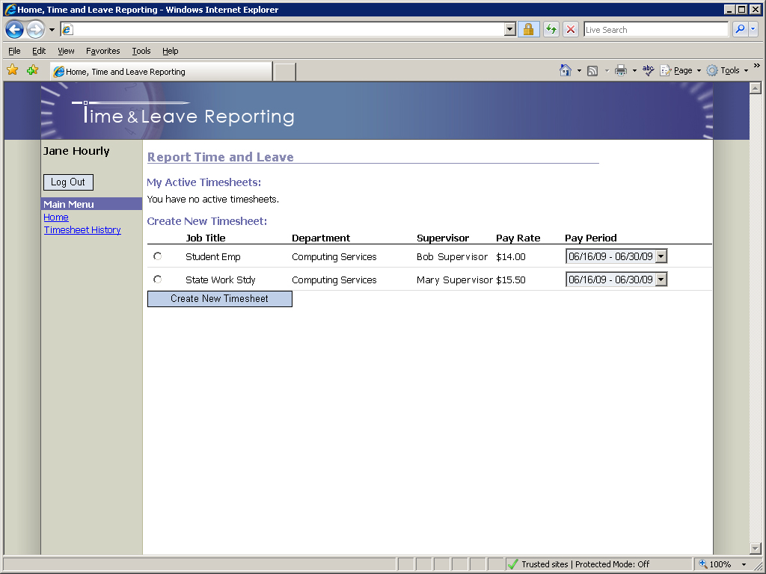

The Home page is where employees are able to create new timesheets and also see the list of their active timesheets (those that have not been processed by payroll).

Creating a Timesheet
To create a timesheet, on the Home page (Refer to the “Create New Timesheet” section in Figure 2):
- Select a job for which you are submitting a timesheet (if you have only one job in the list it will already be selected).
- Select an appropriate pay period. You may choose a current, past, or future pay period.
- Click the “Create Timesheet” button.
Once the “Create Timesheet” button is clicked you will be redirected to the timesheet page (Figure 3).

Editing a Timesheet
Figure 3 - Timesheet Page
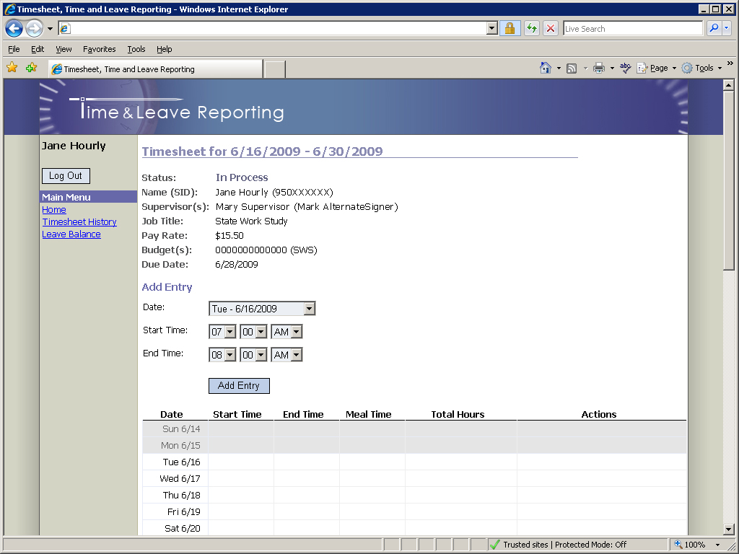

Adding entries to a timesheet and editing existing entries
To add a new entry to a timesheet:
- Select the day from the “Date” dropdown list.
- Specify “Start Time” and “End Time” of your shift.
- Click the “Add Entry” button.
If your shift lasts five hours or more, you will be asked to specify the duration of a meal break as per Department of Labor & Industries’ rules:
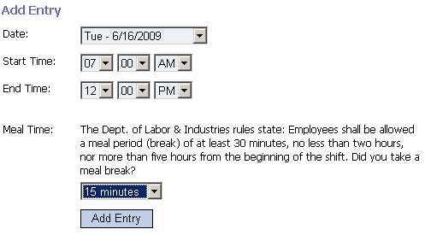

As entries are added to a timesheet, they will appear in the calendar:
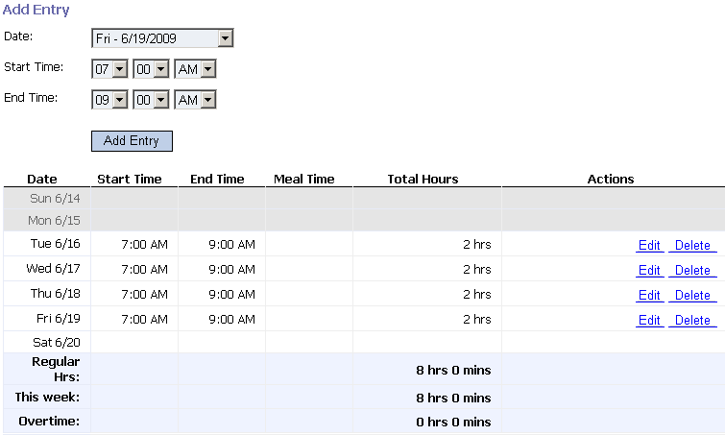

Editing and deleting timesheet entries
To edit a timesheet entry:
- Click on the entry you want to edit. Details of the entry will be displayed above the timesheet.
- Update the information using the same interface described in the “Add entry” section.
- Click the “Update” button.
To delete a timesheet entry:
- Click on the entry you want to delete. Details of the entry will be displayed above the timesheet.
- Click the “Delete” button.

Adding, editing, and deleting timesheet remarks
The employee, supervisor and payroll personnel can add one or more remarks to timesheets.
To add a remark:
- Click the “Add Remark” button.
- Enter remark text.
- Click the “Save Remark” button.
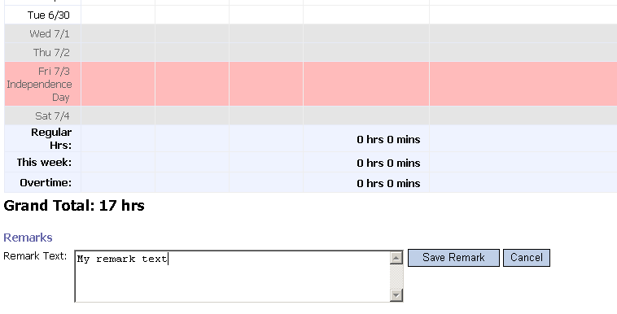
The remark will be displayed directly below the timesheet:
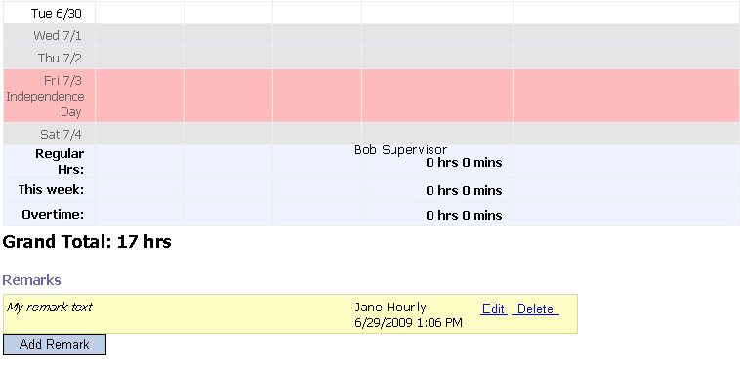
To edit a remark:
- Click the “Edit” link next to the remark.
- Make the necessary changes.
- Click the “Save Remark” button.
To delete a remark:
- Click the “Delete” link next to the remark.
- Confirm the deletion by clicking “Ok” in the pop-up prompt.

Submitting a Timesheet
When you complete your timesheet you can submit it to your supervisor for approval by clicking the “Submit Timesheet” button towards the bottom of the Timesheet page. Unless rejected back to the employee, once timesheets are submitted they cannot be modified or deleted.

Deleting a Timesheet
You can delete a timesheet that you have created by clicking the “Delete Timesheet” button towards the bottom of the timesheet page. Only timesheets with the status “In Process” can be deleted.

Timesheet Status
The status of your active timesheet(s) can be viewed on the home page under the “My Active Timesheets” section (Figure 6). Timesheets are considered “Active” until processed by Payroll.
Figure 3 - Timesheet Status
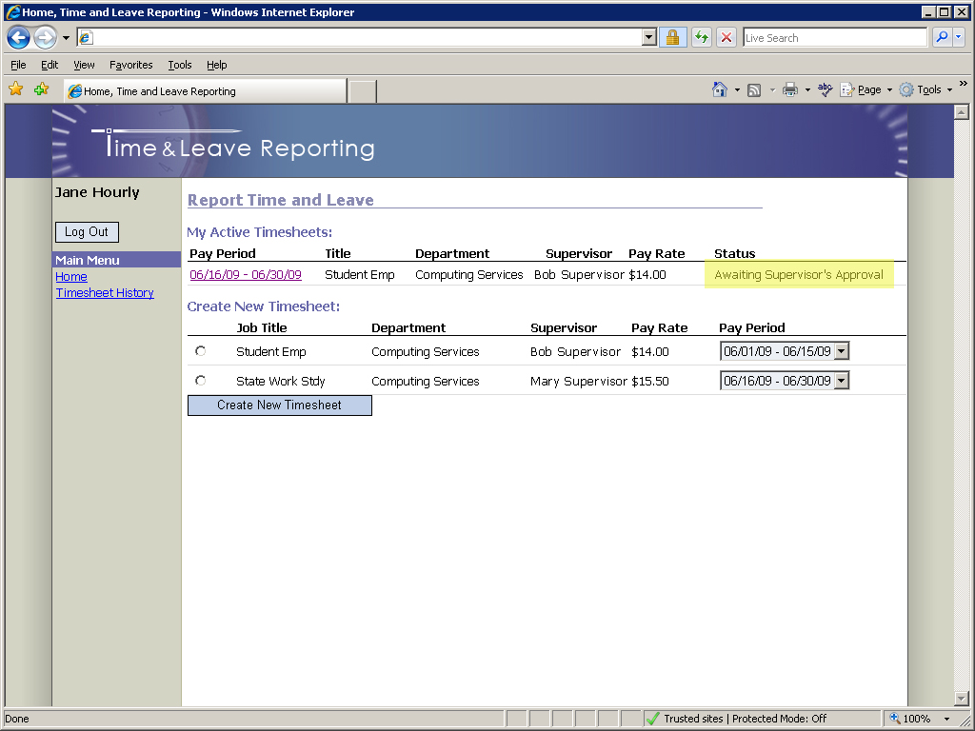

Timesheet History
The Timesheet History page allows all employees to search through previously created and submitted timesheets. To review timesheet history, click on the “Timesheet History” link in the navigation pane (Figure 7). By default, you will see the five latest timesheets; they can also be searched by start and end date. To specify dates for a search, type dates directly into the Start/End Date textboxes or click on the calendar icons to the right of the textboxes and select the appropriate dates. When finished entering dates, click on the “Search” button to run the search. Results will be displayed below the “Search” button.
Figure 4 - Timesheet History Page
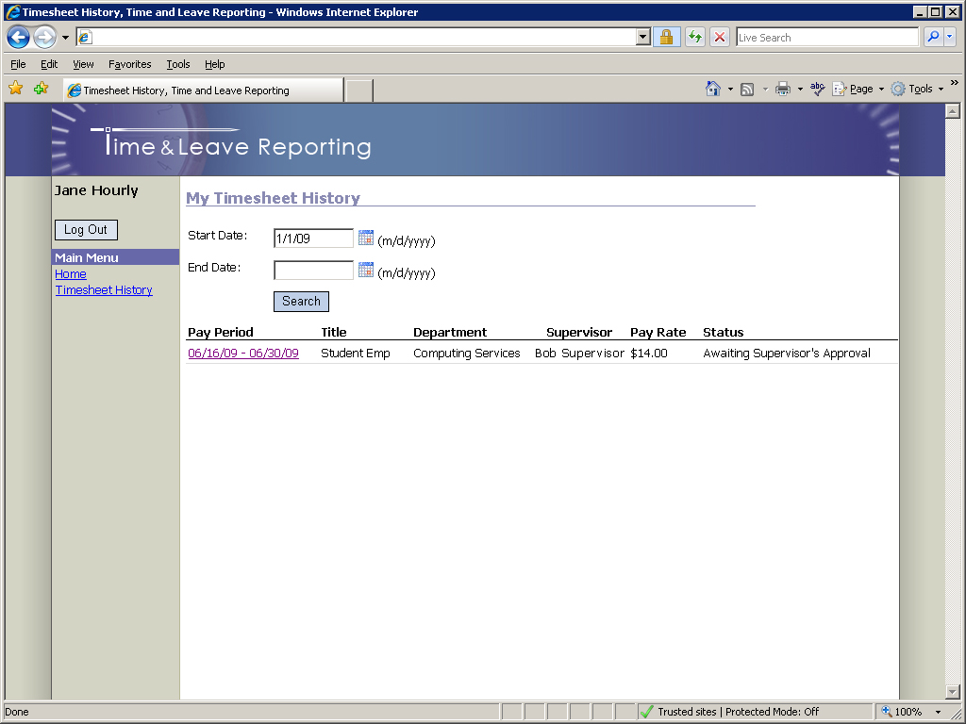

For further assistance, please consult the Payroll Office.

