

Time and Leave Reporting
User Guide for Supervisors

October, 2009
Table of Contents
Introduction 3
Approving Timesheets 3
Approving Timesheets for Full Time Employees 5
Approving Timesheets for Hourly Employees 6
Search Timesheets 7
Search Employees 8
Employees’ Balances 10

Introduction
Within Time and Leave Reporting (TLR), Supervisors have unique views and abilities. These include viewing employees’ leave balances and approving and rejecting timesheets. Alternate supervisors can take the same actions as the primary supervisor and should only do so when the primary supervisor is absent.

Approving Timesheets
To access the list of all timesheets that need to be approved click on “Approve Timesheets” in the navigation pane on the left. If timesheets are awaiting approval, they will be listed under either Primary Approval or Alternate Approval (Figure 1).
- Primary Approval. These are the timesheets for which you are listed as a primary supervisor. You are expected to approve those timesheets.
- Alternate Approval. This list contains timesheets for which you are listed as the alternate approver. You do not have to approve these timesheets unless the primary supervisor is unavailable. (Note: The Primary Supervisor and the Alternate Supervisor(s) should discuss how they how they will handle approval.)

Figure 1 - Approve Timesheets
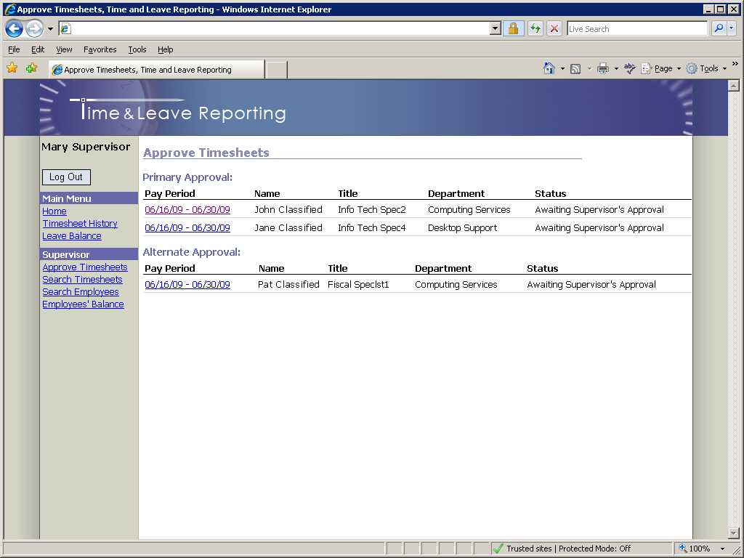
Click on the timesheet you wish to approve. You will be redirected to the Timesheet page.

Approving Timesheets for Full Time Employees
Figure 2 - Timesheet Page
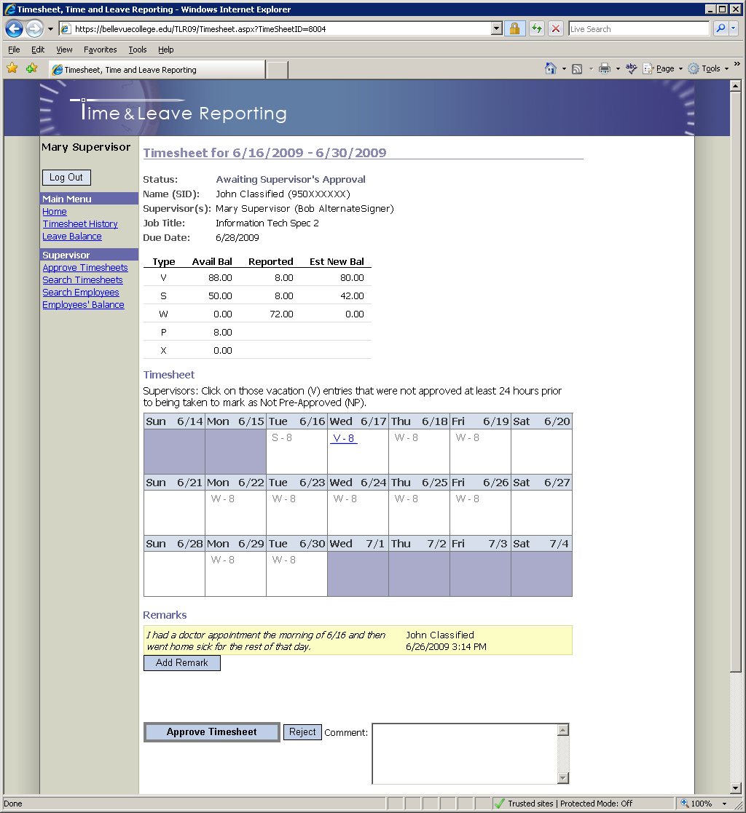

On the Timesheet page (Figure 2) you can review all the information on the timesheet and add remarks if necessary. For instructions on how to add remarks please refer to the document “TLR User Guide – Full Time Employees”. Note: Message above timesheet in Figure 2 no longer applies.

Finally, to approve a timesheet click the “Approve Timesheet” button at the bottom of the page or, if you wish to reject that timesheet, click the “Reject” button (Note: comment is required when rejecting timesheets).
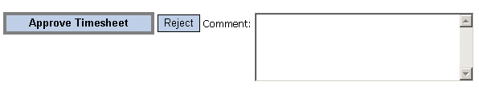

Approving Timesheets for Hourly Employees
There are three different cases for approving timesheets for hourly employees which are distinguished by the number of budgets on each individual timesheet
- Timesheets with one budget.
- Timesheets with multiple budgets but without grants.
- Timesheets with multiple budgets, one or more of those budgets being a grant budget.

Approving timesheets with one budget
There are no special steps required prior to approving such timesheets as all hours will be assigned to the budget listed for that job. See below for further approval instructions.
Approving Timesheets with multiple budgets but without grants
Prior to approving this type of timesheet the supervisor is required to specify the distribution of hours worked between the available budgets associated with the timesheet (Note: if the budget information on a timesheet is incorrect, please contact your Payroll department to make necessary adjustments).
To specify the distribution of hours, use the “Budget Allocation” interface located just below the “Remarks” section of the timesheet:
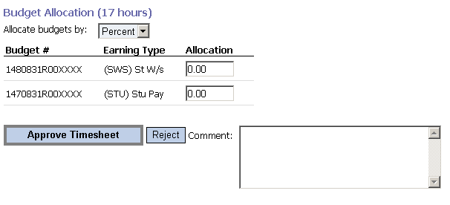

- Select either “percent” or “hours” as a means of allocating the total from the “Allocate budgets by:” dropdown list.
- Enter the values for the distribution (Note: values must add up to the total number of hours worked or 100%, depending on your allocation choice.)
- Click the “Approve Timesheet” button.
An error message will appear if any mathematical or other errors occur.

Approving Timesheets with multiple budgets, one or more of those budgets being a grant budget
Per federal mandate, prior to approving such timesheets the supervisor is required to specify the distribution of hours worked between the available budgets on a timesheet, FOR EACH TIMESHEET ENTRY (Note: if the budget information on a timesheet is incorrect, please contact your payroll department to make necessary adjustments).
To specify the distribution of hours, enter the appropriate values for each budget entry, similar to the example shown below:
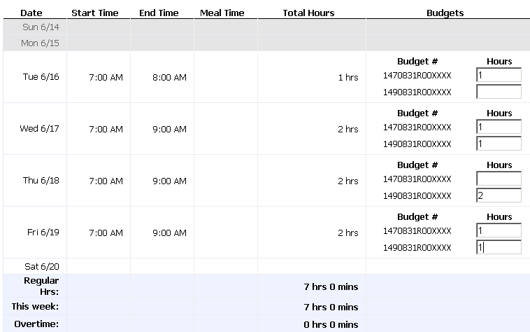
After entering values for all timesheet entries click the “Approve Timesheet” button to send the timesheet to Payroll.

Search Timesheets
You may search any of your employee’s timesheets using the “Search Timesheets” feature (Figure 3), to access that page click on the “Search Timesheets” link in the navigation pane.

Figure 3 - Search Timesheets
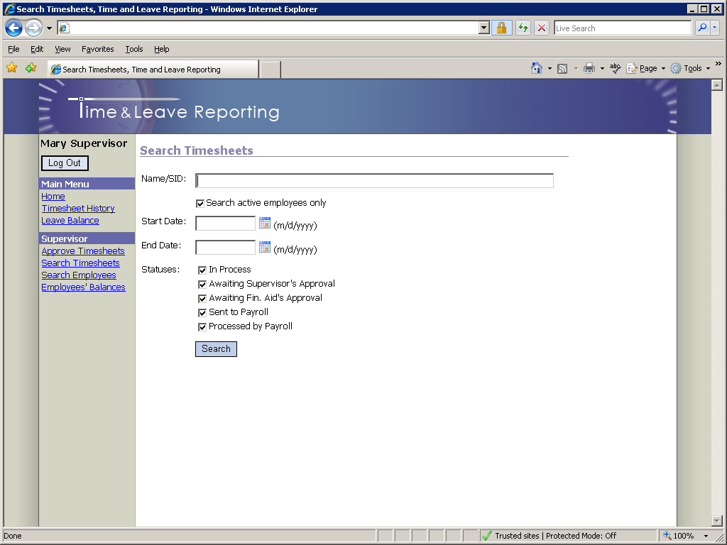
You may search by any combination of Name/SID, Start Date, End Date, or Status. (Note: at least one of the following parameters is required; Name/SID, Start Date, or End Date).

Search Employees
Supervisors in charge of full time employees have the ability to search and view employee details, which include work hours (only for overtime eligible employees), current leave balances, and timesheets. To access this information, first click on the “Search Employees” link in the navigation pane. You will be presented with the list of employees under your supervision (Figure 4)
Figure 4 - Search Employees
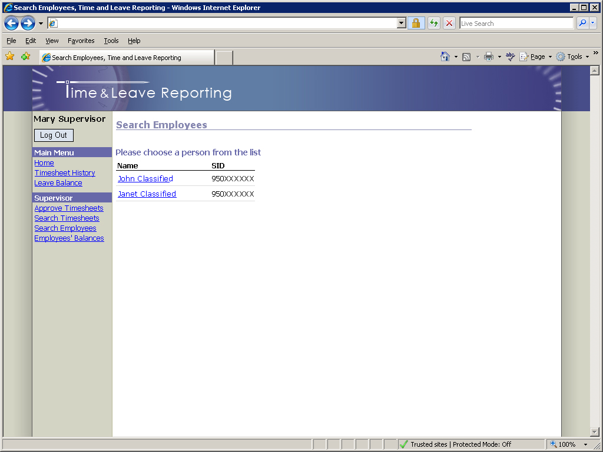
Click on the employee’s name to view their employee details. (Figure 5)

Figure 5 - Employee Details
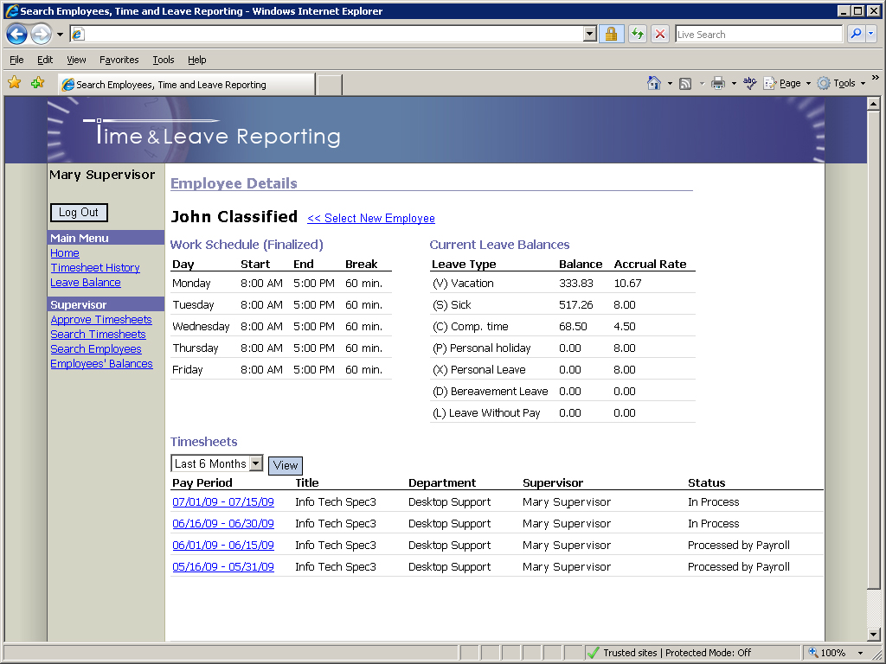

Employees’ Balances
Supervisors can view their employees’ balances by clicking on the “Employees’ Balances” link in the navigation pane. This page reflects current balance, accrual rate, employees’ anniversary date, and leave expiration month (Figure 6).
Figure 6 - Employees' Balances
