

Time and Leave Reporting
User Guide for Classified
and Administrative/Exempt Employees

October, 2009
Table of Contents
Introduction 3
Login and Home Page 3
Create, Edit and Submit Work Hours 4
To Enter Work Hours 5
Creating a Timesheet 6
Editing a Timesheet 8
Importing work hours onto a timesheet (for overtime-eligible employees only) 8
Adding entries to a timesheet and editing existing entries 9
Editing and deleting timesheet entries 9
Adding, editing, and deleting timesheet remarks 10
Submitting a Timesheet 11
Deleting a Timesheet 11
Timesheet Status 11
Timesheet History 12
Leave Balance 13

Introduction
The Time and Leave Reporting (TLR) application is available to all full-time employees. TLR streamlines the process of reporting time, including the reporting of positive time (for Classified employees) and the approval process for exceptions to employees’ work schedules.
Features in TLR include: the ability to enter work schedules (for overtime-eligible employees only), submit a timesheet, review past timesheets, and view leave balances.

Login and Home Page
Logon credentials required for TLR are employee System Identifier (SID) and Personal Identification Number (PIN) (Figure 1). If assistance with credentials is required, please contact your Human Resources department. Note, when entering a SID and PIN use digits (numbers) only.
Figure 1 - Login Page
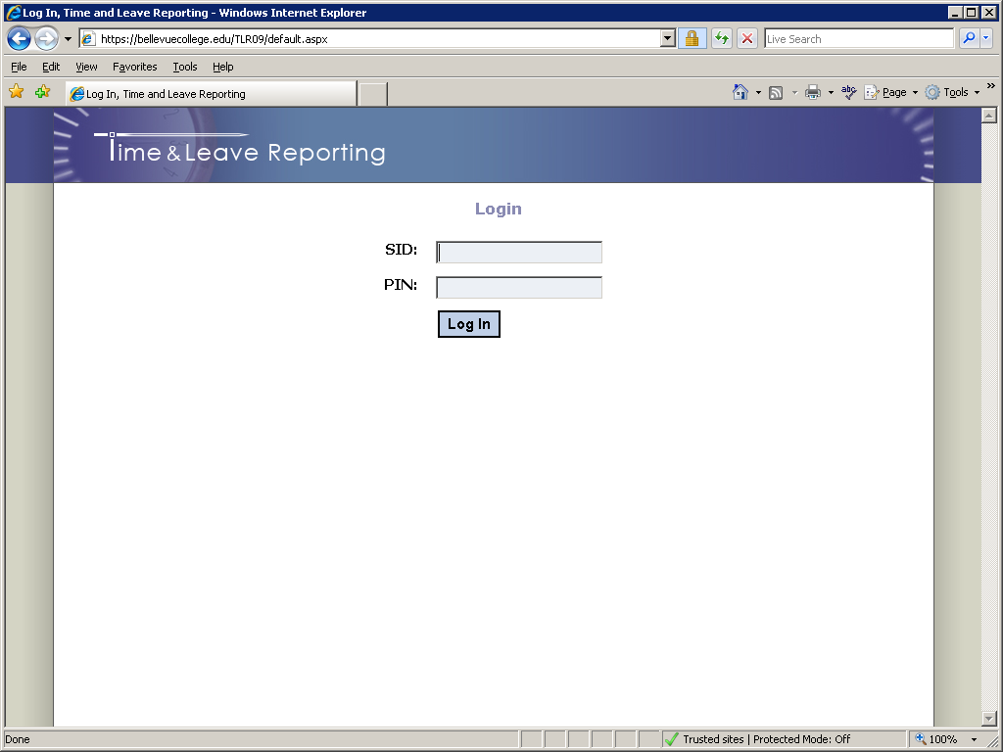

After logging in, users will be taken to the Home page of the application (Figure 2).
Figure 2 – TLR Home Page
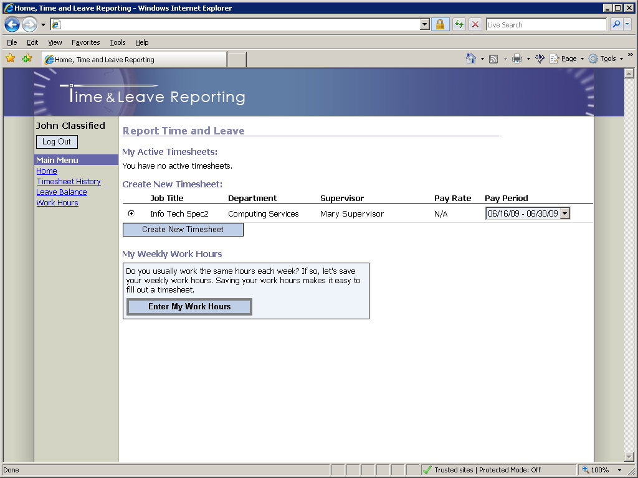

The Home page is where employees are able to create new timesheets and also see the list of their active timesheets (those that have not been processed by payroll).
Navigation menu options vary slightly depending on employee classification or work area. Classified employees will have a Work Hours option in the navigation pane on the left.

Create, Edit and Submit Work Hours (for classified employees)
This feature is available only for overtime-eligible employees; Washington State requires a record of positive time. On the Home page (Figure 2), a section called “My Weekly Work Hours” is located toward the bottom of the screen. If an employee has not created a weekly work schedule previously, a button titled “Enter My Work Hours” will appear at the bottom of this section:
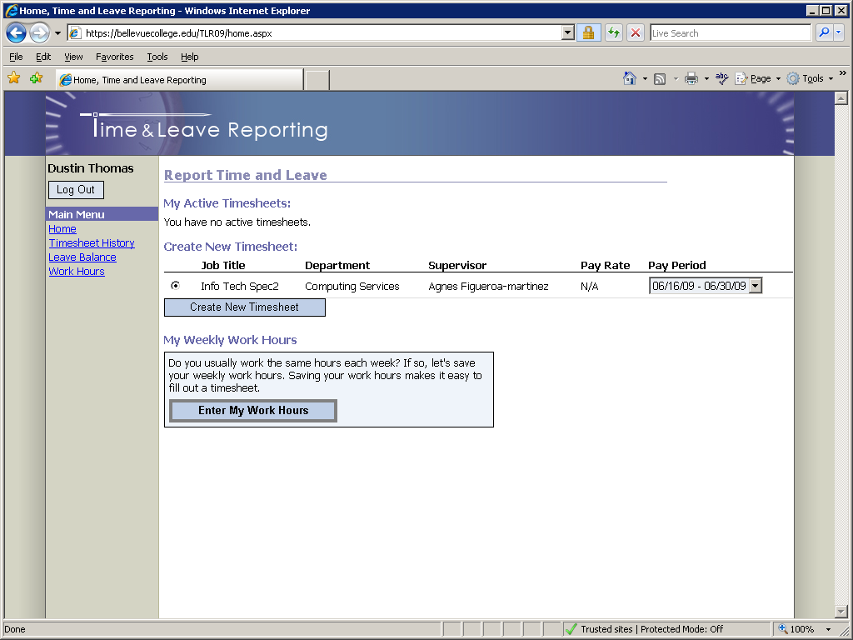
Work hours need to be submitted in order to be finalized. Submitting work hours sends an e-mail to the employee’s primary supervisor letting him or her know what that work schedule is and sets the work schedule’s status to “Finalized”. Until that happens, the work schedule will remain a “Draft” and the following message will be displayed on the Home page and on the Timesheet page:
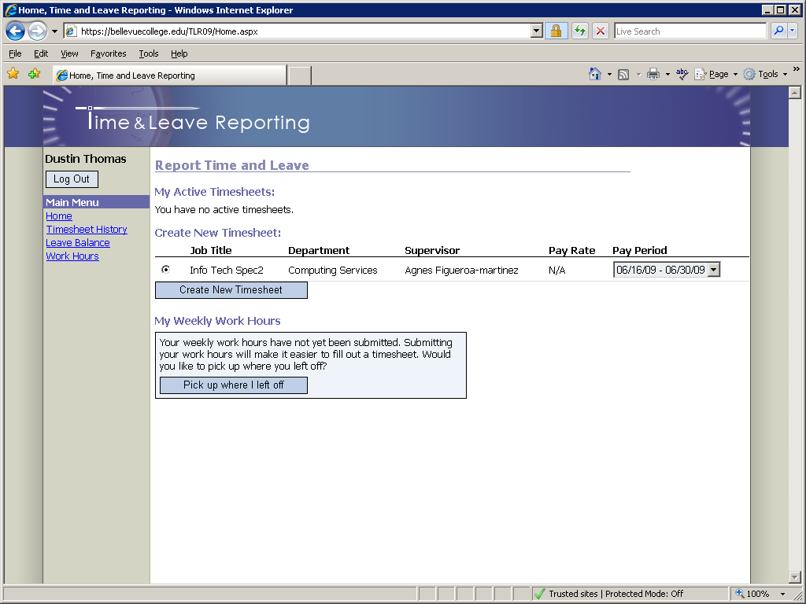
If an employee has submitted their work hours, those hours will be displayed on the Home page along with an Edit Work Hours button:
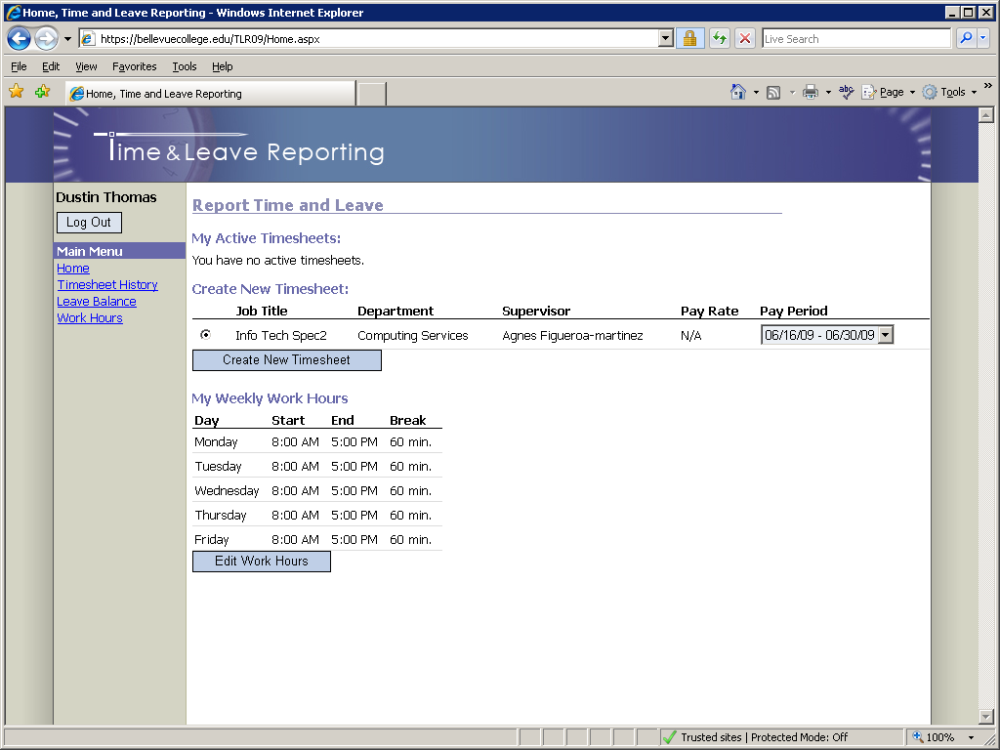

To Enter Work Hours
Click on the “Work Hours” link in the navigation pane to go to the “My Work Hours” page (Figure 3).
Figure 3 - Work Hours Page
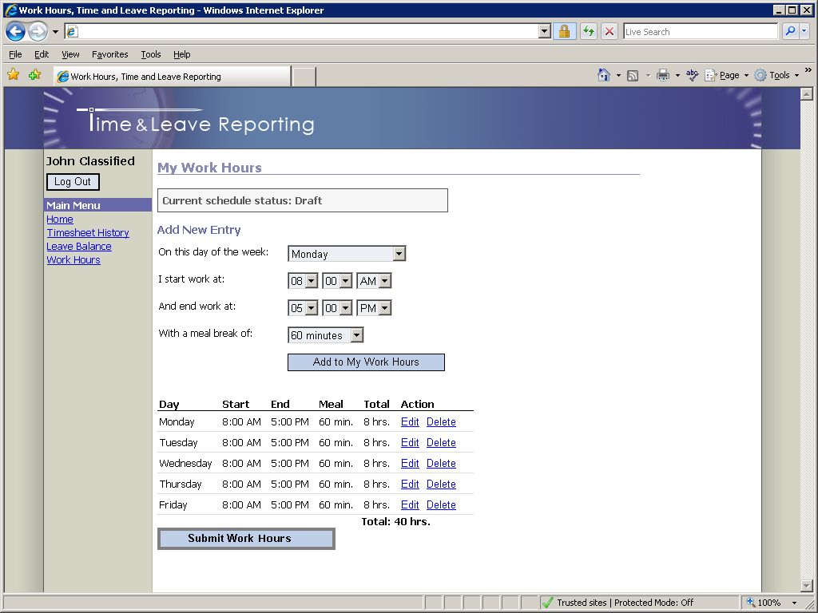

Select day of the week, start time, end time, and meal break and then click the “Add to My Work Hours” button to add that entry to your work hours. You can also edit or delete existing entries by clicking on the “Edit” or “Delete” links in the column titled “Action”.
Note:
- Every time a change is made to the work hours, the employee must re-submit them by clicking the “Submit Work Hours” button or the Work Hours will remain in “Draft” form.
- The total number of work hours cannot exceed 40.
- The employee’s supervisor is notified via e-mail every time work hours are submitted.

Creating a Timesheet (Admin/Exempt and Classified Employees)
To create a timesheet, on the Home page (Refer to the “Create New Timesheet” section in Figure 2):
- Select a job for which you are submitting a timesheet (if you have only one job in the list it will already be selected).
- Select an appropriate pay period. You may choose a current, past, or future pay period.
- Click the “Create Timesheet” button.
Once the “Create Timesheet” button is clicked you will be redirected to the timesheet page (Figure 4).

Editing a Timesheet
Figure 4 – Timesheet Page
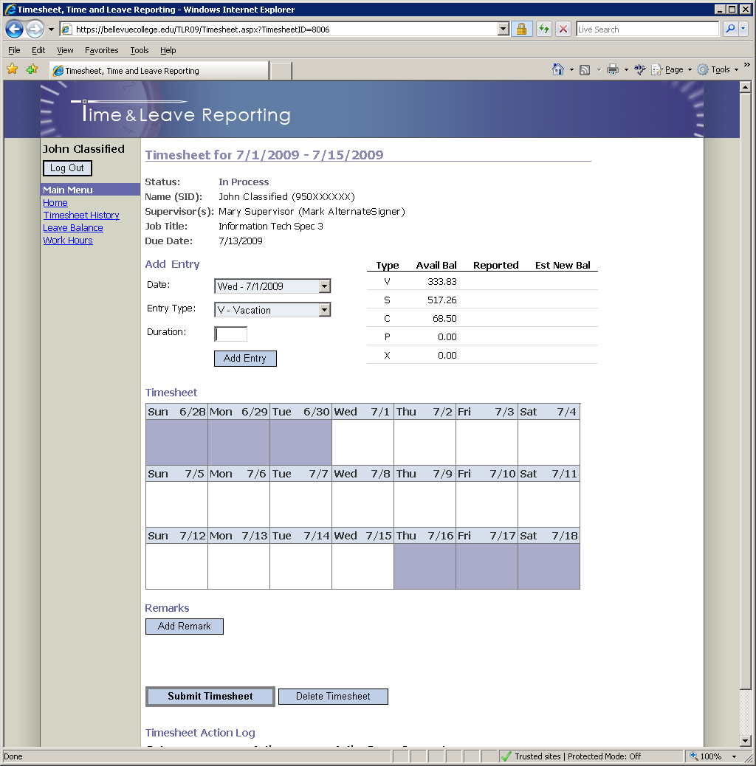

Importing work hours onto a timesheet (for classified employees only)
If your work hours have been submitted they can be imported onto a timesheet as positive time entries (shown as “W”) by clicking the “Import My Work Hours” button:
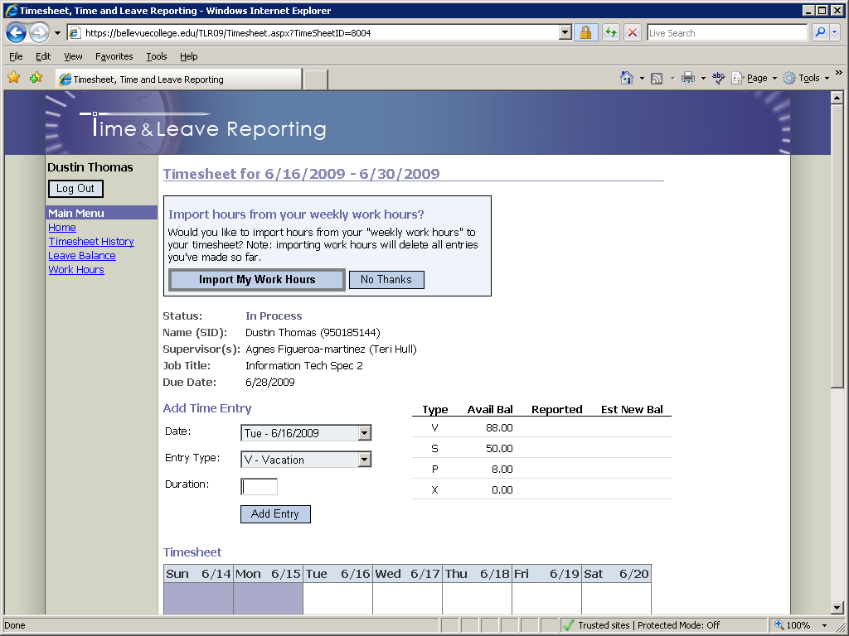
You may also choose not to import work hours by clicking the “No Thanks” button (only this timesheet will be affected).
Note to classified employees:
When importing work hours, any existing entries on a timesheet will be deleted.

Adding entries to a timesheet and editing existing entries
To add a new entry to a timesheet:
- Select the day from the “Date” dropdown list.
- Select a type of entry from the “Entry Type” dropdown list (“V – Vacation”, “S – Sick”, etc.). Certain types of leave require a timesheet remark (see below).
- Enter the duration in the “Duration” text box.

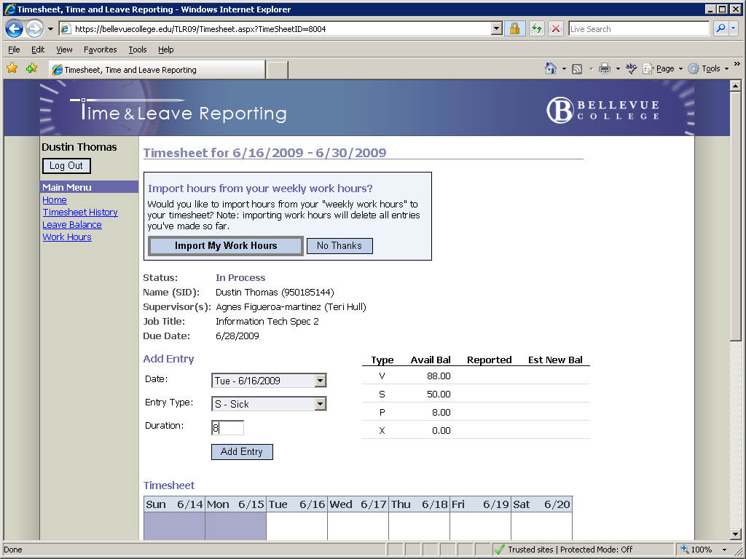
Note to classified employees:
If you decided not to import your work schedule onto a timesheet you can still enter positive time by selecting “W – Positive Time” from the “Entry Type” dropdown list.

Editing and deleting timesheet entries
To edit a timesheet entry:
- Click on the entry in the calendar (ex: “S – 8”) you want to edit. Details of the entry will be displayed above the timesheet.
- Update the information using the same interface described in the “Add Entry” section.
- Click the “Update” button.
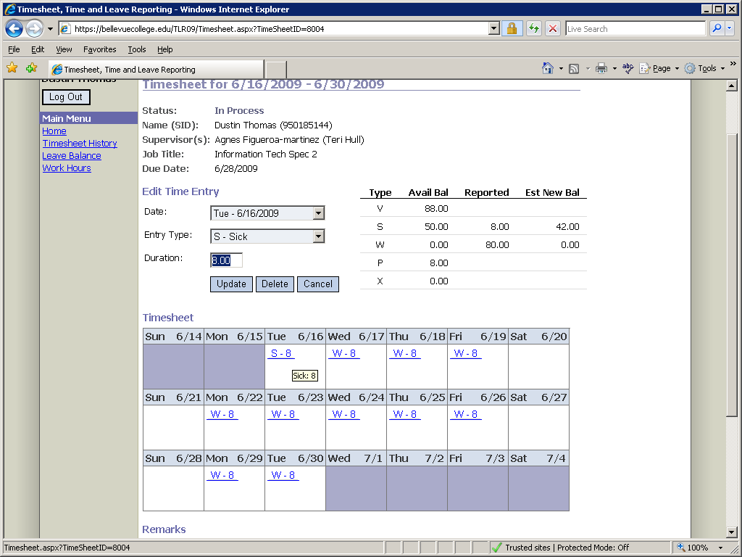
To delete a timesheet entry:
- Click on the entry in the calendar you want to delete. Details of the entry will be displayed above the timesheet.
- Click the “Delete” button.

Adding, editing, and deleting timesheet remarks (required for certain types of leave, see Appendix A)
The employee, supervisor and payroll personnel can add one or more remarks to timesheets.
To add a remark:
- Click the “Add Remark” button (refer to Figure 4).
- Enter remark text.
- Click the “Save Remark” button.
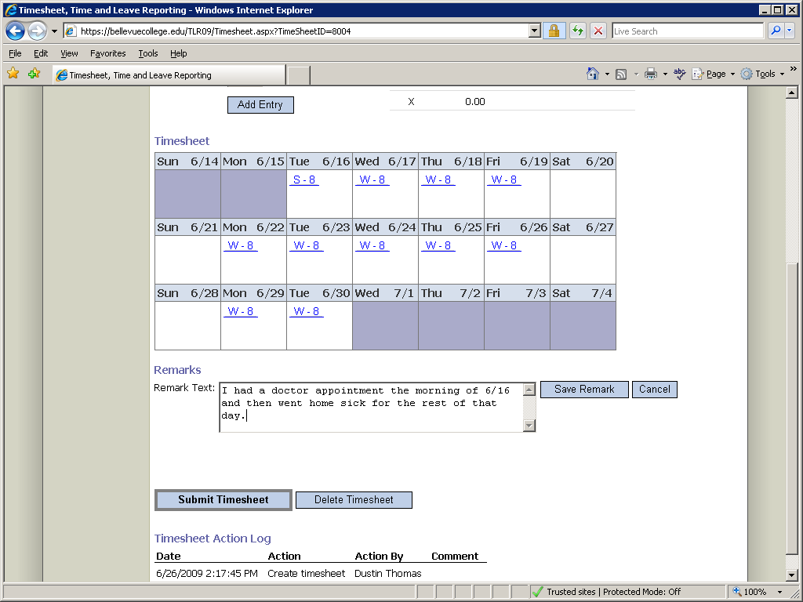
The remark will be displayed directly below the timesheet:
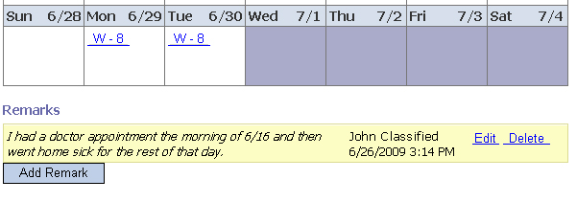
To edit a remark:
- Click the “Edit” link next to the remark.
- Make the necessary changes.
- Click the “Save Remark” button.
To delete a remark:
- Click the “Delete” link next to the remark.
- Confirm the deletion by clicking “Ok” in the pop-up prompt.

Submitting a Timesheet
When you complete your timesheet you can submit it to your supervisor for approval by clicking the “Submit Timesheet” button towards the bottom of the Timesheet page. Unless rejected back to the employee, once timesheets are submitted they cannot be modified or deleted.

Deleting a Timesheet
You can delete a timesheet that you have created by clicking the “Delete Timesheet” button towards the bottom of the timesheet page. Only timesheets with the status “In Process” can be deleted.

Timesheet Status
The status of your active timesheet(s) can be viewed on the home page under the “My Active Timesheets” section (Figure 5). Timesheets are considered “Active” until processed by Payroll.
Figure 5 - Timesheet Status
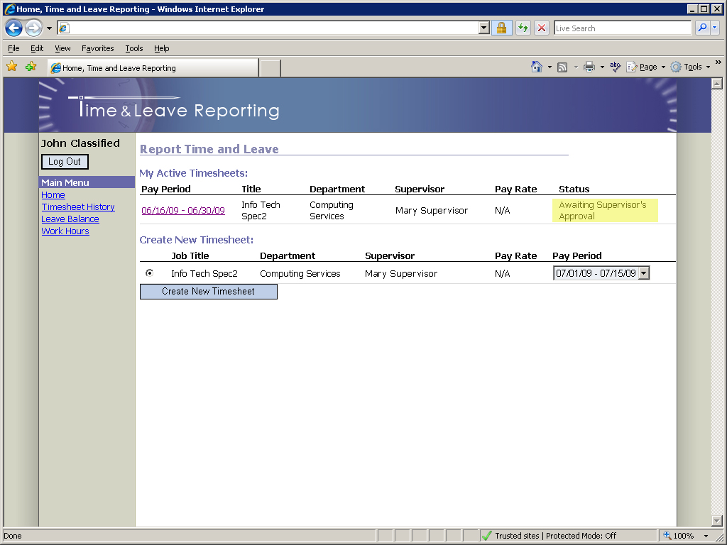

Timesheet History
The Timesheet History page allows all employees to search through previously created and submitted timesheets. To review timesheet history, click on the “Timesheet History” link in the navigation pane (Figure 6). By default, you will see the five latest timesheets; they can also be searched by start and end date. To specify dates for a search, type dates directly into the Start/End Date textboxes or click on the calendar icons to the right of the textboxes and select the appropriate dates. When finished entering dates, click on the “Search” button to run the search. Results will be displayed below the “Search” button.
Figure 6 - Timesheet History Page
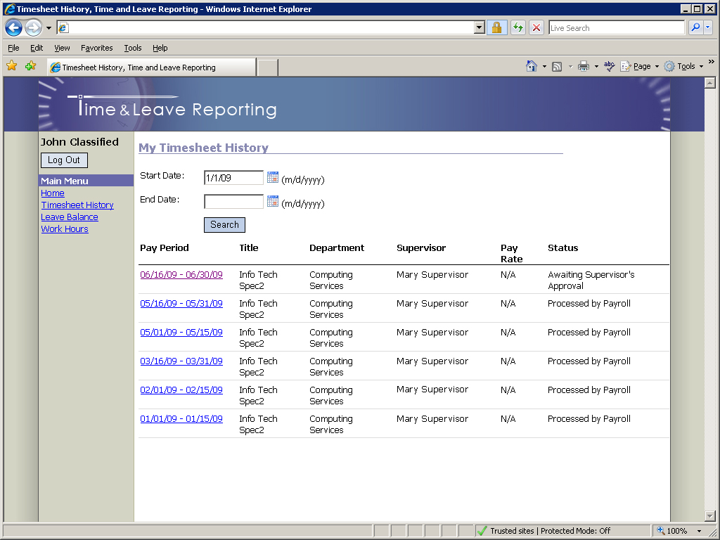

Leave Balance
Employees can view Leave Balance information by clicking on the “Leave Balance” link in the navigation pane. The Leave Balance page (Figure 7) is shown below.

Figure 7 - Leave Balance Page
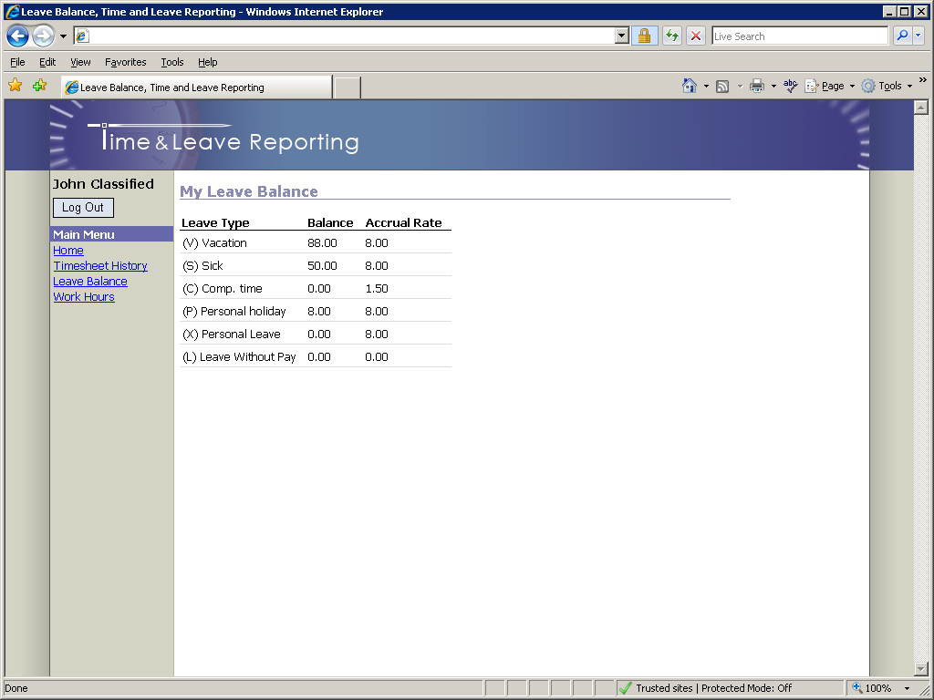

For further assistance, please consult the Payroll Office.

