**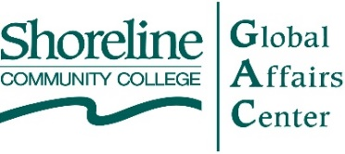**

***Presents . . .***

**Alternative Energy and Climate Change:**

**The Nuclear Option**

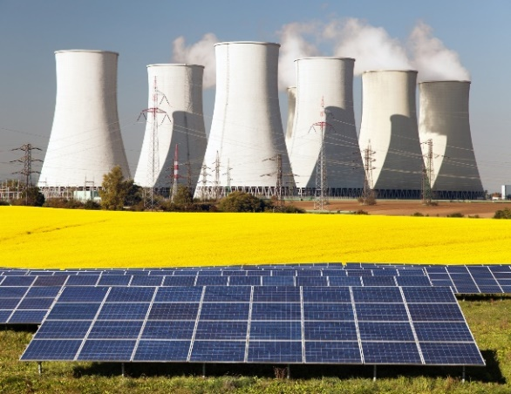**Scott Montgomery**

Geoscientist, and affiliate faculty member, University of Washington, Jackson School of International Studies

**Nick Touran, PhD**

Advanced nuclear reactor physicist, TerraPower

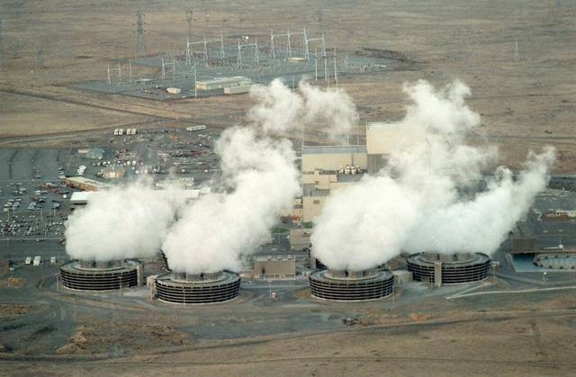Creator of popular website [whatisnuclear.com](http://whatisnuclear.com)

**Tuesday, April 18, 2017**

**7:00 – 8:30 PM**

Shoreline Community College

Room 9208

*This event is* ***open to the public*** *and* ***FREE***

*Parking on campus after 5:00 PM is* ***FREE***

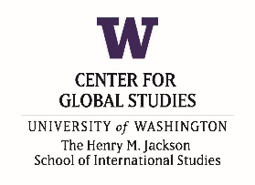

S:\SS\gac\logos\Capture._ind contrib.JPG

***Support from . . .***

*Shoreline Community College does not discriminate on the basis of race, sex, age, color, religion, national origin, marital status, gender, sexual orientation or disability.*

**Speaker Bios**

**Scott Montgomery**

Scott L. Montgomery is a geologist, independent scholar and adjunct faculty member in the Jackson School of International Studies and Honors Program, University of Washington. He has written widely on topics in scientific communication, the history of science, science and art, contemporary culture and translation. His books include: The Chicago Guide to Communicating Science (University of Chicago, 2003); Science in Translation: Movements of Knowledge Through Cultures and Time (University of Chicago, 2000) and The Scientific Voice (Guilford, 1996), among others. Two new works, both forthcoming from the University of Chicago Press are Powers Rich and Afflicted: Energy in the 21st Century—Resources, Issues, Geopolitics and also The Eye of Nature: Studies on Science and Art. He holds a BA in English from Knox College and an MS in geological sciences from Cornell University.

**Nick Touran, PhD**

Nick Touran is a nuclear engineer working on the design and deployment of advanced nuclear power plants at TerraPower, LLC in Bellevue. He runs the nuclear methods development group and is the architect of the primary reactor analysis tool. He also runs the volunteer-powered nuclear public-education website at [www.whatisnuclear.com](http://www.whatisnuclear.com).