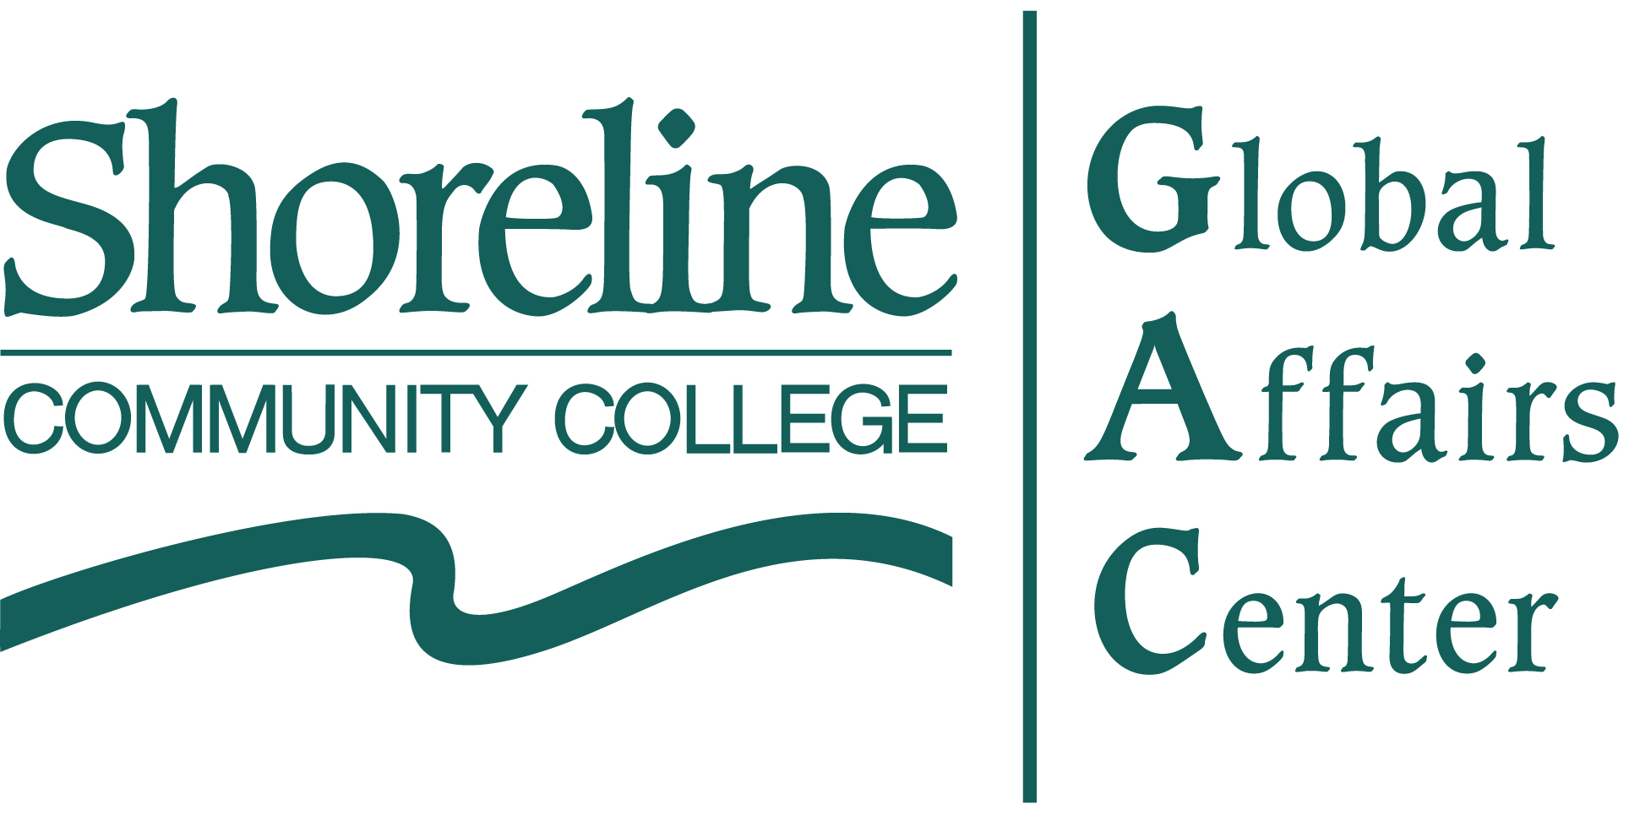
May 5, 2009

Mission
. . . to inspire critical thinking, engagement and collaboration on global issues that lead to greater awareness and understanding of today’s interdependent world.
Vision
- Critical thinking that fosters awareness of political, economic and social circumstances that leads to …
- Engagement through adoption of lifelong habits of listening, giving and doing through …
- Collaboration with others in the immediate and global community.
Planned Activities

- Community programs – These are the anchor activities of the Global Affairs Center aimed at engaging the communities on global issues through lectures, panels and discussion. Programs will be organized that highlight local as well as international perspectives and that create opportunities for partnerships between the college and members the larger community.
- Guest speaker series
- Brownbag discussions
- Great Decisions series

- Internship program – When fully operational this program aims to help students find internship opportunities with public, business and non-profit organizations.
- Partner programs - Navigating the global economy and social environs can be daunting and possibly overwhelming. The Global Affairs Center will serve as a “first point of contact” for businesses and other organizations in need of assistance seeking global opportunities.
  - Business partnerships
  - Humanitarian assistance partnerships
  - Cultural exchange programs

    - Ongoing program Support - The Global Affairs Center will support ongoing programs at Shoreline Community College, such as International Studies, Global Pathways, Study Abroad, and student/faculty exchange agreements with foreign colleges and schools.
Benefits
- Enhances SCC program excellence and advancement of global awareness and multicultural understand, two of six general education outcomes, through advancement of learning opportunities outside the classroom.
- Raises awareness of SCC commitment to global education, engagement, and community service.
- Furthers Shoreline's reputation as an international campus.
- Builds partnerships with Shoreline and regional governments, the Chambers of Commerce, local and foreign businesses, non-profit organizations, and local schools.
- Serves as a resource to nearby citizens and businesses interested in global issues.

Accomplishments to Date

- Presidential Candidates and the UN, October 23, 2008
  - Michael K. Vaska, speaking on behalf of Senator McCain
  - Gael Tarleton, speaking on behalf of Senator Obama

- Asian Perspectives on Global Economic Crisis
- Mitsunori Namba, Consul-General, Consulate of Japan in Seattle, “Japan’s International Cooperation,” February 10. 2009
- Daniel Liao, Director General, Taipei Economic and Cultural Office, Seattle, “Taiwan’s Response to the Global Financial Crisis,” February 17, 2009
- Brownbag series
- Comparing Political and Economic Circumstances 1929 and 2009, Robert Francis, Economics Department, Kenny Lawson, Dean, BUS/IAS/SS Division, Larry Fuell, Director, Global Affairs Center, February 26, 2009
- Social Responses to the Economic Crisis, Amy Kinsel, History Department; Diana Knauf, Psychology Department, Tim Payne, Economics Department, March 13, 2009
- Healthcare During A Time Of Economic Crisis, Hermien Watkins, Allegra Klein, Christina Capone and Patti Kwok, Nursing Department, April 10, 2009.

- Iran Encounters, Abdi Sami, Associate Producer, “Iran Today" documentary, April 14, 2009.

- Great Decisions discussions, examination of current global politics/foreign policy issues.
- Rising Global Powers, Staser Holcomb, April 30, 2009
- Energy and the Global Economy, Robert Francis, May 7, 2009
- Afghanistan and Pakistan, tba, May 14, 2009
- Cuba, Carlos Lazo, May 21, 2009
- Global Food Supply, Larry Fuell, May 28, 2009
- Universal Human Rights, Bruce Kochis, June 4, 2009

- Infant Health in Guatemala – Mariana Petersen, Roosevelt Hospital, Guatemala City, Guatemala, In conjunction with Nursing Department and International Programs Office, May 27, 2009.

Planning Priorities
Program
- Speakers program
- Internship program
- Local business and community cooperative program

Institutional Development
- Funding
- Website/Facebook development
- Advisory Groups
- Contact lists
- Coordination with the campus office (PIO and Foundation Office)

For more information contact:
Larry Fuell, Director
206-533-6750, gac@shoreline.edu

