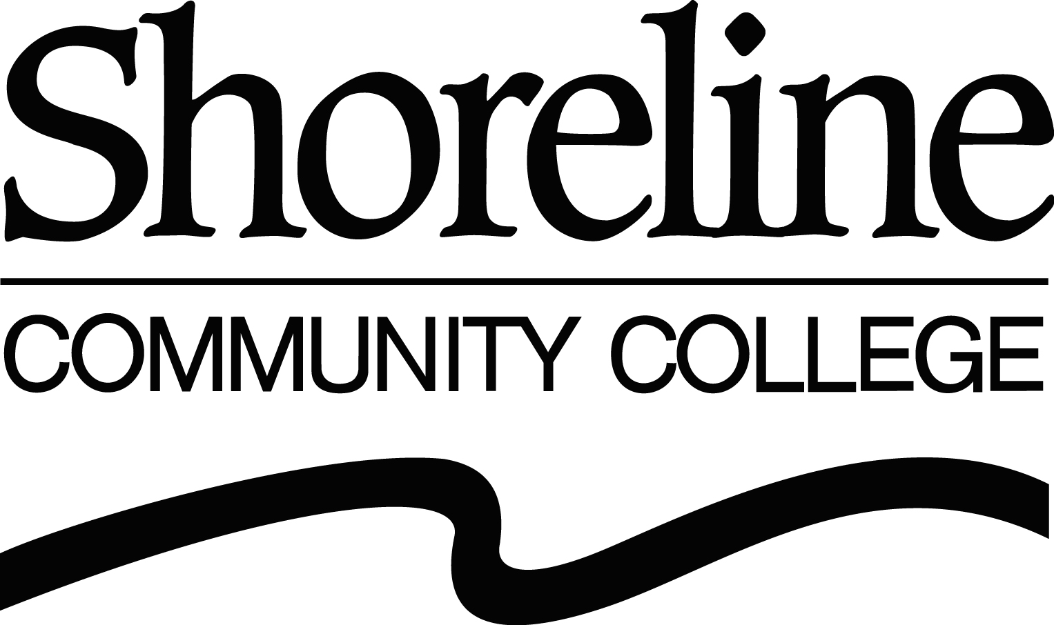

Educating the Workforce for Green Jobs

Lee Lambert
President, Shoreline Community College
Shoreline, WA

Testimony before the Senate Committee on Health, Education, Labor & Pensions

Monday, April 21, 2009

Mr. Chairman, members of the committee, my name is Lee Lambert, President of Shoreline Community College, located a few miles north of downtown Seattle, Washington, and thank you for the opportunity to address this topic that is of such importance in these challenging economic times.

Community colleges are the closest thing this country has to a national network of ubiquitous, low cost and high quality training providers. At the national level, the American Association of Community Colleges (AACC) represents the nation’s more than 1,200 community colleges. We support the AACC positions in the following areas that will allow us to revamp, renew and implement the kinds of programs we’re here to talk about today:

- Training Capacity
- Trainer Eligibility
- Workforce Boards
- Infrastructure
- Adult Basic Education
- Entrepreneurship
- Labor Exchange Information

As it is across the country, Washington State’s comprehensive community and technical colleges are charged with being all things to all people. It is a difficult task, but one that community and technical colleges embrace because we know the role has impacts on such a broad scale, from the lives of our students to the health of the nation’s economy.

The one quality that allows community and technical colleges to meet that spectrum of need is flexibility. At Shoreline Community College, we both respond to and anticipate the needs of the community. Just as Shoreline has done for the past 45 years, we are addressing the needs of the emerging green economy by focusing on four areas: programs, partnerships, performance and points of consideration.
While today I’ll highlight two green-jobs programs at Shoreline, one new and one existing, please note that many of our other existing programs are moving toward becoming green-related by virtue of new technologies and our changing personal behaviors.

Zero Energy Technology

Shoreline was one of the first schools in the country to launch a “photovoltaic system design” program. That means students learn how to assess a building’s power needs, design an appropriate solar-panel system and the installation to not only meet the owner’s needs, but also actually feed power back to the electric utility grid. That may sound way ahead of the curve, but remember our program started just a year ago and this curve is headed nowhere but up.

Solar in damp, cloudy Seattle? Well, if it works there it will work anywhere and one need only look at the numbers to see this is more than wishful thinking. Currently, Germany leads in photovoltaics with more than 50 percent of the all the system installations in the world. When the sun shines in Bavaria, 20 percent of that region’s electricity needs are met by photovoltaics. Surprisingly Washington State has more sunny weather than Germany.

Shoreline Community College is now home to a demonstration project called the Zero Energy House designed and built by students enrolled at Washington State University, one of our major partners. Earlier this month, on April 1, it snowed on campus, but the solar panels on the Zero Energy House kept the heat pump going and still had the power meter running backward, feeding the grid. Sen. Murray, you will be proud to know that the Shore-North Cooperative Preschool just received a two-year endorsement as an eco-healthy child-care program for their efforts in reducing the Preschool’s carbon footprint.

Shoreline’s solar design class is the first piece of our growing Zero Energy Technology Program. The name refers to a “net-zero” energy use goal and the program also includes classes in:

- Energy auditing, which helps determine a building’s overall energy use and identify cost-saving efficiencies
- Building design, to educate and train energy efficient design concepts
- Blueprint reading
- Solar space and water heating system design
- Sustainability in the built environment
- Renewable energy

All the classes Shoreline offers are in direct response to expressed needs of business and the labor market. Indeed the program is vibrant and growing because of the strength of its partnerships, which include:

- Education - Washington State University
- Labor - International Brotherhood of Electrical Workers
- Local businesses -Silicon Energy, Outback Energy
- International business – REC Silicon
- Local government – Cities of Seattle and Shoreline
- State government – Incentive legislation
- Federal government – Dept. of Labor grants
- Utilities – Seattle City Light
- Advocacy groups – NW Solar Center, Shoreline Solar Project

The result is nearly 300 students with state-certified green job skills have been trained since the inception of the program. Some students who enrolled in the Zero Energy Technology program were currently employed and wanted to upgrade their skills, some students found employment with various Washington State businesses after their training and some became entrepreneurs starting their own new businesses.

Shoreline continually evaluates the quality and responsiveness of its professional and technical training programs to meet the needs of employers and businesses. When the Photovoltaic System Design class launched, there were approximately 200 applications for solar-panel system installations statewide, just two years later, there are more than 1,000. Of course not all of that is due to our program, but it does help outline the need. In January, the Zero Energy Technology program was honored with a national Bellwether Award as one of the top 10 workforce development programs in the country.

I spoke of the ancillary impacts, the spinoffs, of green technologies and green-jobs training and here are just two:

- Shoreline offers a highly acclaimed respected manufacturing and computer controlled machining program. As the photovoltaic-system design students work through installation problems, they are generating design-change ideas for the solar-panel mounting brackets. These aluminum parts are exactly the kind of item our students are learning to design and manufacture in the computer-controlled machining program. As the market grows, these industrial cross-pollinations will also grow, integrating new and existing technologies, creating new jobs for our economy.

- A number of Washington State’s community and technical college programs, including Shoreline’s, train students in energy auditing, or how to assess a building’s energy efficiency. The auditing skills learned in these programs open the door to an array of energy conservation/efficiency employment opportunities, including weatherization, insulation, heating, ventilation and air conditioning technology and others.

Automotive Technology

Just a decade ago, one might not have immediately thought of an automotive technologies program as a green-job opportunity. Today, it is one of the most rapidly changing manufacturing technology areas and Shoreline Community College is responding to meet the needs of manufacturers and society.

Shoreline’s automotive program stands out as an excellent model of what partnerships and collaboration can achieve in these difficult economic times. Our program is built around the needs of the manufacturers, suppliers, Puget Sound Auto Dealers Association and students. Shoreline provides certified and sponsored training from:
- General Motors
- Chrysler
- Honda
- Toyota

All of those manufacturers are moving rapidly into hybrid, plug-in hybrids, and all-electric technologies. The program partnerships are key to assuring that cutting-edge quality is maintained. Students are guaranteed jobs when they begin the program because they are sponsored by individual new car dealers representing the four vehicle manufacturers. Students receive training in the very latest in automotive technology advancements.

Toyota recently recognized the Shoreline’s as one of their top training programs in the country, honoring it with the T-Ten Award for the third year in a row. Looking at just the training programs involving direct hybrid technology training, nearly 400 students have entered the workforce since we began this level of training a few years ago with new green-jobs skills. The dealer/manufacturer relationship completes the circle as each manufacturer certifies the students.

The program is expanding in large part due to those partnerships. Groundbreaking is imminent on a 26,000-square-foot addition to the automotive facility at Shoreline Community College. The capital costs of about $4 million will be shared by the State of Washington, the Puget Sound Auto Dealers Association, local new car dealers and manufacturers, most notably $1 million is being provided by Toyota.

In addition, the college has a General Service Technician program, initially developed through funding received by the U.S. Department of Labor. The program is an entry-level automotive technician curriculum and allows outreach to underserved communities such as students with limited English proficiency, out-of-school youth and dislocated workers. English as a Second Language and Adult Basic Education instructors work side-by-side with the automotive instructors to ensure student success. Students who complete this industry-certified curriculum earn a Certificate of Proficiency and move easily into entry-level positions as general service technicians, making good salaries now while putting them on a career and education pathway for further advancement.

In November, 2008, the Automotive Training and Career Opportunities Partnership (ATCOP) at Shoreline Community College received the Governor’s Award for Best Practices in workforce development. The College’s General Service Technician (GST) training program received this honor awarded by the Workforce Training and Education Coordinating Board (WTECB). WTECB recognizes local and regional agencies, organizations, and community and technical colleges for their leadership and excellence in developing programs and achieving results to advance best practices in workforce development. There were 21 projects nominated for this award, six of which were selected to receive the Governor’s Award.

In making the award, the WTECB said it was looking for programs that are innovative, replicable, and transferable – the key elements of a best practice.

In addition to educating and training for new employees, the Shoreline automotive program provides skills updating and training for thousands of incumbent workers. These short-term training programs bring existing workers to state-of-the-art facilities to learn the latest programs and techniques. Indeed, with the recent closure of the General Motors Training Center based in Portland, Ore., Shoreline Community College will become a hub for incumbent worker automotive technologies training in the West.

While hybrid, plug-in hybrid, and all-electric automotive technology is still new, think about the lifecycle of an automobile and you’ll see the next step for Shoreline’s automotive technologies program. While much of the technology is currently proprietary, eventually owners of those now cutting-edge hybrids are going to start taking them to the thousands and thousands of independent vehicle repair shops. Extending the training and skills to those employers will be critical in the not-so-distant future.

Through existing and coming programs, Shoreline expects to educate and train 2,500 incumbent manufacturer-sponsored workers and another 5,000 at independent repair shops over the course of the next few years. In partnership with the Workforce Development Councils and community-based organizations, Shoreline is working to track the success of these students with a program called Career Navigator.

So, I’ve told you of the successes, now, let me tell you how our flexibility is allowing us to address some of the challenges that accompany innovative and cutting-edge training programs.

Many of those who seek employable, green-jobs training lack basic literacy skills. To get those students to the point where they have the math, reading, language and even the so-called “soft” or performance skills to participate in the training, we develop programs that address those needs.

Through the work of the State Board of Community and Technical Colleges, Washington State has developed an Integrated Basic Education and Skills Training program, better known as I-BEST, and a student financial assistance program called Opportunity grants to help meet the needs of under-prepared workers.

I-BEST provides educational access and support for Adult Basic Education (ABE)/English as a Second Language (ESL) so students can progress further and faster along career pathways. I-BEST pairs ABE/ESL instructors with professional-technical instructors in the classroom, working together to advance students in both basic academic and professional-technical skills. Washington State currently has 128 different I-BEST programs, many aimed at green jobs.

Shoreline has already had success in pairing I-BEST with the Automotive Technology Program and we’re now looking to replicate that success with the Zero Energy Technology program.

Shoreline has utilized the opportunity grant program to support the financial needs of under-prepared workers where traditional financial aid programs leave off. This allows our students to not have to make the difficult choices of whether to participate in a job training program versus taking a second job to meet their basic needs.

Other Green Jobs Programs

While I’m understandably proud of Shoreline’s programs, many Washington State community and technical colleges offer green-jobs programs, including:

Green Construction and Remodeling - Bates Technical College
Five-course certificate (10 credits) in “built green” and LEED methods, appropriate building materials, air and water quality, and marketing and sales. Bates is an approved education provider for the U.S. Green Building Council’s (USGBC) online green construction and remodeling series.

Green/Sustainable Design - Bellevue College
Certificate (15 credits) in the design of "green" interior environments or specialist in healthy interiors.

Solar/Photovoltaic Design - Columbia Basin College
Short certificate (5 credits) to select and/or certify solar panel systems for residences and commercial buildings and prepare students for the Silicon Energy Manufacturing Solar Installation Certificate and the National Photovoltaic (PV) Installer Certification through the North American Board for Certified Energy Practitioners (NABCEP).

Associate of Applied Science-Transfer degree in Environmental Technologies and Sustainable Practices - Cascadia Community College
Two, two-year degree tracks with two related certificates:
- Business track: Graduates address savings and spending using applicable terms and tools.
- Technical track: Graduates perform in a hands-on environment.
- Certificate 1: Solar PV System Specialist (51-57 credits) covers commercial and residential systems.
- Certificate 2: Energy Management Specialist (64-68 credits) covers conservation and efficiency in new and existing buildings

Interior Design/Green Design - Clover Park Technical College
Certificate (19 credits) in historic preservation, sustainable environments and independent study courses.

Green Real Estate - North Seattle Community College
Two-quarter, seven-course certificate (16.5 credits) that includes some continuing education fulfillment and qualification as a Built Green Certified Professional. Other topics include: green building materials, energy efficient design and development, healthy buildings, indoor air quality and marketing.

Zero Energy Technology – Shoreline Community College
Three certificates and a pre-apprenticeship program:
- Certificates: Prepare students for the Silicon Energy Manufacturing Solar Installation Certification and the national PV Installer Certification through the North American Board of Certified Energy Practitioners (NABCEP)
- Solar/Photovoltaic Energy Designer (5 credits)
- Zero Energy Building Practices (15 credits)
- Zero Energy Building Practices (59-63 credits)
- Pre-Apprenticeship: Training for Green Careers in the Trades (12 credits) developed with City of Seattle and Seattle City Light

Energy Auditor - South Seattle Community College
Certificate (12 credits) for residential buildings.

Sustainable Plant Production - South Puget Sound Community College
Certificate (41-44 credits) in plant propagation, production and marketing of native and nonnative horticultural crops.

Associate of Technical Sciences in Sustainable/Organic Fruit Production - Wenatchee Valley College
Two-year degree developed cooperatively with Washington State University in horticulture, integrated pest management production, processing and marketing of perennial fruit crops.

In short, I would like to thank the committee for giving me an opportunity to share some of the exciting opportunities the State of Washington is providing its residents with in the area of green jobs. As you have heard, the Washington State Board for Community and Technical Colleges and our 34 community and technical colleges are moving Washington State forward in training and educating the green workforce through its innovative programs and strong partnerships with business and industry, community based partners, the local workforce development councils and myriad of other state and local organizations.

