SHORELINE COMMUNITY COLLEGE
Learning-Centered Primer

Learning Paradigm
A paradigm shift occurred in higher education as institutions moved from a teaching or instructional paradigm to a learning paradigm in the mid-1990s. Learning colleges emerged with emphasis placed on learning that is integrative, comprehensive, holistic, transformative, and multi-centric. A New Paradigm for Undergraduate Education (Barr and Tagg, 1995) provides examples of the shift:
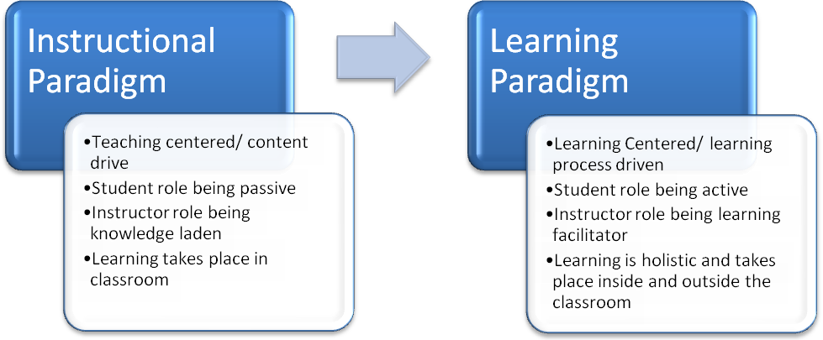
An integrated and holistic approach places the learner at the center of an interconnected educational experience.. In Learning Reconsidered (Keeling, 2004), interconnectedness includes understanding the learner including their background, diverse perspectives or areas context such as social, academic and institutional. Learning takes place when the learner is able to make meaning, emotional connections, and apply learning in an integrated way ultimately impacting their identity, emotional, and behavioral formation.
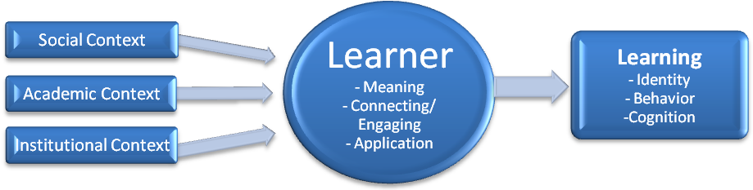

Learning Reconsidered details each:
Social Context: personal relationships | group memberships | inter-group connections
Academic Context: opportunities for reflective judgment and critical thinking | constructivist classroom teaching methods | interdisciplinary courses | experiential learning | integrative conversations with faculty in all domains
Institutional Context: opportunities/reward structure – leadership roles, work study positions, teaching and laboratory assistantships, off-campus connections to service and learning | campus culture – ethical codes, judicial processes, norms of behavior, annual rituals and celebrations, geographic and economic locations.
Learning: identity formation | emotional elements | behavioral elements |meaning making

The Learning-Centered College
In Creating More Learning-Centered Community Colleges, O’Banion (1997) describes learning-centered colleges as placing the learning first and providing educational experiences for learners, anyway, anyplace, and anytime. He identifies six key principles for learning-colleges:
- Creates substantive change in individual learning.
- Engages learners in the learning process as full partners, assuming primary responsibility for their own learning.
- Creates and offers as many options for learning as possible.
- Assists learners to form and participate in collaborative learning activities.
- Defines the roles of learning facilitators by the needs of the learners.
- Success is when the college and its learning facilitators improve and expand learning.

Language and terminology are important to clarify, including terms such as learning, learning colleges, learning-centered, learning communities, learning programs and services, and learning outcomes. While all are connected, a learning-centered approach defines “integrative learning that is comprehensive, holistic, transformative, and multi-centric.” The learning-centered approach guides integrated learning experiences, such as Freshman Year Experience programs and interdiscplinary studies (or learning communities) that cluster courses together intentionally to help students make connections and discover relationships. Learning programs and services provide co-curricular opportunities for students to engage in learning inside and outside the classroom such as student leadership, service-learning, and interacting in the physical learning environment. Learning outcomes guide learning through general education outcomes and student learning outcomes (see Appendix A for learning outcomes).

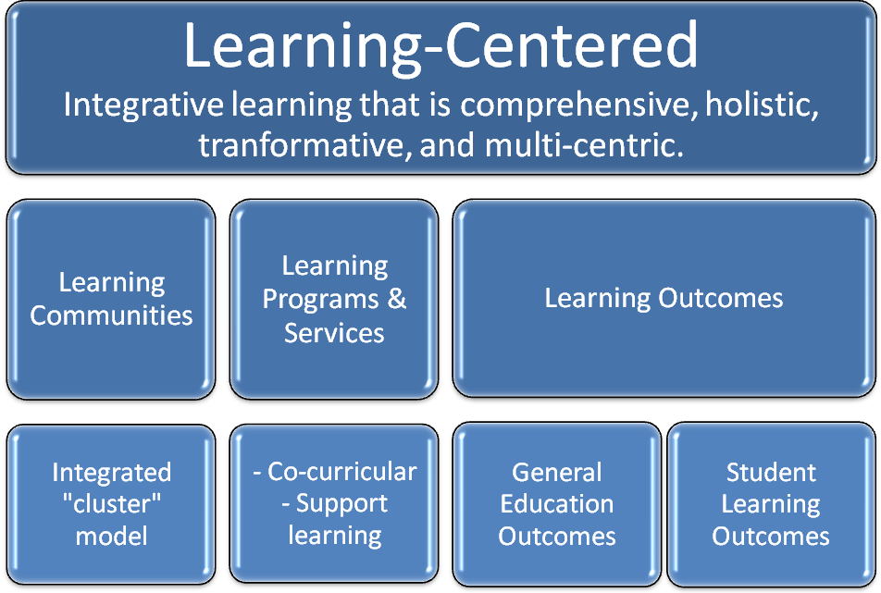

Institutional Transformation
Transformation begins by placing learning first. In Launching a Learning-Centered College, O’Banion (1999) describes critical steps institutions must take to become learning-centered, including placing learning first in every policy, program, and practice. All operations of the college—instruction, student services, facilities, human resources, fiscal management, etc.—focus on the mission of learning. Moving towards learning-centered can capitalize on a natural trigger events (e.g., budget cuts and reorganization) to turn them into “teachable moments.” Additional steps include identifying needs through assessment, building on existing innovations, engaging in conversations of learning, building a critical coalition, creating an emerging vision, creating action plans, involving stakeholders, creating an open system of communication, and reallocating resources.

A learning-centered approach guides the philosophy of the institution towards filling its vision and mission, and guides the approaches in strategic planning, objectives, and structure (See Appendix B).
Appendix A

SCC General Education Outcomes | CAS Learning Outcomes
Quantitative Reasoning: Students will demonstrate college-level skills and knowledge in applying the principles of mathematics and logic. Information Literacy: Students will access, use, and evaluate information in a variety of formats, keeping in mind social, legal and ethical issues surrounding information access in today’s society. | Knowledge acquisition, integration, construction and application: Understanding knowledge from a range of disciplines: connecting knowledge to other knowledge, ideas and experiences; constructing knowledge; and relating knowledge to daily life
General Intellectual Abilities: Students will think critically within a discipline, identify connections and relationships among disciplines, and use an integrated approach to analyze new situations. | Cognitive complexity: Critical thinking; reflective thinking; effective reasoning, and creativity
Multicultural Understanding: Students will demonstrate understanding of issues related to race, social class, gender, sexual orientation, disabilities and culture and role these issues play I the distribution of power and privilege in the United States.  Global Awareness: Students will demonstrate understanding and awareness of issues related to, and consequences of, the growing global interdependence of diverse societies by integrating knowledge from multiple disciplines. Students will describe how social, cultural, political, and economic values and norms interact. | Intrapersonal Development: realistic self-appraisal, self-understanding, and self-respect; identity development; commitment to ethics and integrity; and spiritual awareness  Interpersonal Competence: Meaningful relationships; interdependence; collaboration; and effective leadership  Humanitarianism and Civic Engagement: Understanding and appreciation of cultural and human differences; social responsibility; global perspective; and sense of civic responsibility
Communication: Students will read, write, speak in, and listen to college-level English. Effective communication incorporates awareness of social nature of communication and the effects of ethnicity, age, culture, gender, sexual orientation and ability on sending and receiving oral, non-verbal, and written messages. | Practical Competence: Pursuing goals; communicating effectively; technical competence; managing personal affairs; managing career development; demonstrating professionalism; maintaining health and wellness; and living a purposeful and satisfying life

Appendix B

MISSION FULFILLMENT
Vision, Mission, Guiding Principles, Core Themes, Strategic Plan
Shoreline Community College is dedicated to integrative learning that is
comprehensive, holistic, transformative, and multi-centric.
Vision | Mission | Guiding Principles | Core Themes  (Board of Trustees) | Strategic Plan
Student Success | Educational  Workforce | Excellence | Equity | Engagement | Educational Attainment  Program Excellence | Student Success  Program Excellence
 | Cultural | Excellence | Equity | Engagement | Access & Diversity | Diversity, Equity, and Access  Multicultural & Global Competence  Campus Culture
Community Engagement | Community | Excellence | Equity | Engagement | Community Engagement | Community Engagement
 |  | Excellence | Equity | Engagement | Public Stewardship | Environmental Stewardship and Sustainability
 |  | Excellence | Equity | Engagement |  | Infrastructure and Technology
VISION: We will be a world-class leader in student success and community engagement.
MISSION: We are dedicated to serving the educational, workforce and cultural needs of our diverse community.
CORE THEMES: (Board of Trustees)
- Educational Attainment: SCC is committed to facilitating the success of each student’s stated educational goals and to support students in the attainment of course completion, certificates, degrees, personal enrichment, and/or professional development. SCC provides excellence in academics so that all students will complete their program and/or graduate with the academic preparation and skills necessary to continue their education, meet the demands of the workplace or improve their quality of life through leisure-time activities.
- Program Excellence: SCC fosters excellence in its educational programs, services and resources to meet the needs of students, employers, and the community.
- Community Engagement: SCC initiates, cultivates, and nurtures relationships with cities, including Shoreline and Lake Forest Park, local school systems, business, the SCC Foundation, community based and international organizations. As a learning, entertainment, and gathering hub of the community, the College is a proactive, responsive and responsible partner and resource in community and economic development and sustainability.
- Access and Diversity: SCC maximizes student access to all its transfer, professional/technical and development programs. SCC promotes a diverse student body and employees who reflect the local, state, regional and international communities that the college serves.
- Public Stewardship: SCC will service as a model of effective stewardship to citizens of the State of Washington.
STRATEGIC PLAN:
- Program Excellence: SCC fosters excellence in its educational programs.
- Student Success: Students find enrichment in a safe environment for personal and professional growth. Students reach their goals through innovative programs of study, support services and a diverse campus life.
- Diversity, Equity and Access: SCC enables access to educational opportunities for all members of the community by promoting diversity and equity in our working and learning environment.
- Infrastructure and Technology: SCC provides state-of-the art buildings, classrooms and technology in a safe and attractive campus.
- Environmental Stewardship and Sustainability: SCC models sustainability in its curriculum and operations that are ecologically sound, socially just and economically viable.
- Multicultural and Global Competence: SCC supports and educates all members of the campus community in their development as multiculturally and globally competent citizens.
- Community Engagement: SCC is the learning, entertaining and gathering hub of the community.
- Campus Culture: We value and respect each others’ diverse contributions to our collective goals.

