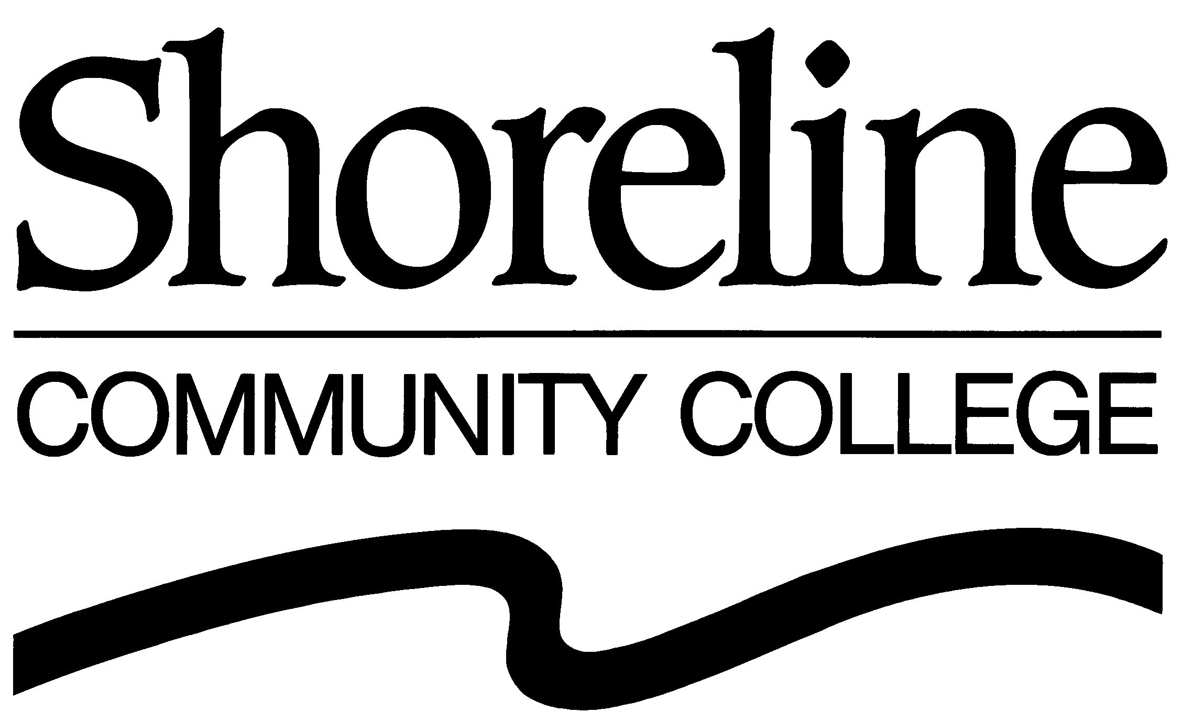

PHOTO, AUDIO, AND VIDEO PROMOTION RELEASE FORM

Shoreline Community College may take and use photographs or videos of me and/or my child or materials or excerpts of statements I provided to be used for public information purposes, such as college publications, the Web site, displays, news releases, podcasts, blogs, video presentations and advertisements with the understanding that my image will be used to promote Shoreline Community College. I do this willingly, expecting no compensation or gratuity of any kind from Shoreline Community College.

(Please complete and sign.)

Name: _________________________________________________________

(Minor’s name):__________________________________________________

Address:________________________________________________________
_______________________________________________________________

_______________________________________________________________

Telephone:______________________________________________________

E mail: _________________________________________________________

Degree/Certificate Program: ________________________________________

Signature:_______________________________________________________

Date:___________________________________________________________

___ (initial) I have supplied the college with an original piece of music/art which the
college may also use for the purposes listed above, crediting me as the artist.

Other Information:

03/30/10

