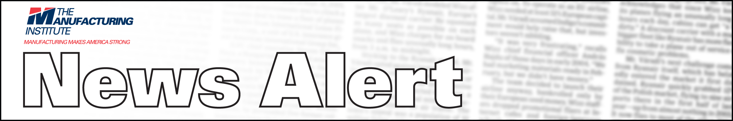

098-107-MI CONTACTS:
LAURA NARVAIZ (202) 637-3104
FOR IMMEDIATE RELEASE HANK COX (202) 637-3090

MANUFACTURING INSTITUTE RECEIVES GATES FOUNDATION GRANT FOR NATIONAL SKILLS CERTIFICATION SYSTEM

System Will Revolutionize Education and Training for New Manufacturing Workforce

WASHINGTON, D.C., May 27, 2009 – The Manufacturing Institute (MI) has been awarded a $1.5-million grant from the Bill & Melinda Gates Foundation to comprehensively plan and implement postsecondary education programs that include the National Association of Manufacturers (NAM)-endorsed Manufacturing Skills Certification System. These integrated educational programs in community colleges will prepare students, particularly low-income young adults and transitioning workers, with entry-level skills necessary to succeed in advanced manufacturing careers.

A postsecondary credential—two-year, four-year, or certificate—is a fundamental prerequisite for economic success. The current economic climate has only reinforced the importance of college. Adults 25 and older with at least an associate’s degree have average earnings 30% higher than those of high school graduates without college.

In the MI initiative, the worker credentials needed by the industry will be integrated into associate degree programs offered in community colleges. There are three primary benefits:

- Postsecondary education and training will become more engaging and meaningful to students who may stay in school and earn postsecondary credentials with real value in the workplace. The “stackable” industry credentials also provide more “on” and “off” ramps to postsecondary education needed in today’s workforce.
- Skill certifications will lead to employment in high-quality, middle-class jobs in advanced manufacturing.
- The number of skilled new workers for U.S. manufacturers will increase.

“We need to get kids engaged in learning, and we need to give them options,” said NAM President John Engler. “Moving these industry-recognized skills certifications into community college programs will provide meaningful, relevant education for students and ultimately produce a highly skilled and mobile workforce – making us more competitive in the global economy.”

Leading community colleges in North Carolina (Forsyth Technical Community College), Ohio (Lorain County Community College), Texas (Alamo Colleges) and Washington (Shoreline Community College) will be the first to implement the NAM-endorsed Manufacturing Skills Certification System.

“Community colleges have taken the lead in adapting their postsecondary education to meet industry needs in their regional economies,” said MI President Emily DeRocco. “Successful integration of industry-driven skills credentials by these progressive community colleges will revolutionize postsecondary education, ensuring graduates have credentials with real value in the workplace.”

Community colleges enroll nearly half of all higher education students nationwide. With relatively low tuition and open admissions policies, they are a vital pathway to better jobs and higher earnings for many adults. Only about a third of those who enter a community college, however, earn a degree or certificate six years later.

“The integration of the NAM-Endorsed Manufacturing Skills Certifications – ‘stackable’ industry-recognized credentials – provides more flexibility for students facing many challenges to successfully pursue a single pathway to a degree. The system offers more ‘on’ and ‘off’ ramps in postsecondary education, and each credential earned increases the students’ value in the manufacturing workplace,” DeRocco said.

The NAM-endorsed Skills Certification System initially focuses on the core, basic skills required for entry-level workers in all sectors of manufacturing, from alternative energy and computers to aerospace and life-saving pharmaceuticals. The skills certifications address personal effectiveness competencies, foundational academic competencies, general workplace skills and manufacturing industry-wide technical skills. Entry-level science, technology, engineering and math (STEM) skills are included in the system.

The NAM system organizes individual certification programs designed and validated by partners ACT, Inc.; the Manufacturing Skills Standards Council; the American Welding Society; the National Institute of Metalworking Skills; and the Society of Manufacturing Engineers into a national structure creating scalable educational pathways with “stackable” credentials leading to an associate degree.

-NAM-

The Manufacturing Institute is a non-partisan 501(c) (3) affiliate of the National Association of Manufacturers focused on delivering leading-edge information and services to the nation’s manufacturers through its Center for the American Workforce and its National Center for Manufacturing Research.

