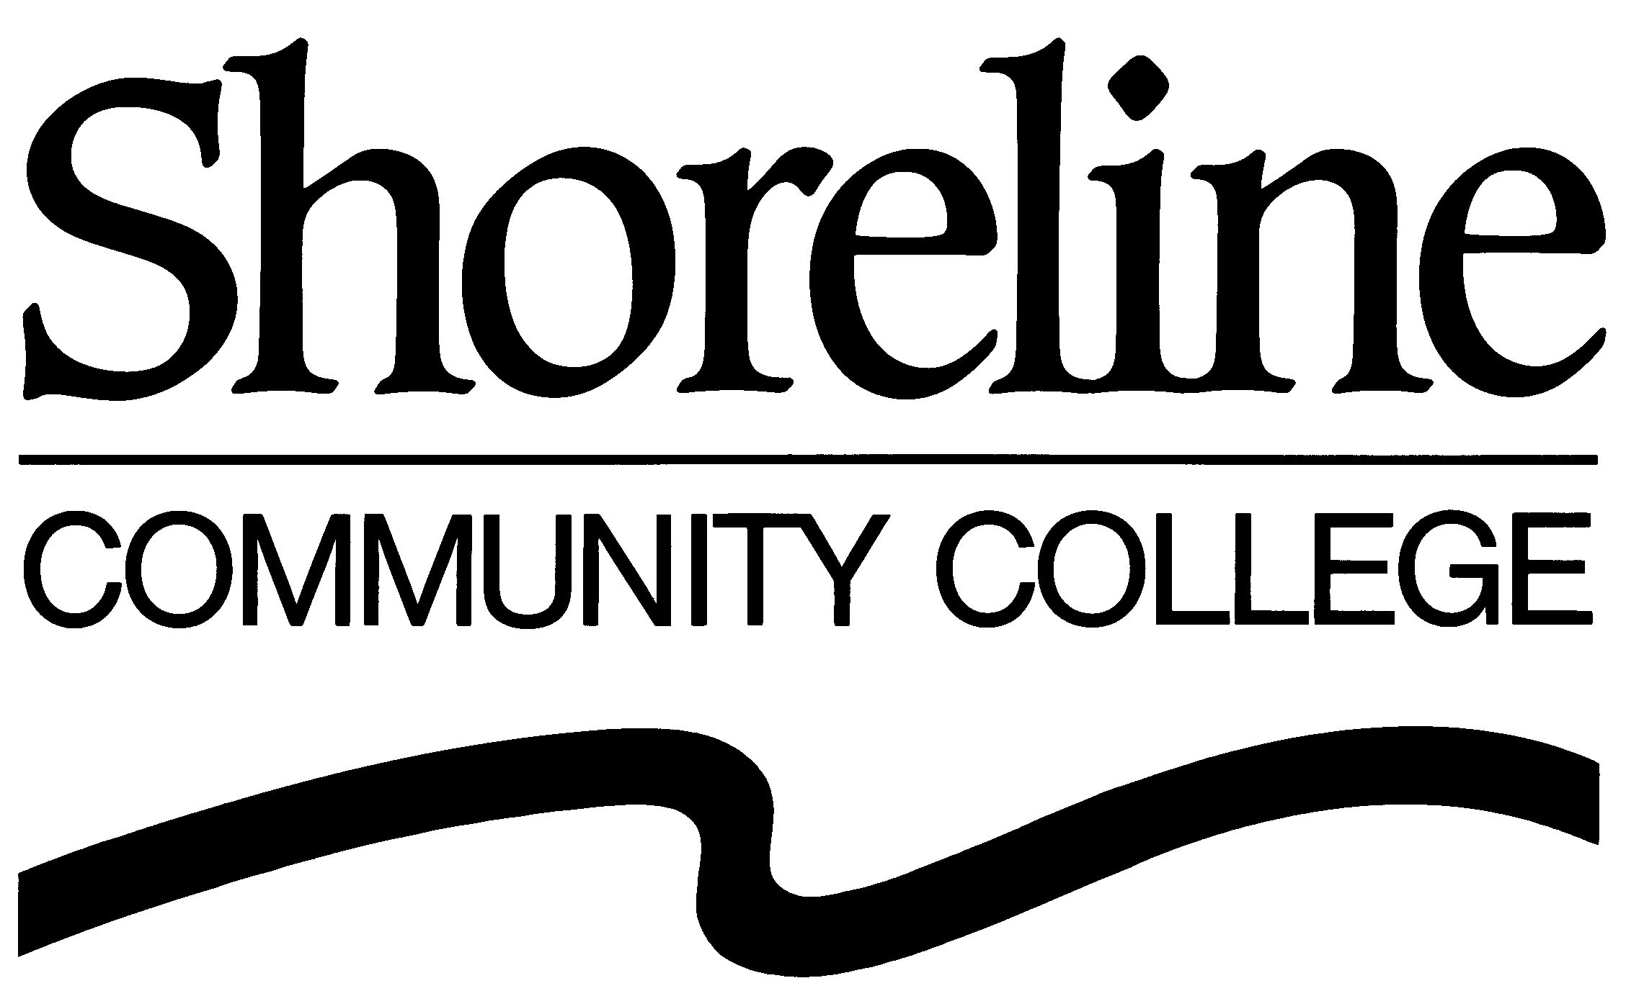

To: House Higher Education Committee
From: Jim Hills, Special Assistant to the President, Shoreline Community College
Re: HB 2634
Date: Friday, Jan. 15, 2010

Madam chair, members of the committee, my name is Jim Hills, Special Assistant to the President for Shoreline Community College. I have been asked by Shoreline President Lee Lambert to speak this morning on behalf of the College in support of the legislation before you, House Bill 2634.

Washington community and technical colleges already receive national acclaim as an innovative, effective and efficient higher-education system. However, we recognize that - especially in these unprecedented economic times - there may be opportunities to leverage advanced technologies and review organizational approaches. An examination of these opportunities could reveal further cost containment for the state while increasing student access and outcomes.

Shoreline is currently working with neighboring colleges, exploring ways to share resources, both administrative and academic. We welcome the opportunity to participate with the State Board and other districts to examine additional ways we can increase service to our students, our community and our state.

Thank you.

