Shoreline Community College
Substantive Change to Core Themes, Objectives, and Indicators
This supplemental report describes the proposed change to Shoreline’s Core Themes, Objectives, and Indicators.

Need for Change (d.1)
Over the past three years Shoreline has engaged in an intentional planning process that has led to significant re-interpretation of the College’s vision and mission. From January 2015 through May 2016, Shoreline developed a robust strategic plan for 2016-2021, followed by a one-year process to clarify the campus community’s values and associated behaviors (see Appendix A).
In this two-year process, it became clear that the College’s current Core Themes (included in Appendix B) were conflated with Shoreline’s values and were focused more on strategic approaches to planning as opposed to ongoing fulfillment of Shoreline’s mission statement. Because of this conflation, the indicators had not proved useful in assessing mission fulfillment and had not been consistently used in reporting to the Board of Trustees and campus community about the state of the College. The primary motivation for changing the Core Themes is to use indicators of mission fulfillment that are (a) more meaningful than the existing indicators and (b) relate to data the College already uses to measure success.
Appendix C includes a full description of the proposed new Core Themes, objectives, and indicators. As shown in Table 1 below, the change moves from Core Themes that describe a mix of values and activities, to one that captures the College’s four primary service areas: transfer education, professional-technical education, basic education for adults, and community education.
Table 1. Summary of change from Shoreline’s current Core Themes to proposed Core Themes
Current Core Themes | Proposed New Core Themes
 | Transfer Education | Professional-Technical Education | Basic Education for Adults | Community Education
Student Success
Program Excellence | Addressed in vision & strategic plan
Community Engagement
Access & Diversity
College Stewardship | Addressed in vision & strategic plan

The rationale for moving towards this interpretation of Shoreline’s is contained within the mission statement itself, as well as the original legislation that established Washington State’s system of community and technical colleges (See Figure 1).
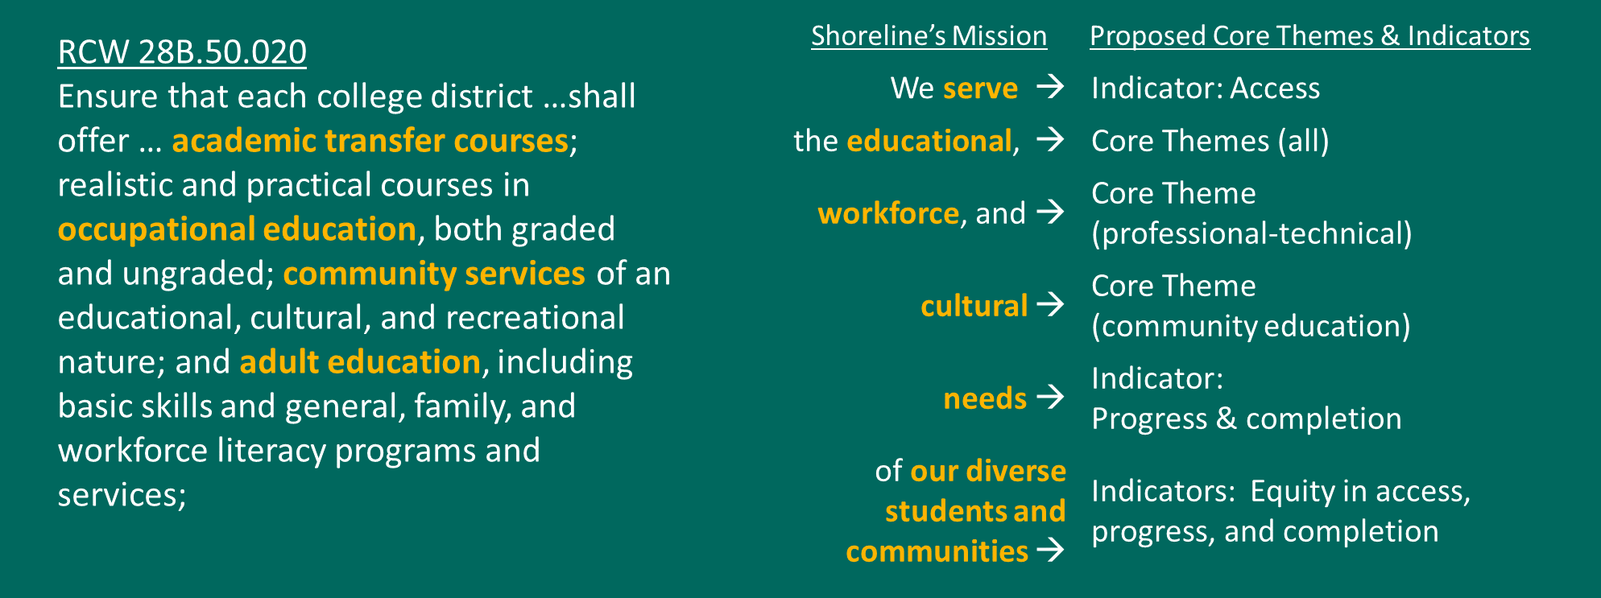
Figure 1. Demonstration of how proposed core themes map to the original stated purpose of Washington’s system of community and technical colleges (RCW 28B.50.020) and Shoreline’s Mission statement
The goals, values, and activities described in Shoreline’s current Core Themes will either be part of the proposed new Core Themes or captured in other aspects of the College’s work, including the newly clarified values, the College vision, and the 2016-2021 strategic plan, as shown in Table 2.
Table 2. Summary of the relationship between Shoreline’s current Core Themes and other aspects of the
Current Core Themes | Mission | Strategic Goal | Values | Indicator | Vision
Student Success
Program Excellence
Community Engagement
Access & Diversity
College Stewardship

Decision-making procedures (d.2)
The proposed change in Core Themes represents the culmination of a three-year process involving extensive college-wide participation and feedback, as described below.

Phase 1: Strategic Plan
Shoreline began working on a revised strategic plan in January of 2015.
- January – March 2015: Preliminary planning, formation of strategic planning task force representing all employee constituents and students
- April - June 2015: SWOT meetings with over 200 employees participating in person and 131 students and employees participating online; environmental scan data reviewed by strategic planning task force
- June – July 2015: Work groups representing all employee constituent groups reviewed SWOT analyses results and environmental scan data
- July – August 2015: Draft of strategic plan developed
- August 24, 2015: Open forum with community members (~25) on draft of strategic plan
- September 16, 2015: Draft strategic plan reviewed by all employees (~300) during convocation
- September - November 2015: Strategic plan revision at division meetings and strategic plan task force
- November 6, 2015: Presentation of revised strategic plan for final round of feedback. all-campus meeting December 2015 for final round of feedback
- January – February 2016: Feedback gathered during open forums and division meetings to adjust Vision and Mission statements; continued revision of strategic plan by strategic planning task force and Executive Team
- February 19, 2016: Proposed wording change to Vision and Mission introduced at special meeting of Shoreline Board of Trustees; draft Strategic Plan presented as an informational item (See Appendix D: Shoreline Board of Trustees, February 19, 2016 Special Meeting Minutes)
- March 16 2016: Board of Trustees reviewed and approved wording changes to the Vision and Mission statements; final version of strategic plan, approved by Shoreline’s Executive Team, provided as informational item (See Appendix E: Shoreline Board of Trustees, March 16 Regular Meeting Minutes)
- May 20, 2016: Final presentation of strategic plan at campus update and establishment of steering committees

Phase 2: Values

- September 14, 2016: Preliminary conversation with all employees at convocation with guiding questions
- November 18, 2016; January 27, 2017; March 10, 2017: Continued conversation and feedback at all-campus update meetings
- September 22, 2017: Final values and self-assessment questions (Appendix A) distributed to at convocation

Phase 3: Core Themes
Developing the strategic plan and refining values led to a reconsideration of the definition of mission fulfillment, as distinct but related to the strategic plan and values. The strategic plan represents where Shoreline is headed in the next five years to better fulfill the mission, and the values describe how everyone at Shoreline approaches the work to fulfill the mission. In contrast, the Core Themes need to represent a distillation of how the College defines and assesses that mission fulfillment. The current Core Themes do not provide that essential clarification that guides and defines ongoing assessment; hence, the proposed change in Core Themes.
This analysis and proposed change were presented, with feedback solicited according to the following timeline:
- May 2017: Survey about proposed change to Core Themes
- December 1, 2017: Feedback session with guiding questions and gallery walk at all-campus meeting
- January 5, 2018: Proposed Core Themes presented to Board of Trustees at winter board retreat
- February 22, 2018: Core Themes approved by Executive Team
- March 9, 2018: Presentation of Core Themes, Objectives, and Indicators (Appendix C) at all-campus meeting

Organizational arrangements (d.3)
The primary implications of this change are related to ongoing assessment of mission fulfillment, with ongoing reporting from the Office of Institutional Assessment and Data Management. This office has added a Director of Research and Grants (formerly an Assistant Director position) who will lead ongoing assessment and reporting of mission fulfillment.

Timetable of implementation steps (d.4)
The most immediate next step will be clarifying and defining indicators and developing infrastructure for reporting the indicators. Table 3 provides a summary of the proposed indicators for the proposed Core Themes. Please see Appendix A for more detailed information.
Table 3. Summary of Core Theme Indicators
New Core Themes | Indicators
 | Access &  Equity | Student Learning | Student Progress  & Equity | Completion & Equity | Contribution to Workforce
Transfer education
Professional-technical education
Basic education for adults
Community education & training

- July, 2018: Refinement of indicator definitions
- August 2018: Development of indicator reporting tools
- September 13 – 14 2018: Presentation of Core Theme indicators to Board of Trustees at annual retreat
- October 2018: Presentation of Core Theme indicators at all-campus update

