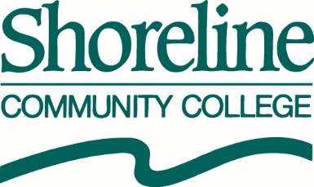

O F F I C E O F T H E P R E S I D E N T

**NOTICE OF SPECIAL MEETING(S) OF THE BOARD OF TRUSTEES**

The Shoreline Community College Board of Trustees will be holding its Annual Retreat, hereby noticed as Special Meetings:

* On Tuesday, August 9, 2016 (commencing at 9:00 AM) in room 301 at Shoreline City Hall (17500 Midvale Avenue North; Shoreline, WA 98133-4905); and
* On Thursday, August 11, 2016 (commencing at 9:00 AM) in the Board Room at the North City Water District (1519 NE 177th Street; Shoreline, WA 98155).

Submitted & Posted By:

* Lori Yonemitsu, Executive Assistant to the President &

Secretary to the Board of Trustees

* + (206) 546-4552
  + [lyonemitsu@shoreline.edu](mailto:lyonemitsu@shoreline.edu)

Posted Friday, August 5, 2016; 12:25 PM