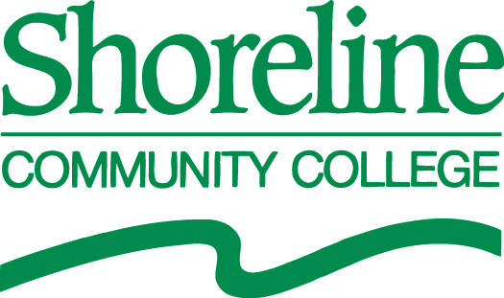

**2012 BOARD OF TRUSTEES REGULAR MEETINGS**

**(Approved by the Board of Trustees: October 26, 2011 Regular Meeting)**

WAC 132G-104-010 (Time and Place of Board Meetings) and Policy 7511 (Meetings of the Board of Trustees) of the Shoreline Community College Board of Trustees Bylaws state, “The Board of Trustees shall hold one regular meeting on the fourth Wednesday of each month at 4:00 pm and such special meetings may be requested by the Chair of the Board or by a majority of the members of the Board and announced in accordance with law.”

**The Regular Meeting dates for calendar year 2012:**

|  |  |  |
| --- | --- | --- |
| **Winter Quarter** | **Spring Quarter** | **Fall Quarter** |
| January 25, 2012 | April 25, 2012 | September 26, 2012 |
| February 22, 2012 | May 23, 2012 | October 24, 2012 |
| March 21, 2012**1** | June 27, 2012 | December 5, 2012**2** |

**1**Third Wednesday in March.

**2**The November and December 2012 meetings are combined with the meeting scheduled for the first Wednesday in December.