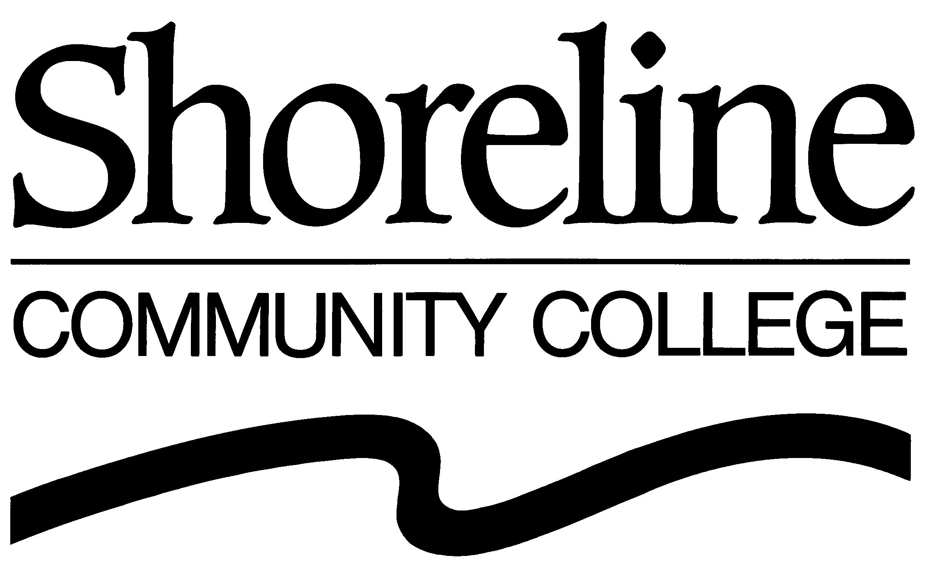

2010 BOARD OF TRUSTEES REGULAR MEETINGS
(Approved by the Board of Trustees : October 28, 2009 Regular Meeting)

The Shoreline Community College Board of Trustees shall hold Regular Meetings at 4:00 PM in the Board Room (#1010M) in the Administration Building (#1000) at Shoreline Community College (16101 Greenwood Avenue North, Shoreline, Washington). The Board is scheduled to meet on the following dates in calendar year 2010:

Winter Quarter | Spring Quarter | Fall Quarter
January 27, 2010 | April 28, 2010 | September 22, 2010
February 24, 2010 | May 26, 2010 | October 27, 2010
March 17, 2010¹ | June 23, 2010² | December 1, 2010³

¹Third Wednesday in March.

²The June 23, 2010 Board meeting will be held in Room 5 at Shoreline Community College’s Lake Forest Park location (SCC@LFP), Lake Forest Park Towne Center (17171 Bothell Way NE, Suite A220, Lake Forest Park, Washington).

³The November and December 2010 meetings are combined with the meeting scheduled for the first Wednesday in December.

