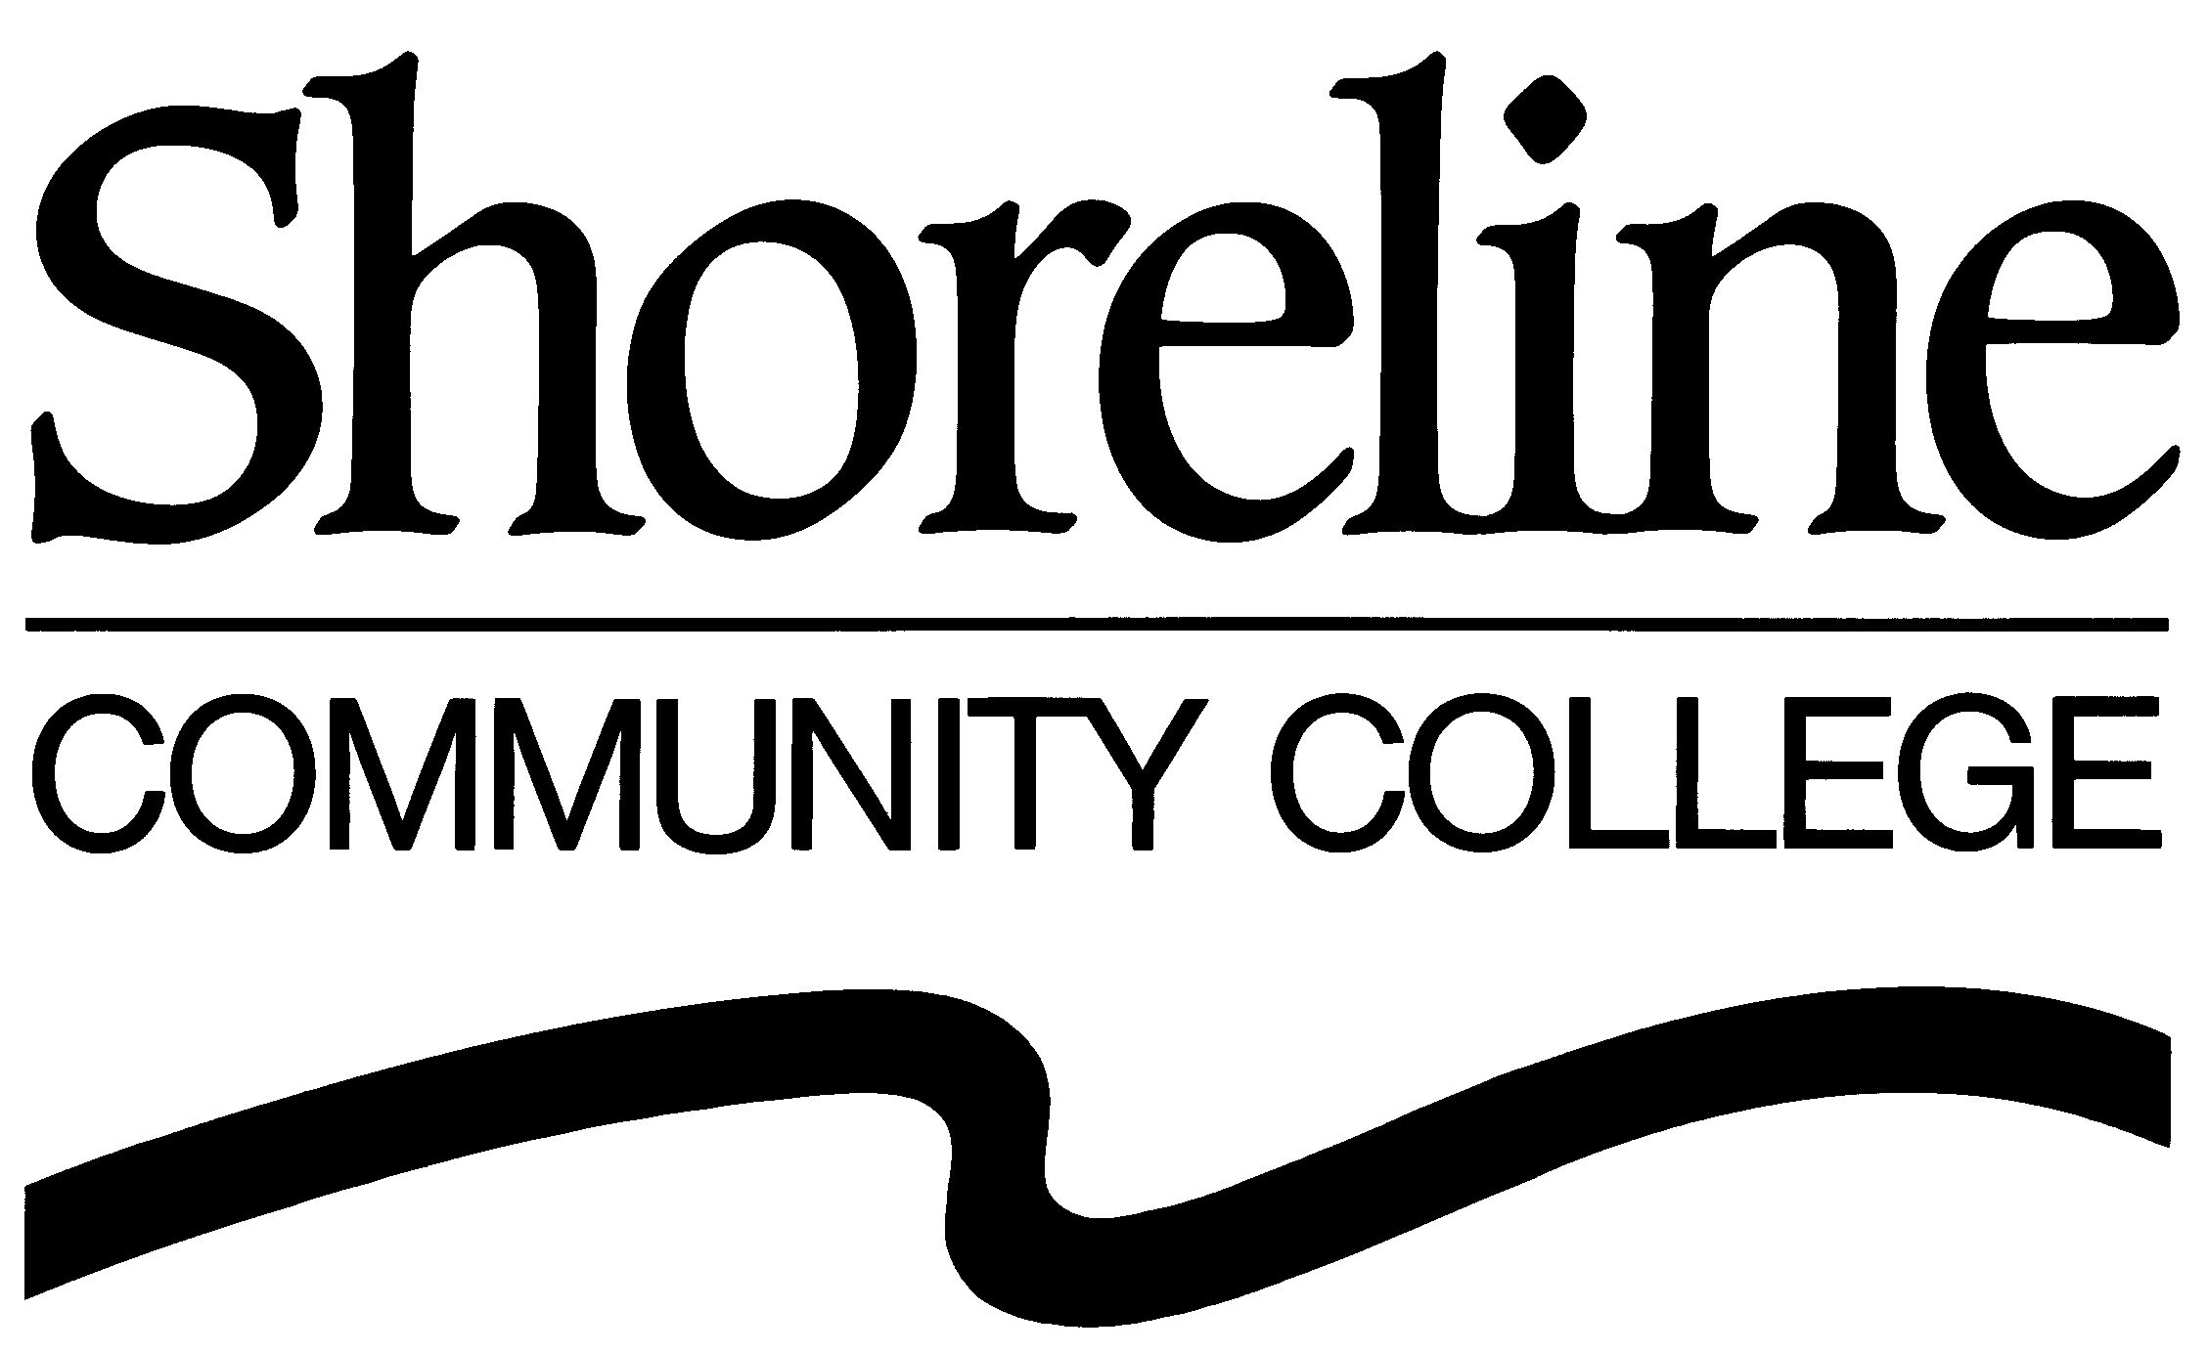

2009 BOARD OF TRUSTEES REGULAR MEETINGS
(Approved by the Board of Trustees : October 22, 2008 Regular Meeting)

The Shoreline Community College Board of Trustees shall hold Regular Meetings at 4:00 PM in the Board Room (#1010M) in the Administration Building (#1000) at Shoreline Community College (16101 Greenwood Avenue North, Shoreline, Washington). The Board is scheduled to meet on the following dates in calendar year 2009:

Winter Quarter | Spring Quarter | Fall Quarter
January 28, 2009 | April 22, 2009 | September 23, 2009
February 25, 2009 | May 27, 2009 | October 28, 2009
March 18, 2009¹ | June 24, 2009² | December 2, 2009³

¹Third Wednesday in March.

²The June 24, 2009 Board meeting will be held in Room 5 at Shoreline Community College’s Lake Forest Park location (SCC@LFP), Lake Forest Park Towne Center (17171 Bothell Way NE, Suite A220, Lake Forest Park, Washington).

³The November and December 2009 meetings are combined with the meeting scheduled for the first Wednesday in December.

