Requesting Accommodations
Requesting accommodations is a process that must be done every quarter through your Student AIM Portal. Once you’ve logged in to the Student AIM Portal, the beginning of the accommodations request process is located in the “Overview” section of your Dashboard – the default homepage when you log in. Find the heading “Select Accommodations for your Class.”
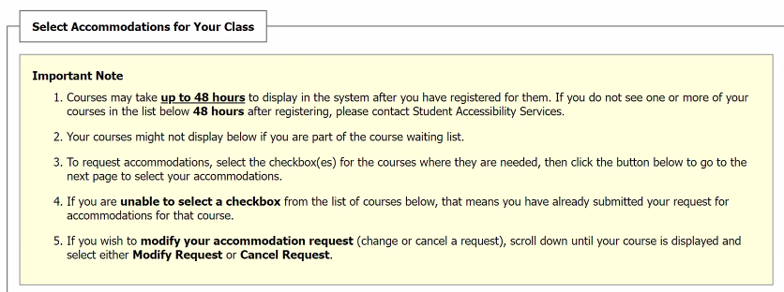

Step One: Select Class(es)
Find the box labeled “Step 1: Select Class(es).” If you finished registering for classes more than 48 hours ago, but don’t see some or all of them listed here, contact Enrollment Services via email at enrollmentservices@shoreline.edu or via phone at (206) 546-8611.
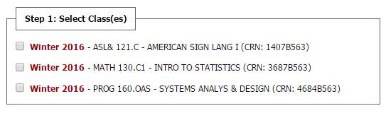
To select a class, click the checkbox next to it. You can select as many of your classes as you like. We do recommend requesting accommodations for all classes for which you might end up using accommodations. You do have the option of coming back and requesting accommodations later if you decide you want to use them. It is important to note that accommodations are not applied retroactively and will only be made available from the date you request them.
Once you’ve checked the classes you want, click the gray button labeled “Step 2 – Continue to Customize Your Accommodations” as seen below:

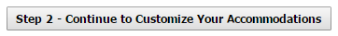

Navigating the Accommodation Request Page
The Step 2 button will take you to a page where you can select the accommodation you want for each of your classes.
The major fields on the Select Accommodations page are the following:
- Course Heading: The gray bar at the top lists the Course ID, Name, and Course Reference Number (CRN).
- Course Information: Lists instructor’s name, and information about when and where the class meets.
- Wrong CRN box: If you have accidentally selected a class for which you do not wish to use accommodations, select this box. Then you can continue to select accommodations for your other classes and your submission will be accepted.
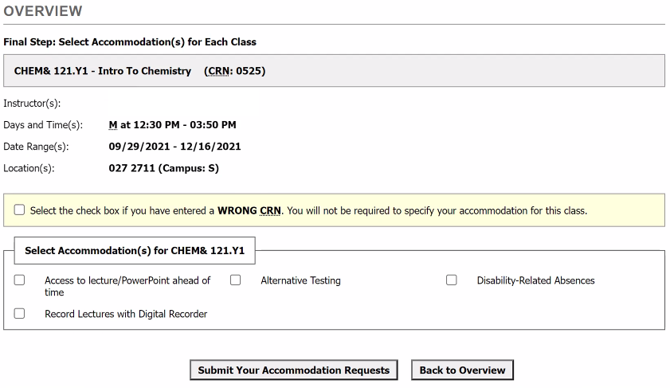
These first three parts can help verify which class you are selecting accommodations for. Once you know you’re looking at the right class, you can move on to the box that’s labeled “Select Accommodation(s) for…” followed by the course ID for your class. The following includes some important notes:
Inside the box, each of your accommodations will be listed with a checkbox next to each of them.
- By default, all accommodations are automatically selected.
- If you do not want one of the auto-selected accommodations, uncheck it.

When you’ve finished with one class, move to the next. Once you’ve finished with all the classes for which you want accommodations, click the button labeled “Submit Your Accommodation Requests” located near the bottom of the page.

Accommodations Request Submitted
When you’ve submitted the request, your browser will return you to your Dashboard. There will be a notification at the top of the Overview section confirming that your accommodation requests have been submitted to the system and will be processed by Student Accessibility Services (SAS) before being sent to your instructors.
Your Eligibilities (your accommodations)
You will be copied on the emailed notifications that are sent to your instructors about your accommodations.
To see your accommodations listed at any time, click the “My Eligibilities” link on the left-hand menu in your Student AIM Portal.

Questions?
Please feel free to contact SAS via email at sas@shoreline.edu or by phone at (206) 546-4545 with any questions, concerns, or issues you have with this process.

